“Challenges make you discover things about yourself that you never really knew.” – *Unknown.* Although this project was difficult, I really enjoyed it. I had a lot of fun working on the model with my dad. My plot size was 30 ft by 30 ft. We were told to maximize our polygon to our given plot size. My polygon was a hexadecagon, which has 16 sides. After zoning rules of only being able to build within 3 ft. of the given plot size, my plot size was marked down to 24 ft by 24 ft. (Figure 1.)

***Part 2.***



Figure 1. Polygon Maximized on Plot

Figure 1 shows the 4 polygons on the plot that was originally a 30ft by 30ft, but after zoning laws was scaled down to a 24ft by 24ft.

***Central Angle***

The central angle of my polygon would be $\frac{360°}{number of sides}$. Since my polygon is 16 sides, I would take $\frac{360° }{16}$. Then the central angle would equal 22.5°.



Figure 2. Polygon 1

Figure 2 shows the 16 sided polygon, with one triangle taken out then cut in half.

***Polygon 1.***

In Polygon 1, to find the side length, I cut the triangle in half. (Refer to Figure 2.) That would leave the angle 22.5° as 11.25°. I then used $tan({11.25)=}{\frac{opposite}{adjacent}}$. Since the height is adjacent side, the height would be 12 since it is half of 24. So then the function would be $tan\left(11.25\right)={\frac{opposite}{12}}$. I then multiplied each side by 12, to get the opposite alone. Then the function ended up being 12 × $\tan\left(11.25\right)=$ opposite. I got 2.39 and multiplied it by 2, because the triangle was cut in half. One side length in Polygon 1 is approximately **4.77 ft**. Since the area of a triangle is ½ base x height, I took ½ 4.77 x 12. I then got 28.64 ft² for the area of the triangle. There are 16 triangles in my polygon. So I took that area and multiplied it by 16. The total area of Polygon 1 is approximately **458.29 ft².**



Figure 3. Polygon 2

Figure 3 shows the 16 sided polygon, with one triangle taken out then cut in half.

***Polygon 2.***

In polygon 2, to find the side length, I again cut the triangle in half. (Refer to Figure 2.) That would again change the angle from 22.5° to 11.25°. I used $tan({11.25)=}{\frac{opposite}{adjacent}}$. Since the height is 1 ft. less than polygon 1’s height of 12, that would leave polygon 2’s height as 11 ft. So then the function would be $tan\left(11.25\right)={\frac{opposite}{11}}$. I multiplied each side by 11 to get the opposite alone. The function then moved on to being 11 x $\tan\left(11.25\right)=$ opposite. I then got 2.19 and I multiplied that by 2 because the triangle was cut in half. One side length of Polygon 2 is approximately **4.38 ft**. To find the area I used the area of a triangle first. Since the area of a triangle is ½ base x height, I plugged in my numbers to get the following formula of ½ 4.38 x 11. After working out the problem I got, 24.07 ft². Since there are 16 triangles in polygon 2, I multiplied 24.07 by 16 to get the total area. The total area of Polygon 2 is approximately

**385.09 ft²**.



Figure 4. Polygon 3

Figure 4 shows the 16 sided polygon, with one triangle taken out then cut in half.

***Polygon 3.***

In this polygon, I again split one of the triangles in half. (Refer to Figure 4.)The angle measure is now 11.25° instead of the original 22.5°. I used $tan({11.25)=}{\frac{opposite}{adjacent}}.$ Since the last polygons height was 11 and the heights decrease by 1 each time, this polygons height is 10. So then the function would be $tan\left(11.25\right)={\frac{opposite}{10}}$, because 10 is the adjacent side. I then multiplied each side by 10 to get the opposite by itself. Then the formula would be 10 x $\tan\left(11.25\right)=$ opposite. I then got 1.99 and I multiplied that by 2 because the triangle was split in half. One side length in Polygon 3 is approximately **3.98 ft.** To find the area, I used the area of a triangle. The formula to find this would be ½ base x height. I plugged in my numbers to get ½ 3.98 x 10. I then got the total area of that triangle to be 19.89 ft². Again, since there are 16 triangles, I multiplied the 19.89 by 16. The total area of Polygon 3 is approximately **318.26 ft².**



Figure 5. Polygon 4

Figure 5 shows the 16 sided polygon, with one triangle taken out then cut in half.

***Polygon 4.***

In this polygon, I again cut the central angle of 22.5° in half to 11.25°. (Refer to Figure 5) I used $tan({11.25)=}{\frac{opposite}{adjacent}}.$ Since the height is moved down by 1 ft. again; the new height would be 9 ft. because the last height was 10 ft. I then plugged in 9 as the adjacent side because it is next to the angle of 11.25°. After plugging in that number I came up with $tan\left(11.25\right)={\frac{opposite}{9}}$. I multiplied each side by 9 to get the opposite alone on the other side of the equal sign. After multiplying it out, my final equation was 9 x $\tan\left(11.25\right)=$ opposite. I then got 1.79 and I multiplied that by 2 because the triangle was cut in half. One side length of Polygon 4 is approximately **3.58 ft**. To find the area of the hexadecagon, I first found the area of one triangle. Since the formula to find the area of a triangle is ½ base x height, I plugged in the 3.98 as the base and 9 as the height. The area of the triangle would then be 16.12 ft². There are 16 triangles in my polygon, so I multiplied the total area of the one triangle by 16. The total area of Polygon 4 is approximately **257.79 ft².**

***Part 3.***



Figure 6. Footing

The footing, shown in Figure 6, goes from polygon 1 to polygon 4 which is 3 feet thick and has a height of 3.5 feet. The center is hollow.

To find the volume of the footing (shown above in Figure 6), I took the area of polygon 1 – the area of polygon 4 and that will equal the area of the footing. So it would be 458.29 ft² - 257.79ft ² and that would equal 200.50 ft². Then I took the area of the footing x the height of the footing. So the equation would be 200.50ft² x 3.5 ft. The volume of the footing will be approximately **701.76ft³**.



Figure 7. Plexiglas Floor

The Plexiglas floor, shown above, will be 4 in. thick.

To find the volume of the floor, I took the area of polygon 4 and multiply that by the height of the floor. (Floor shown above in Figure 7.) The equation would then be 257.79ft² x 4 in. To convert 4 in. into feet, I divided it by 12. Then it would be 257.79ft² x 1/3 ft. The volume of the floor will be approximately **85.93ft³.**

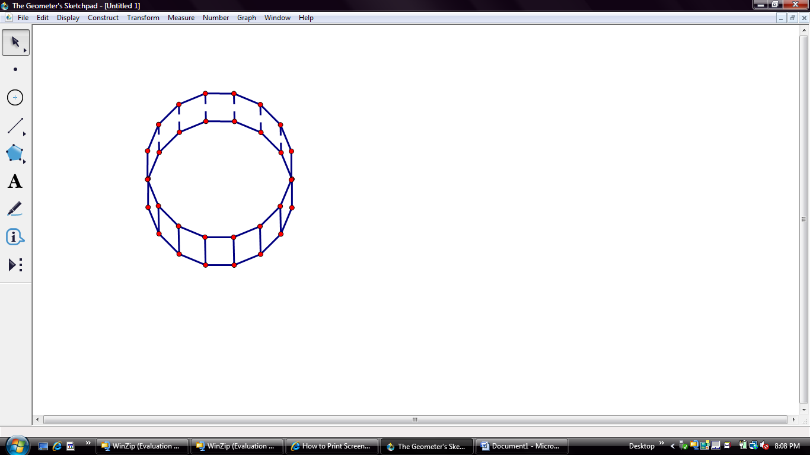

Figure 8. Aquarium

The aquarium, shown in Figure 8, is built into the floor so the millionaire has the feel that she is walking on water.

To find the volume of water in the aquarium, (Shown in Figure 8), I took the area of polygon 4 and multiply it by the height of the footing. The area of polygon 4 is 257.79 ft² x the height of the footing which is 3.5ft. The volume of the aquarium is 902.27ft³. I then took the volume of the aquarium and multiplied that by the water that is going to be in there. The aquarium is going to be 75% full, so I took the volume of the aquarium which is 902.27ft³ and multiplied it by .75. The volume of the water in the aquarium is approximately **676.70ft³.**

To find the cost of the concrete I took the volume of concrete and divided that by the cubic yard and multiplied it by the price of concrete. Since there is 27 cubic feet in a yard I divided the volume by 27. So then the equation would look like $\frac{701.76 ft³}{27 ft}$ x $115.00. The cost of concrete will approximately be **$2,988.99.**

To find the cost for Plexiglas, I took the area of polygon 4 and divided that by the Plexiglas size. Since each sheet is 48 in. by 96 in. I converted that into feet by dividing each number by 12. So, 48 in. would turn into 4 ft. and 96 in. would turn into 8 ft. Then I multiplied those numbers together to receive the total area of Plexiglas. So the sheet area would be 32 ft². Then I took the area of polygon 4 and divide that by the sheet area. So, after plugging in all numbers the new equation would be $\frac{257.79 ft²}{32 ft²}$. That would equal approximately 8.06 sheets needed. The company cannot bring .06 of a sheet, so I rounded up to the nearest whole number. So I will need 9 sheets. Then I took the number of sheets needed and multiplied that by the installation price. Next the equation would be 9 x $1,100. The total cost of Plexiglas would be approximately **$9,900.00.**

***Part 4.***



4.38 ft

8.75 ft

Figure 9. Base of the Tower

In Figure 9, the base of the tower is made from polygon 2.

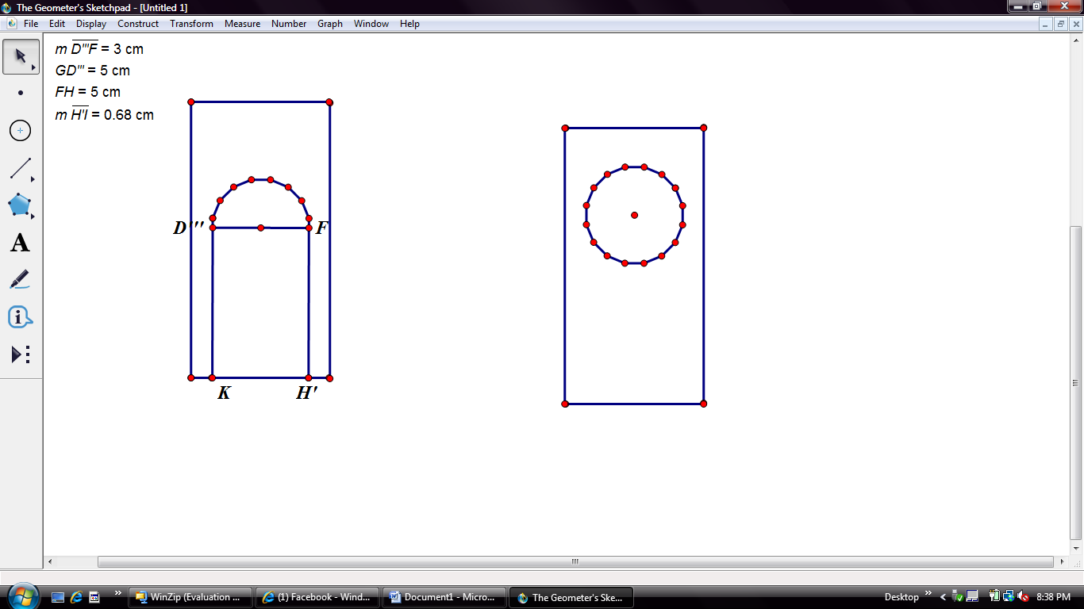

Figure 10. Door and Window

The door is 5 ft tall and 3 ft wide. The window arch on top the door is half my polygon shape. The window on the wall is my full polygon shape.

One face of the outer wall has a base of 4.38 ft. and a height of 8.75 ft. (Refer to Figure 9) The reason behind this is the base has the same length as one side from polygon 2. Also, the height of the prism is twice the size of the base. To find the lateral surface area, I would first find the area of the door and the two windows. (Both shown above in Figure 10) To find the area of the door, I would first find the rectangular region. The dimensions given were a 3 ft. by 5 ft. area. So I multiplied them together and get 15ft² as the surface area of the rectangular region of the door. To find the half of my polygon that is the arch of the door, I used tangent. The angle would still stay the same, because angles do not change in size transformation. I already know the height, because it would be half of 3 which is 1.5. So first I took tan (11.25) = $\frac{opposite}{adjacent}$. The adjacent side is the height, which is 1.5. Then the equation would look like tan (11.25) = $\frac{opposite}{1.5}$. I then multiplied each side by 1.5 to get the opposite alone on the right side of the equal sign. The next equation I came up with was tan (11.25) x 1.5 = opposite. I worked out that problem and got .30. I multiplied that by 2 since the triangle was cut in half. For the one side length I got .60ft. I found the area of that triangle doing ½ base x height. Since the base was .60 ft I multiplied that by the height of 1.5 and then split that answer in half. The area of one triangle was .45ft². I then multiplied that answer by 8, because that is half of my polygon that will be added on the door. For the arch window I got 3.58ft² as the surface area. I then added that to 15 and the total surface area of the door would be 18.58 ft². To find the area of the window I did the same thing for finding the arch window, but instead of multiply the area of the triangle by 8 I multiplied it by 16 since this shape is my total polygon. For the area of one window I got 7.16 ft². Next in finding the lateral surface area I set up my equation like this: lsa= 16(bh) – area of whole door- 2(area of windows). I then plugged in my numbers to make my equation then look like this: lsa= 16(4.38 x 8.75) – 18.58 – 2(7.16). I then simplified my equation down to: 16(38.3) – 18.58 – 14.32. I then distributed the 16 to the 38.3 and receive 612.80. I then subtracted the 18.58 from the 612.80. I then came up with 594.22- 14.32. The lateral surface area of the outer prism is approximately **579.90ft².**

***Part 5.***



3.98 ft.

8.75 ft.

8.75 ft.

Figure 11. Face and Inner Prism

Figure 11 shows one lateral face of the inner prism which is polygon 3.

To find the volume of the inner base prism, (Refer to Figure 11) I took the area of polygon 3 and multiplied it by the height of the wall. I used polygon 3, because the inner wall is at its edges. The height of the wall was found when you multiplied the length of one side of polygon 2 by 2. One side of polygon 2 was 4.38 and when doubled equals 8.75. After I plugged in the numbers, my equation then looked like 318.26ft² x 8.75 ft. The volume of the inner base prism is approximately **2,784.77ft³.**

***Part 6.***



Figure 12. Pyramid

Figure 12 shows the outer pyramid with the height as the dashed line and the slant height as the solid thick line.

To find the height of the pyramid, it is given information that it is 3 times the base side in polygon 2. (Figure 12) Since one side in polygon 2 is 4.38 ft., I multiplied that by 3. The height of the pyramid is approximately **13.13 ft.** Next, when I found the angle between the prism face and prism base. I used $\tan^{-1}{\frac{opposite}{adjacent}}$ = angle measure. The length from the side to the center is 11, because it is the height of the triangle in polygon 3, which is the adjacent side while the height of the outer pyramid is the opposite side. The equation is then $\tan^{-1}{\frac{13.13}{11}}$. The angle measure is approximately **50.04°.** To find the slant height I then used cos(50.04) = $\frac{11}{hypotenuse}$. I divided each side by 11 to get the hypotenuse by itself. I came up with 11/cos(50.04)= hypotenuse. The slant height is approximately **17.13 ft.**

***Part 7.***

Angle B



4.38 ft

17.13ft

Angle A

Figure 13. Lateral Face of the Pyramid

To find the angle measures on the lateral face of the outer pyramid, (Broken down and shown above in Figure 13.) I first cut the triangle in half. I then came up with a triangle with a height of 17.13 ft, which is the slant height. Since the base is one side length of polygon 2, I cut it in half to get the new base of 2.19. I then used inverse tangent to find the angles. I first found the angle at the bottom (angle A). I used $\tan^{-1}{\frac{opposite}{adjacent}}$ = A. I plugged in my numbers to get $\tan^{-1}{\frac{17.13}{2.19}}$ = A. Angle A is approximately **82.78°.** Next I also used inverse tangent to find angle B. The equation was $\tan^{-1}{\frac{opposite}{adjacent}}$ = B. I plugged in my numbers to get $\tan^{-1}{\frac{2.19}{17.13}}$ = B. I then got 7.22, but then the triangle was cut in half so to get the correct angle you would multiply that by 2. Angle B is approximately **14.44°**. Then Angle C would also be **82.78°** if you did the math again on the other side.

To find the lateral surface area of one face, I used the formula of ½ base x height. Since the base is the length of one side of polygon 2, the base would equal 4.38 ft. The height would be the slant height which is 17.13 ft. I then plugged those numbers into my equation to get ½ (4.38 x 17.13). I came up with ½ (78.95). The lateral surface area of one face would be approximately **34.38 ft².**

To find the total lateral surface area of the outer pyramid I took the lateral surface area of one face, previously shown above how to get, and multiplied that by 16 to get the lateral surface area. So I took 16 x 34.38 ft². The lateral surface area of the outer pyramid is approximately **599.61 ft².**

***Part 8.***



Figure 14. Pyramid

Figure 14 is the same image shown above in Figure 12. This pyramid is the inner pyramid instead.

The height of the inner pyramid is 3 times the height length of polygon 3’s base. (Refer back to Figure 14) Since the base length is 3.98 ft, I multiplied that by 3. My height of the inner pyramid is approximately **11.93 ft.**

To find the volume of the inner pyramid I used the formula of 1/3 area of base x height. The area of the base would be the area of polygon 3. The equation would now look like 1/3 (318.26 x 11.93). I then came up with 1/3 (3798.35). The volume of the inner pyramid is approximately **1,266.12 ft³.**

***Part 9.***



Figure 15. My Tower

Figure 15 shows my tower put together with base and pyramid.

To find the lateral surface area of my whole tower would be adding the lateral surface area of the base and the lateral surface area of the pyramid together. The lateral surface of the base is 579.90ft². The lateral surface area of the pyramid is 599.61 ft². Then I added them together. The lateral surface of my whole tower is approximately **1,179.51 ft².**

To find the total volume of my tower I added the volume of the base and the volume of the pyramid together. The volume of the base was 2,784.77ft³. The volume of the pyramid was 1,266.12 ft³. Then I added those volumes together. The volume of my whole tower is approximately **4,050.89ft³.**

As a student, I, of course, had some difficulty with this project. I mean, who wouldn’t? There were many frustrations in building. Although some minor errors could be fixed they were major setbacks. Over the course of the year and before I started the school year I heard many former students talk about how treacherous the tower project was. In my opinion, it wasn’t that bad. I actually enjoyed it. I loved spending time with my dad building it and the paper was a lot easier than I thought. All in all, it was a great project and I really enjoyed it. It was a struggle, but who doesn’t love a little bit of a challenge?

My Tower in Progress!

Day 1.

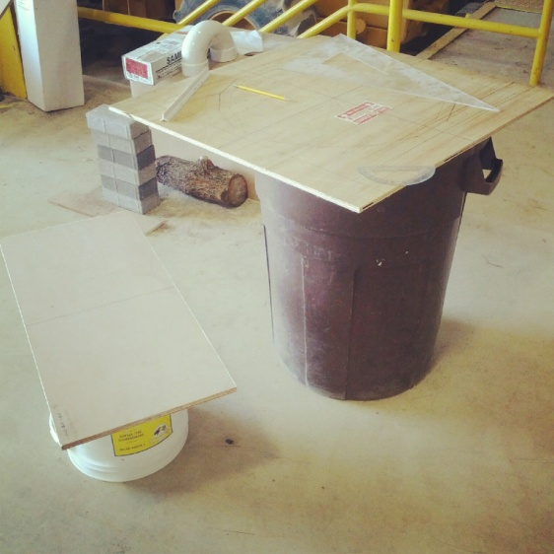

Day 3. Forming

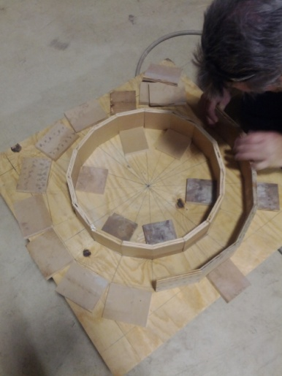 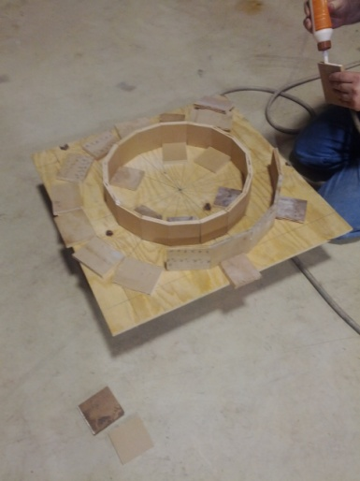

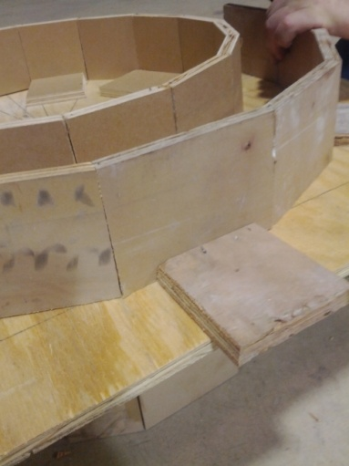 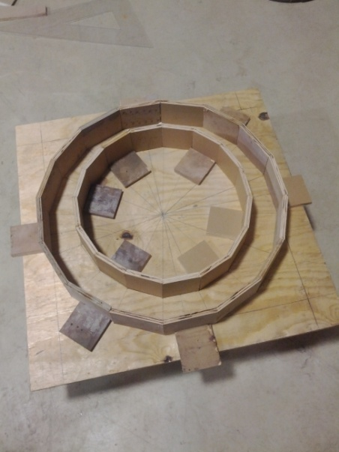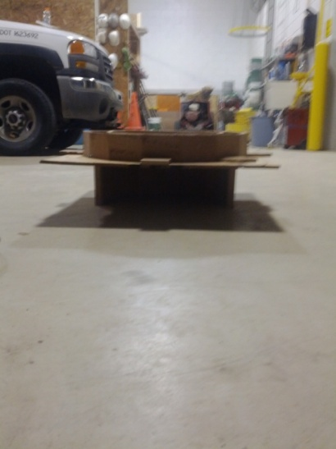

Pouring! ☺

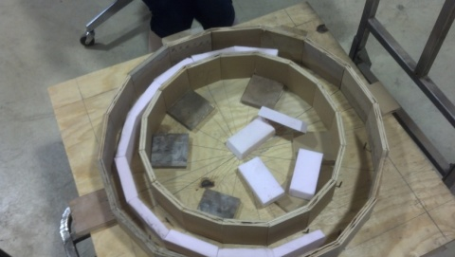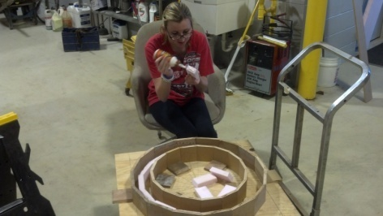

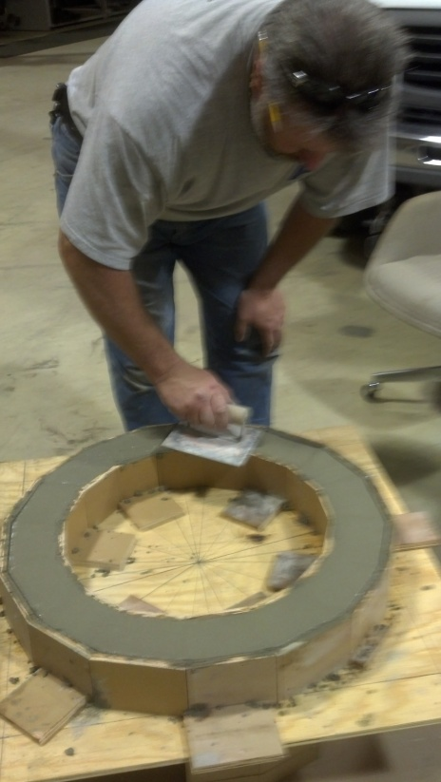 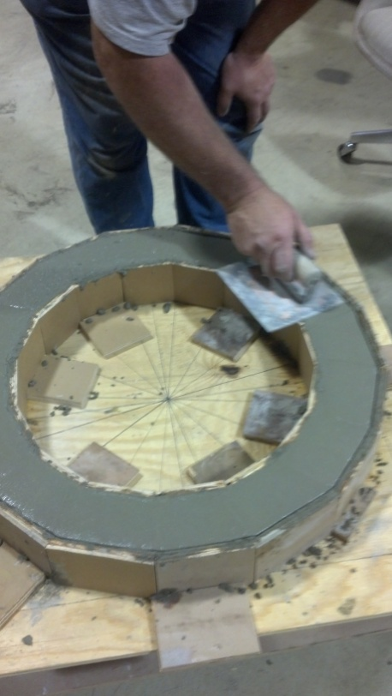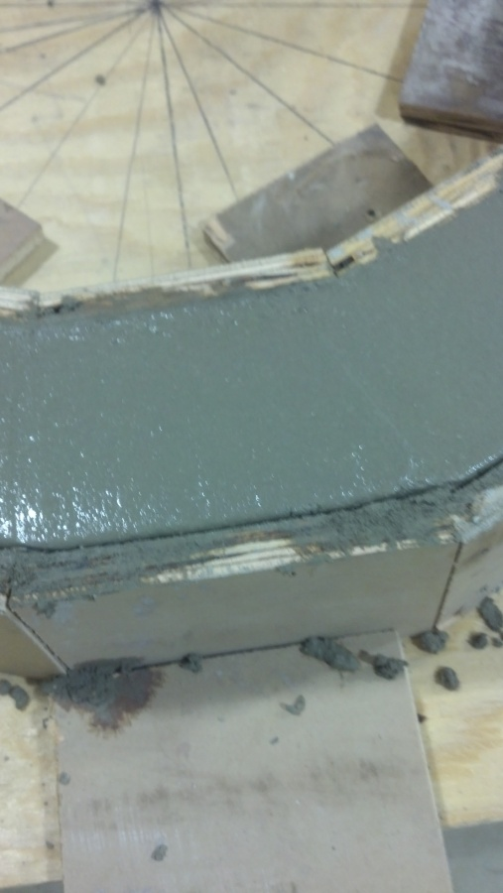 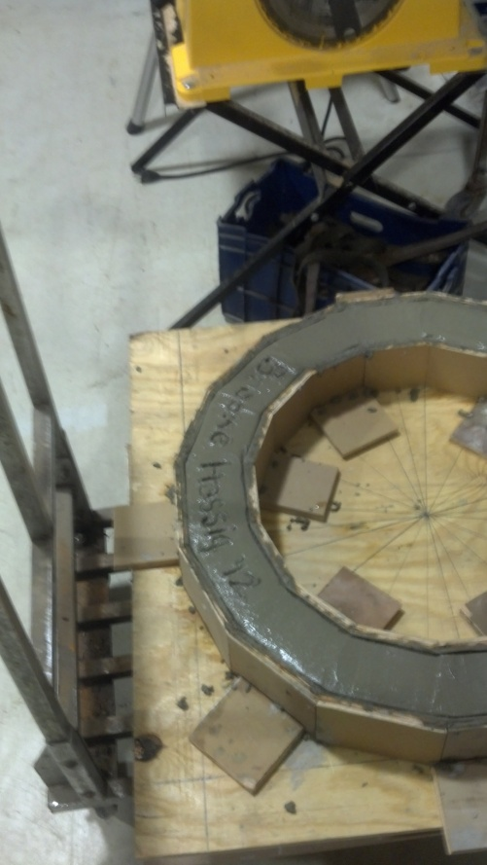

Day 4.

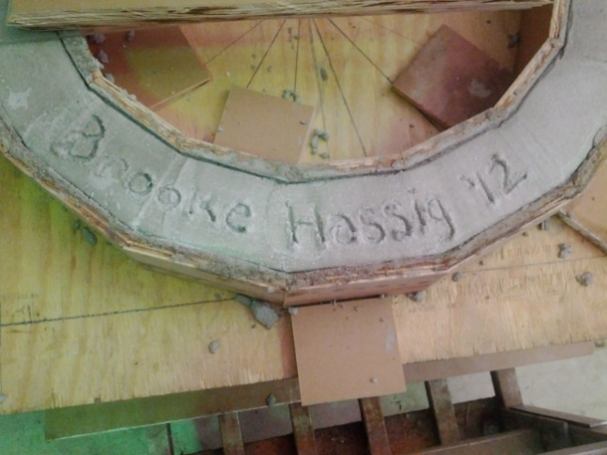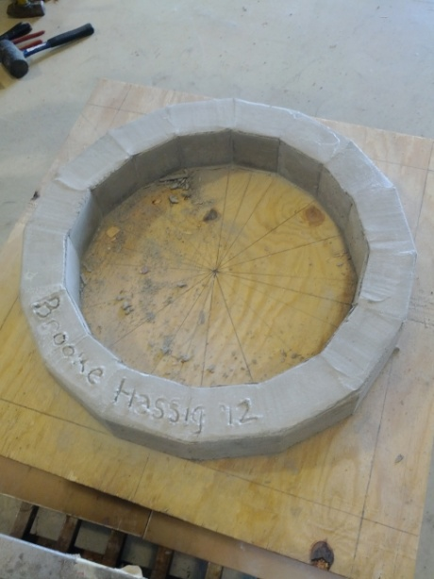

Day 5. Hand Cutting All Roof Pieces

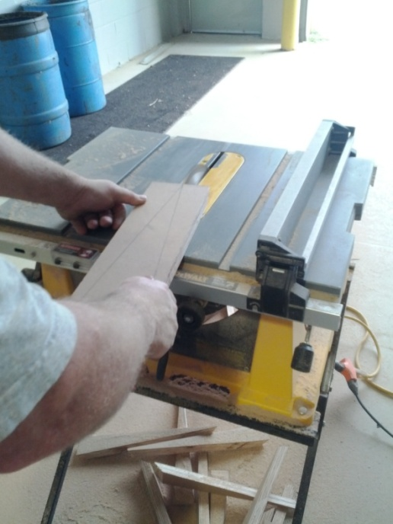

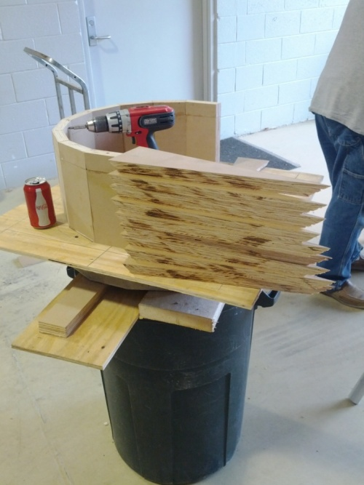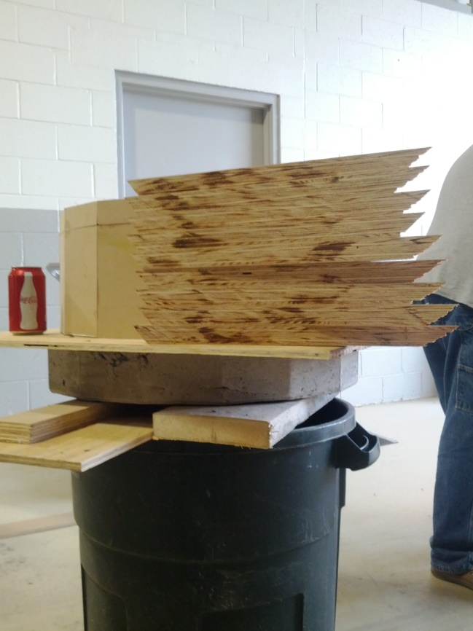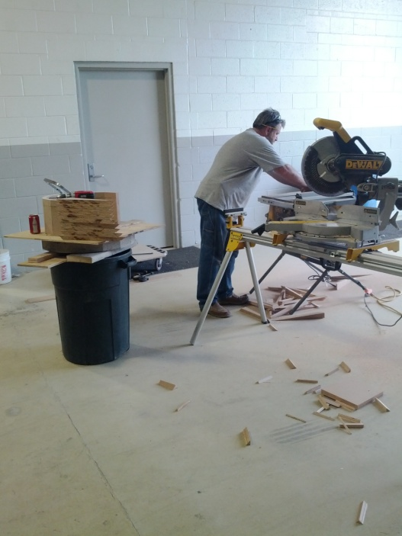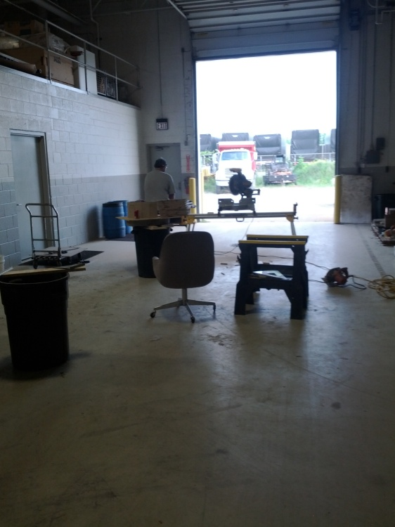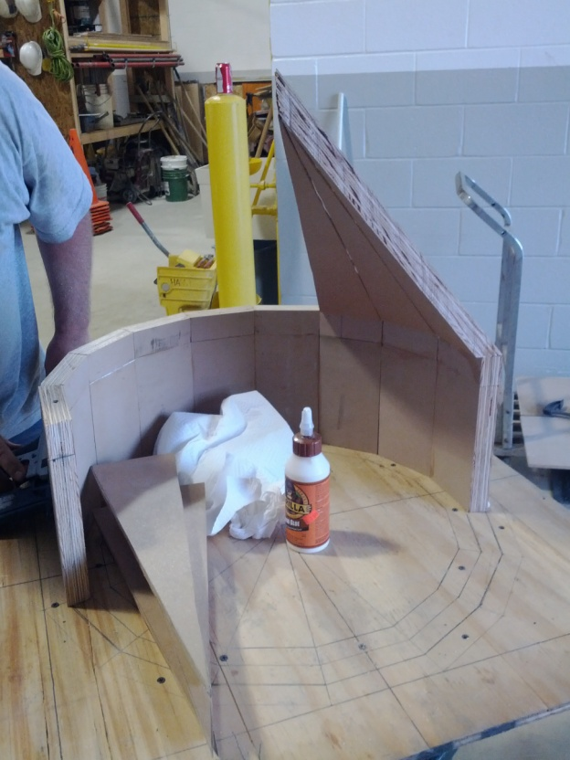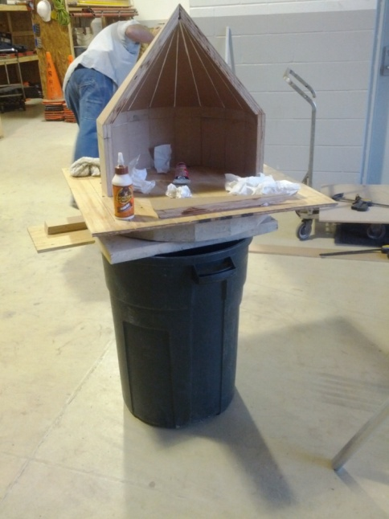

FINALLY DONE WITH BUILDING!

