Identification of an Unknown Metal

Brooke Hassig and Olivia Smith

Macomb Mathematics Science and Technology Center

Chemistry / IDS 10 / FST

10C

Mrs. Hilliard/ Mr.Supal/ Mrs. Dewey

May 20th, 2013

Table of Contents:

Introduction………………………………………………………………………………1

Background and Review of Literature………………………………………………...3

Problem Statement……………………………………………………………………...9

Experimental Design of Specific Heat……………………………………………….10

Experimental Design on Linear Thermal Expansion……………………………….13

Data and Observations………………………………………………………………..16

Data Analysis and Interpretation……………………………………………………..25

Conclusion……………………………………………………………………………...38

Acknowledgements……………………………………………………………………42

Appendix A……………………………………………………………………………..43

Appendix B……………………………………………………………………………..44

Appendix C……………………………………………………………………………..45

Appendix D……………………………………………………………………………..46

Appendix E……………………………………………………………………………..47

Appendix F……………………………………………………………………………..48

Appendix G……………………………………………………………………………..49

Appendix H……………………………………………………………………………..50

Works Cited…………………………………………………………………………….51

Introduction:

According to Alan W. Cramb, a professor in the Department of Materials Science and Engineering at Carnegie Mellon University, there are 86 known metals in the world. Niobium is among these 86 metals being found in the 19th century and the 13th metal to be identified out of all 86. (Cramb) Niobium is used in jewelry and in wires because this metal is super conductive. With an alloy of Niobium and Titanium can make super conductive metals. Niobium’s most important use is in surgical implants, because this metal does not react with human tissue. (Niobium)

The researchers’ objective in this experiment was to identify the unknown metal as the same as the known metal. They planned on identifying the metal using the specific heat and linear thermal expansion experiments. These experiments can be used in the world today when miners are extracting metals from the Earth that have yet to be identified. The purpose of this experiment was to correctly identify whether or not the unknown metal was the same as the researchers’ known metal of Niobium. The researchers’ accomplished their objective of correctly identifying the metal as either the same metal or a different metal by conducting specific heat and linear thermal expansion experiments.

The specific heat of a metal is the amount of heat used to raise the temperature per unit by one degree Celsius. The specific heat experiment was conducted using a calorimeter. The metal was taken out of the boiling water and placed directly into the calorimeter to measure the change in temperature. Most metals have different specific heats, although a few have similar. Niobium’s specific heat is 0.265 J/ºC. Linear thermal expansion is the change in length of metal when the metal is heated and then cooled back down to the temperature of the room. The linear thermal expansion experiment was conducted using a linear thermal expansion jig. The metal was placed in hot water, then directly into the jig to find the change in length. Most of these metals again have different linear thermal expansion alpha coefficients. Niobium’s linear thermal expansion alpha coefficient is 7.1 x 10-6 1/ºC. These intensive properties helped the researchers’ to identify the unknown metal.

The researchers’ reached the results of their objective by conducting a two sample t-test. This test would result in a t-value which was converted to a p-value to find whether or not the metals were the same or different. This test statistic concluded if the known metal of Niobium and unknown metal were the same or different.

Background and Review of Literature:

Niobium’s history of discover is very perplexed. John Winthrop discovered a mineral columbite around 1734. He then sent the mineral to England where Hatchett determined there was an unknown element in columbite. He named this unknown element columbium. William Wollaston compared columbite to tantalite. The confusing part of this tantalite and Niobium are very similar metals. Niobium was then rediscovered and renamed by Heinrich Rose when he made two new acids (The Element Niobium).

Niobium, Nb, is collected in two separate ways. In the first way, companies who collect pyrochlore convert the niobium oxide units to HSLA ferro-Niobium by reduction in an electric furnace. Niobium powders can be produced by the reduction of potassium niobium heptaflouride using sodium or reduction of Niobium oxide with magnesium. Niobium is extracted first by forming the oxide (Nb2O5). This oxide is then reduced by either carbon or hydrogen (Niobium).

Niobium is used in many things. It is used in jewelry and as an alloying agent. Niobium is superconductive; in response superconductive wire can be made from an alloy of Niobium and titanium (The Element Niobium). The alloy of Niobium and Titanium can also make superconductive magnets which are used as key locations on an electrical grid during power outages (Superconducting Magnet System Applications).

Niobium has a melting point of 2410°C. It has a boiling point of 5100°C. The melting and boiling point are so high, because Niobium has a strong metallic bond which requires intense heat to break these bonds (The Element Niobium). Niobium has high boiling and melting points like other metals. Niobium is very similar to Tantalum. Tantalum has a melting point of 2850°C and a boiling point of 6000°C (Niobium). Niobium and Tantalum have both very similar melting and boiling points. Niobium’s energy of first ionization is 652 kJ/mol, while Tantalums energy of first ionization is 674 kJ/mol (Tantalum). Again, these are both similar.

Niobium’s atomic mass is 92.91 g/mol. Niobium has an atomic radius of 2.08 Å. Niobium’s atomic volume is 10.87 cm3/mol. Each atom has a different atomic radius and atomic volume, which can distinguish Niobium from different metals. Niobium has 41 protons and 52 stable neutrons. Niobium’s electrons are arranged by 2 in the first level, 8 in the second, 18 in the third, 12 in the fourth, and 1 in the fifth level of the electron cloud (Niobium).

[Kr] 4d4 5s1

Figure 1. Niobium’s Electron Configuration

In Figure 1, Niobium’s condensed electron configuration is shown. The placements of Niobium’s electrons are described in the above paragraph.

Niobium is a very unique metal. Niobium has greater strength compared to other metals which is why they are used a key locations on the electrical grid during power outages (Superconducting Magnet System Applications). This includes the ones that are being exposed to low temperatures. Niobium is also superconductive, which means that it is a good use of metal in wires. Niobium is also used as a protective passive layer in surgical implants, because this metal does not react with human tissue (Biomedizinische).

A way to identify the unknown metal would be specific heat. Specific heat is the amount of heat required to increase the temperature of the substance by one degree Celsius. The Kinetic Molecular Theory states that atoms moving at high speeds and bouncing off each other creating greater heat, thus part of the definition of specific heat. The atoms with more motion have a higher temperature (Timm).

Most specific heat experiments that were found used a calorimeter. A calorimeter is used to calculate the heat that was released during a chemical reaction. Calorimeters can be made from all different things. The most basic are made from two Styrofoam cups (ChemLab).

One experiment used to measure specific heat is a calorimeter (Blauch). In most laboratories, calorimeters are used to measure temperature changes that occur. (Barlag) Using a calorimeter you will use a formula to find the specific heat shown below:

$$q=sm∆T$$

In the equation above, q is the quantity of the substance. Specific heat is represented by the variable S, M is the mass and delta T is the change in temperature. In order to find the temperature change the temperature will be measure before and then after. All the known variables are on one side so specific heat can be found:

$$s=\frac{q}{m∆T}$$

In the formula above the specific heat will be calculated easier due to the fact that the equation has been simplified. The specific heat will differentiate Niobium from other metals and help the researchers to identify the unknown metal(De Leon).

Each of the given experiments can be conducted in a classroom environment. The energy used to supply this energy to move the atoms is typically heat. The specific heat is measured in J/g°C (De Leon).Specific heat is an intensive property. The specific heat of elements varies from each one.

Specific is used in the food industry as installation. They used specific heat to keep things warm. Although using specific heat has disadvantages such as special thermal registers with cores and filler thermo/rigid materials (Carmen).

Another way to identify the metal would be linear thermal expansion. Thermal Expansion is the expansion of solids after they have been heated. The reasoning behind thermal expansion is the molecules are now moving more vigorously throughout the solid causing it to need more room. The molecules vibrate more furiously due to heat and thus causing the solid to expand in all directions (Gibbs).

The first experiment to find thermal expansion would be measuring the change in temperature and change in length to find the thermal expansion coefficient. To find the change in temperature, the temperature was measured before and after the solid was heated. The initial temperature was then subtracted from the final temperature. In order to find the length difference, the length of the metal was measured before and after. The initial length was then subtracted from the final length. Materials needed for this experiment are a steam generator, thermometer, battery, voltmeter and a heat tube with micrometer. The formula for this experiment is given below (Stony Brook NN Group).



The equation above shows the thermal expansion formula. The change in length was divided by the original length of the element. Then after all that is figured out, the answer was divided by the change in temperature to find the thermal expansion coefficient. Length is measured in meters and temperature is Celsius.

Another experiment to determine the thermal expansion would include finding the change in volume and the change in temperature to find thermal expansion coefficient. To find the change in length, the initial length of the element was subtracted from the final length of the element after it has been heated. The change in temperature was found by the initial temperature being subtracted from the final temperature of the element. The formula for experiment is given below (ASM International).

$$\frac{∆l}{l_{o}}=α×∆T$$

The thermal expansion formula is shown above. Length was measured in mm. The temperature was measured in Celsius.

Each element has a different thermal expansion property, which is intensive. Linear thermal expansion is used in welding. It is used because there are large differences in values and it has tensile stress in one metal and compressive stress in the other. The metal with tensile stress may crack during the welding process (ASM International). This can determine the unknown element from the known element of Niobium. Thermal expansion will help the researchers identify the unknown element.

Problem Statement:

Problem: The researchers’ problem was to determine whether or not the unknown metal is Niobium by finding the linear thermal expansion alpha coefficient and specific heat.

Hypothesis: The researchers’ developed the hypothesis that if the specific heat and thermal expansion of the unknown metal are found and identified outside a 20% error, then the metal will not be Niobium.

Data: The researchers in the specific heat experiment will determine: the change in temperature of the metal and water which will be measured in °C, the mass of the metal and water will be measured in grams (g). After this data is inserted into the equation, smΔT of the water equals the smΔT of the metal; the specific heat will be found when the smΔT of the water is divided by the mΔT of the metal.

The researchers in the linear thermal expansion experiment will determine the change in temperature of the metal rod measured in °C, the change in length of the metal and the original length of the metal will be measured in millimeters. To find the linear thermal expansion alpha coefficient, the change in length will be divided by the original length which is then all divided by the change in temperature.

Experimental Design:

**Specific Heat:**

Materials:

(2) Unknown Metal Rods

(2) Niobium Rod, Nb

Graduated Cylinder of Water, H2O (100 mL)

Scale (0.01 g)

Thermometer (0.1 °C)

(3) Calorimeter

Hot Plate

Tongs

Metal Loaf Pan

Logger Pro

Temperature Probe (0.1 °C)

Ti-Nspire CX Calculator

Procedure:

1. Randomize the 15 trials with your Ti-Nspire calculator (See Appendix A)

2. Randomize the rod A and B on your calculator. (0 will stand for rod A and 1 will stand for rod B) (See Appendix B)

3. Place 50 mL of water into a loaf pan.

4. Place the loaf pan of water onto the hot plate at a setting of 3 or 4 and heat for 3 minutes.

5. While the water is boiling, mass the unknown metal rod on the scale. Before placing the rod onto the scale, tare the scale first.

6. Using tongs, place the metal rod into the loaf pan for 3 minutes.

7. While waiting the 3 minutes for the rod to heat up, measure out 50 mL of regular water into a graduated cylinder. In the data record the volume of water as the mass of water in grams.

8. Then, using the thermometer, take and record the temperature of the hot water and the tap water

9. Pour the tap water into the calorimeter (For construction of Calorimeter see Appendix C).

10. Carefully use the tongs to remove the metal rod from loaf pan and place it into the calorimeter, then proceed to place in the temperature probe.

11. Place temperature probe attached to the logger pro in immediately after the metal has been placed in. Record the results when the logger pro line has reached the highest temperature (See Appendix D for Logger Pro SetUp).

12. Empty the contents of the experiment. Repeat steps 1 through 12 until all 15 trials are completed.

13. After all trials are done with the unknown metal rod, repeat steps 1 through 12 with the Niobium rod.

14. When all 30 trials are completed, empty your contents into the sink and clean up lab station.

Diagram:

6

5

4

3

2

1

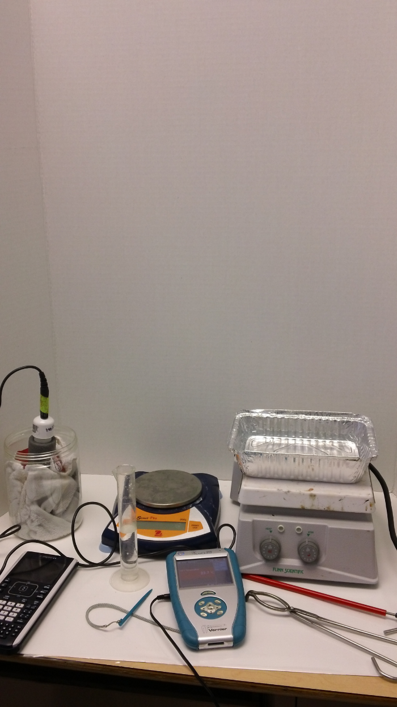Figure 2. Materials for Specific Heat

8

7

In Figure 2 above, a diagram of the materials used for the specific heat trials is shown. Arrow 1 shows the metal placed inside of the calorimeter. Arrow 2 is pointing to the TI-Nspire calculator. Arrow 3 is labeling the scale. Arrow 4 is presenting the graduated cylinder filled with water. Arrow 5 shows the metal loaf pan on top of the hot plate. Arrow 6 is pointing out the logger pro. Arrow 7 shows the thermometer. Finally Arrow 8 shows the tongs the researchers used to place the metal into the calorimeter.

**Linear Thermal Expansion:**

Materials:

(2) Unknown Metal Rods

(2) Niobium Metal Rods

Metal Loaf Pan

Hot Plate

Tongs

Stop Watch

Linear Expansion Jig (0.001 mm)

Thermometer (0.1ºC)

TI-nspire Calculator

TESR Caliper 00530085 (0.01 mm)

Spray Bottle

Graduated Cylinder

(50mL) Water

Procedure:

1. Randomize the trials. (See Appendix A)

2. Measure out 50mL of water into the graduated cylinder.

3. Pour the beaker of water into the loaf pan.

4. Turn the hot plate on a setting of 3-4. Start to boil the water.

5. Measure the initial length of the metal rod with the caliper.

6. When the water reaches the temperature of 100ºC submerge the metal into the boiling water.

7. Leave the metal in the water for 3 minutes.

8. After the 3 minutes quickly take the metal rod out of the water and place the rod into the linear thermal expansion jig. ** BE EXTREMELY CAREFUL. MAKE SURE YOU DO NOT HIT THE JIG**

9. Record the dial indicator position on the jig.

10. While the metal is cooling use the spray bottle filled with cold water to help cool down the metal faster.

11. When the hand stops moving record the final dial indicator position. Also record the change in temperature.

12. Record the temperature of the room with the thermometer.

13. Repeat steps 2-11 for each of the trials.

14. Clean up lab station after all trials are done.

Diagram:

1

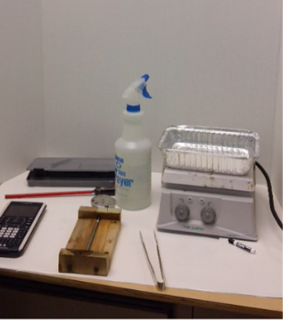

8

7

6

5

3

4

2

Figure 3. Materials from Linear Thermal Expansion Experiment

In Figure 3 above, a diagram of the materials used for the linear thermal trials is presented. Arrow 1 shows the thermometer. Arrow 2 is pointing to the TESR Caliper 00530085. Arrow 3 is labeling the squirt bottle. Arrow 4 is presenting the loaf pan filled with water on the hot plate. Arrow 5 shows the TI-Nspire calculator. Arrow 6 is pointing out the Expo marker. Arrow 7 shows the tongs. Finally Arrow 8 shows the linear thermal expansion jig with the metal inside of it.

Data and Observations:

Data:

Table 1

|  |  |  |  |  |  |  |  |  |  |
| --- | --- | --- | --- | --- | --- | --- | --- | --- | --- |
| **Trials** | **Rod** | **Initial Temp (°C)** | | **Equilibrium Temp. (°C)** | **Change in Temp (°C)** | | **Mass**  **(g)** | | **Specific Heat (J/g °C)** |
| **Water** | **Metal** | **Water** | **Metal** | **Water** | **Metal** |
| 4 | A | 23.4 | 98.5 | 30.1 | 6.7 | -68.4 | 31 | 35.18 | 0.361 |
| 11 | A | 24.4 | 97.5 | 31.5 | 7.1 | -66.0 | 30 | 35.18 | 0.384 |
| 3 | B | 25.1 | 98.5 | 32.2 | 7.1 | -66.3 | 30 | 35.19 | 0.382 |
| 7 | A | 23.1 | 98.5 | 30.2 | 7.1 | -68.3 | 29 | 35.25 | 0.358 |
| 15 | A | 22.1 | 97.2 | 29.1 | 7.0 | -68.1 | 31 | 35.28 | 0.378 |
| 1 | B | 20.5 | 99.3 | 27.1 | 6.6 | -72.2 | 31 | 35.18 | 0.337 |
| 6 | A | 23.4 | 97.2 | 29.1 | 5.7 | -68.1 | 32 | 35.27 | 0.318 |
| 2 | B | 24.5 | 97.5 | 31.2 | 6.7 | -66.3 | 29 | 35.19 | 0.348 |
| 13 | B | 22.2 | 99.2 | 28.9 | 6.7 | -70.3 | 30 | 35.23 | 0.340 |
| 5 | A | 22.5 | 97.6 | 28.5 | 6.0 | -69.1 | 30 | 35.22 | 0.309 |
| 12 | B | 20.2 | 98.4 | 26.7 | 6.5 | -71.7 | 32 | 35.21 | 0.345 |
| 9 | A | 23.6 | 97.6 | 30.4 | 6.8 | -67.2 | 29 | 35.23 | 0.349 |
| 10 | B | 22.5 | 99.0 | 28.8 | 6.3 | -70.2 | 32 | 35.17 | 0.342 |
| 14 | B | 21.3 | 98.1 | 28.4 | 7.1 | -69.7 | 31 | 35.25 | 0.375 |
| 8 | A | 24.3 | 97.2 | 28.7 | 4.4 | -68.5 | 28 | 35.18 | 0.214 |
| Average |  | 22.9 | 98.1 | 29.4 | 6.5 | -68.7 | 30 | 35.21 | 0.343 |

Specific Hear of the Known Metal

Table 1 above shows the results of the 15 trials for specific heat of the known metal Niobium. The specific heat of Niobium is 0.265 J/gºC. The results shown are not exactly the same as Niobium, but are fairly similar. The equation in Figure 4 shows a sample calculation for the first trial conducted in specific heat.

$$s=\frac{sm∆T}{m∆T}$$

$$s=|\frac{4.184\frac{J}{gºC}×31g ×6.7ºC }{35.18 × -68.4}|$$

$s= 0.361$ J/gºC

Figure 4. Sample Calculation of Specific Heat of Niobium

The sample calculation in Figure 4 starts with the specific heat of Niobium equals the specific heat of water multiplied by the mass multiplied by the change in temperature of the water all over the mass of Niobium multiplied by the change in temperature of the metal. The absolute value is taken for the entire equation. The answer for specific heat is in J/gºC.

Table 2

Specific Heat of Unknown Metal

Table 2 presents the data for the 15 specific heat trials of the unknown metal. The average specific heat of the metal was 0.416 J/gºC. From looking at these trials, the unknown metal does not appear to be Niobium.

Temperature was measured to a 0.1ºC precision for both the metal and the water. Mass for water was measured to a 0.01 g precision. The mass of the metal was measured to a .01g precision. Finally, the specific heat was calculated to a 0.001J/gºC precision.

Table 3

Linear Thermal Expansion of Known Metal

|  |  |  |  |  |  |  |  |
| --- | --- | --- | --- | --- | --- | --- | --- |
| **Trial** | **Rod** | **Initial Length (mm)** | **Change in Length (mm)** | **Initial Temp. (°C)** | **Final Temp. (°C)** | **Change in Temp (°C)** | **Alpha Coefficient (1/ºC)** |
| 10 | B | 127.13 | 0.076 | 100.0 | 25.6 | -74.4 | 8.056E-06 |
| 3 | A | 127.10 | 0.080 | 100.2 | 25.7 | -74.5 | 8.449E-06 |
| 15 | A | 127.15 | 0.070 | 100.0 | 25.6 | -74.4 | 7.400E-06 |
| 9 | B | 127.13 | 0.051 | 101.1 | 25.9 | -75.2 | 5.314E-06 |
| 12 | A | 127.12 | 0.080 | 101.1 | 25.9 | -75.2 | 8.369E-06 |
| 13 | A | 127.12 | 0.070 | 101.6 | 26.4 | -75.2 | 7.323E-06 |
| 2 | B | 127.12 | 0.076 | 100.2 | 25.7 | -74.5 | 8.046E-06 |
| 7 | A | 127.00 | 0.070 | 101.3 | 26.2 | -75.1 | 7.339E-06 |
| 14 | A | 127.16 | 0.070 | 100.8 | 26.5 | -74.3 | 7.409E-06 |
| 8 | B | 127.13 | 0.076 | 101.6 | 26.4 | -75.2 | 7.971E-06 |
| 6 | A | 127.13 | 0.070 | 101.1 | 26.6 | -74.5 | 7.391E-06 |
| 5 | B | 126.91 | 0.076 | 101.3 | 26.2 | -75.1 | 7.995E-06 |
| 1 | B | 127.12 | 0.051 | 97.5 | 25.7 | -71.8 | 5.566E-06 |
| 4 | B | 127.12 | 0.076 | 100.8 | 26.5 | -74.3 | 8.068E-06 |
| 11 | B | 127.12 | 0.076 | 101.1 | 26.6 | -74.5 | 8.046E-06 |
| Avg |  | 127.10 | 0.071 | 100.6 | 26.1 | -74.5 | 7.520E-06 |

Table 3 shows the data of the linear thermal expansion alpha coefficient of the known metal Niobium. Niobium’s alpha coefficient is 7.1 x 10-6 1/°C. The average alpha coefficient is not exactly the same, but fairly similar. The equation in Figure 5 shows the sample calculation of the first trial done for the linear thermal expansion alpha coefficient of Niobium.

$$\frac{∆l}{l_{o}∆T}= α$$

$α=\frac{0.076mm}{127.13mm×-74.4°C}$

$$α=8.056 × {10}^{-6} 1/ºC$$

Figure 5. Sample Calculation of Linear Thermal Expansion of Niobium

The sample calculation starts with the change in length of Niobium divided by the original length of the metal multiplied by one over the change in temperature of the metal which equals the alpha coefficient. The answer to the equation is put into scientific notation. The answer for specific heat is in 1/ºC.

Table 4

Linear Thermal Expansion of Unknown Metal

|  |  |  |  |  |  |  |  |
| --- | --- | --- | --- | --- | --- | --- | --- |
| **Trial** | **Rod** | **Initial Length (mm)** | **Change in Length (mm)** | **Initial Temp. (°C)** | **Final Temp. (°C)** | **Change in Temp (°C)** | **Alpha Coefficient (1/°C)** |
| 10 | B | 119.99 | 0.060 | 99.0 | 23.4 | -75.6 | 6.614E-06 |
| 3 | A | 122.85 | 0.060 | 99.0 | 23.4 | -75.6 | 6.46E-06 |
| 15 | A | 122.81 | 0.110 | 99.1 | 23.2 | -75.9 | 1.18E-05 |
| 9 | B | 120.03 | 0.090 | 99.1 | 23.2 | -75.9 | 9.879E-06 |
| 12 | A | 122.67 | 0.080 | 99.6 | 22.3 | -77.3 | 8.437E-06 |
| 13 | A | 122.86 | 0.090 | 99.4 | 21.8 | -77.6 | 9.44E-06 |
| 2 | B | 120.13 | 0.100 | 99.6 | 22.3 | -77.3 | 1.077E-05 |
| 7 | A | 122.88 | 0.100 | 99.5 | 22.7 | -76.8 | 1.06E-05 |
| 14 | A | 122.65 | 0.070 | 99.2 | 22.6 | -76.6 | 7.451E-06 |
| 8 | B | 120.01 | 0.080 | 99.4 | 21.8 | -77.6 | 8.59E-06 |
| 6 | A | 122.82 | 0.100 | 99.3 | 22.8 | -76.5 | 1.064E-05 |
| 5 | B | 120.08 | 0.090 | 99.5 | 22.7 | -76.8 | 9.759E-06 |
| 1 | B | 120.12 | 0.080 | 99.2 | 22.6 | -76.6 | 8.695E-06 |
| 4 | B | 120.10 | 0.100 | 99.3 | 22.8 | -76.5 | 1.088E-05 |
| 11 | B | 120.10 | 0.110 | 99.4 | 22.8 | -76.6 | 1.196E-05 |
| Avg |  | 121.34 | 0.088 | 99.3 | 22.7 | -76.613 | 9.466E-06 |

Table 4 shows the data of the linear thermal expansion alpha coefficient of the unknown metal. This metals average coefficient 9.4662 x 10-6 1/°C. This metals alpha coefficient is not similar to Niobium’s.

The initial length and change in length was measured in millimeters. Initial length was to a 0.01 precision and change in length was to .001 precision. The initial, final, and change in temperatures were measured to .1ºC precision.

Observations:

Table 5

Observations of Specific Heat of the Known Metal

|  |  |  |  |
| --- | --- | --- | --- |
| **Trial** | **Rod** | **Date** | **Observations** |
| 1 | B | 4/18/2013 | Rod was dropped before placement. |
| 2 | B | 4/23/2013 | Metals were not put in at the same time. |
| 3 | B | 4/23/2013 | Cap was not on tight |
| 4 | A | 4/23/2013 | Dropped rod, placed back in pan for another minute |
| 5 | A | 4/23/2013 | Bad tongs, dropped metal |
| 6 | A | 4/23/2013 | Probe was lying on metal |
| 7 | A | 4/23/2013 | Probe not in all the way |
| 8 | A | 4/18/2013 | Metals were not put in at the same times. |
| 9 | A | 4/23/2013 | Logger pro was not started before placing in the metals |
| 10 | B | 4/18/2013 | Dropped rod, placed back in pan for another minute |
| 11 | A | 4/23/2013 | Probes were not put in simultaneously |
| 12 | B | 4/18/2013 | In for over 3 minutes, calculator shut off |
| 13 | B | 4/18/2013 | Tough time getting probe in, kept hitting metal |
| 14 | B | 4/18/2013 | Water came up very high to the top |
| 15 | A | 4/23/2013 | Cap not on tight enough |

Table 5 shows the researchers observations during the 15 trials of specific heat on the known metal Niobium. The researchers did not encounter a lot of problems, but the minor ones they did were not enough to ruin their experiments.

Table 6

Observations of Specific Heat of the Unknown Metal

|  |  |  |  |
| --- | --- | --- | --- |
| 1 | B | 4/22/2013 | Dropped rod before being placed into the calorimeter. |
| 2 | A | 4/22/2013 | Caps not placed on tightly. |
| 3 | A | 4/22/2013 | Rod was in for over 3 minutes |
| 4 | A | 4/22/2013 | Bad tongs, rod dropped |
| 5 | B | 4/22/2013 | Rod dropped placed back in pan for 1 minute. |
| 6 | B | 4/22/2013 | Dropped rod before being placed into the calorimeter. |
| 7 | B | 4/22/2013 | Rod was in for over 3 minutes |
| 8 | A | 4/22/2013 | Calculator shut off, rod was in over 3 minutes |
| 9 | A | 4/22/2013 | Cap was not shut too tight |
| 10 | B | 4/22/2013 | Probe was touching the rod. |
| 11 | A | 4/22/2013 | Dropped rod before being placed into the calorimeter. |
| 12 | B | 4/22/2013 | Metal was measured after taken out of calorimeter, not before it was placed in. |
| 13 | A | 4/22/2013 | Calorimeter cap was not shut tightly |
| 14 | B | 4/22/2013 | Rod was in for over 3 minutes |
| 15 | A | 4/22/2013 | Dropped rod before being placed into the calorimeter. |

Table 6 shows the researchers observations during the 15 trials of specific heat on the unknown. The researchers did not encounter a lot of problems. Any of the minor problems they experienced were not distinct enough to ruin the results of that going trial.

Table 7

Observations of Linear Thermal Expansion of the Known Metal

|  |  |  |  |
| --- | --- | --- | --- |
| **Trial** | **Rod** | **Date** | **Observations** |
| 1 | B | 4/16/2013 | Metal A was dropped before placement. |
| 2 | B | 4/17/2013 | Jig not marked right away |
| 3 | A | 4/17/2013 | Metal A was dropped before being put in the jig |
| 4 | B | 4/17/2013 | Trouble getting rod into the jig |
| 5 | B | 4/17/2013 | Metal was dropped before placement. |
| 6 | A | 4/17/2013 | Did not mark the jig right away |
| 7 | A | 4/17/2013 | Bad tongs, rod dropped |
| 8 | B | 4/17/2013 | Did not spray enough water |
| 9 | B | 4/17/2013 | Jig not marked right away |
| 10 | B | 4/17/2013 | Metal was placed in loaf pan for over 3 minutes |
| 11 | B | 4/17/2013 | Bad tongs, dropped rod |
| 12 | A | 4/17/2013 | Metal A was dropped before being put in the jig |
| 13 | A | 4/17/2013 | Cap fell off the water bottle |
| 14 | A | 4/17/2013 | Rod dropped and then placed back in water before putting it back in the jig |
| 15 | A | 4/17/2013 | Rod was not in for 3 minutes, calculator screen shut off |

Table 7 shows the researchers observations during the 15 trials of linear thermal expansion on the known metal Niobium. The researchers did not encounter a lot of problems, but the most reoccurring problem for the researchers was not grabbing a pair of tongs that would hold their metal with the best grip.

Table 8

Observations of Linear Thermal Expansion of the Unknown Metal

|  |  |  |  |
| --- | --- | --- | --- |
| **Trial** | **Rod** | **Date** | **Observations** |
| 1 | B | 4/19/2013 | Used bad tongs, resulted in dropping rod multiple times |
| 2 | B | 4/19/2013 | Metal rod dropped and was placed back in loaf pan |
| 3 | A | 4/19/2013 | Metal A was dropped before being put in the jig |
| 4 | B | 4/19/2013 | Jig was not marked right away |
| 5 | B | 4/19/2013 | Did not use enough water |
| 6 | A | 4/19/2013 | Metal was in over 3 minutes |
| 7 | A | 4/19/2013 | Rod dropped. Jig not marked right away |
| 8 | B | 4/19/2013 | Jig was not marked right away |
| 9 | B | 4/19/2013 | Marked after placing in Rod A into Jig 1. |
| 10 | B | 4/19/2013 | Jig still had markings on it from before |
| 11 | B | 4/19/2013 | Sprayed too much water |
| 12 | A | 4/19/2013 | Metal A was dropped before being put in the jig |
| 13 | A | 4/19/2013 | Previous markings on jig |
| 14 | A | 4/19/2013 | Cap fell off bottle in process, water spilt on the metal rod. |
| 15 | A | 4/19/2013 | Metal rod dropped. |

Table 8 shows the researchers observations during the 15 trials of linear thermal expansion on the unknown metal. The researcher’s main problem during these trials was not marking the jig right away. This probably wouldn’t have affected their data at all assuming that the dial barely moved.

Data Analysis and Interpretation:

The data collected in these trials were specific heat in J/gºC and linear thermal expansion alpha coefficient in 1/ºC. The data for specific heat was collected using a calorimeter. The mass of the rod, initial and final temperatures for the rod and water were taken to find the specific heat. To find the linear thermal expansion alpha coefficient, the researchers used a jig. For linear thermal expansion the final and initial temperatures were measured and the length and change in length of the rod was measured to find the linear thermal expansion of the metal. The data appears to be valid. Most of the percent errors are low in the data tables for both specific heat and linear thermal expansion. The trials and rods were randomized to provide the most valid data to the researchers’ best ability.

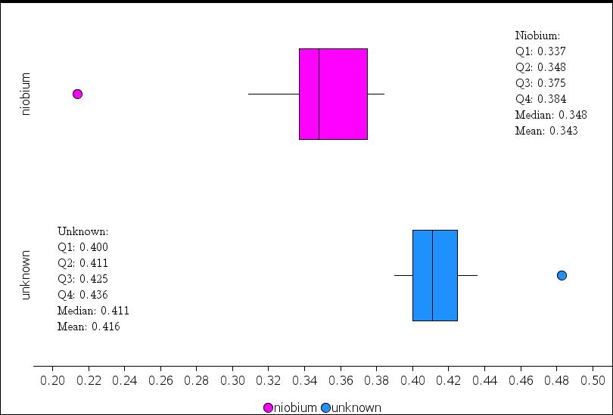

Figure 6. Niobium and Unknown Metal Box Plot

Figure 6 above presents the box plots of the specific heat results of Niobium and the unknown metal. The only overlap in the data is from quartile 3 to quartile four in Niobium over the minimum point of the unknown metal to the first quartile. There are two outliers in the graph. There is one from each section. The space between the first quartile and third quartile is larger in Niobium’s trials than in the unknown metal’s trials.

Table 9

Niobium Percent Error

|  |  |  |
| --- | --- | --- |
| **Trials** | **Rod** | **Percent Error (%)** |
|
| 4 | A | 36.279 |
| 11 | A | 44.839 |
| 3 | B | 44.143 |
| 7 | A | 35.028 |
| 15 | A | 42.603 |
| 1 | B | 27.180 |
| 6 | A | 19.900 |
| 2 | B | 31.488 |
| 13 | B | 28.137 |
| 5 | A | 16.775 |
| 12 | B | 30.084 |
| 9 | A | 31.514 |
| 10 | B | 28.922 |
| 14 | B | 41.441 |
| 8 | A | 19.282 |
| Avg |  | 31.841 |

Table 9 above shows the percent error of Niobium’s specific heat trials. The trials are not in order, because they were randomized. Niobium’s percent error has an average of 29.270%, which is shown in the last box of the third column. The percent error ranges between 16% and 44%. The percent errors for Niobium are all under 45%. In Appendix E, a sample calculation will be shown for the first trial.

Table 10

Unknown Metal Percent Error



In Table 10 above the percent error for the unknown metals specific heat trials is presented. The range of the unknown metals percent error was between 47% and 82%. For the unknown metal, the average percent error was 56.847%.This is significantly higher than Niobium’s percent error. With these results, researchers can conclude the metals are most likely not the same.

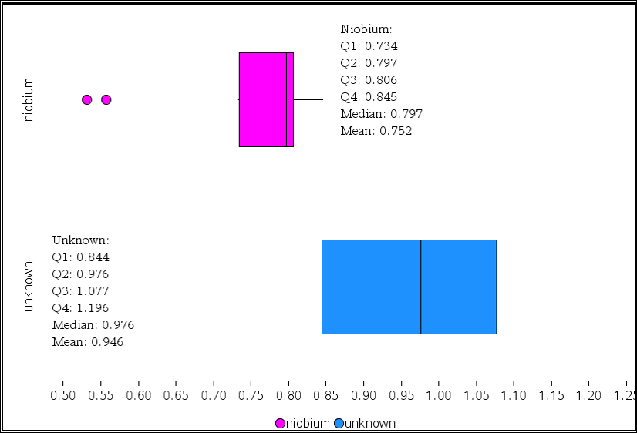

Figure 7. Box Plots of Niobium and the Unknown Metal Rods

Figure 7 shows the linear thermal expansion results from both the Niobium metal robs and the unknown metal rods. Linear thermal expansion is measured in 1/ºC. Both have been placed on the same graph to easily compare the two. Niobium is represented on top in the pink and the unknown metal results are on the bottom in blue. Niobium overlaps the unknown metal until the unknown metal’s first quartile. Niobium has two outliers in the data, one at 0.557 and the other at 0.531. The median for Niobium is 0.797 and the median for the unknown metal was 0.976. These two medians are not close to each other at all.

Table 11

Niobium’s Percent Error

|  |  |  |
| --- | --- | --- |
| **Trial** | **Rod** | **Percent Error (%)** |
| 10 | B | 13.469 |
| 3 | A | 18.995 |
| 15 | A | 4.220 |
| 9 | B | 25.159 |
| 12 | A | 17.869 |
| 13 | A | 3.135 |
| 2 | B | 13.325 |
| 7 | A | 3.370 |
| 14 | A | 4.352 |
| 8 | B | 12.261 |
| 6 | A | 4.096 |
| 5 | B | 12.606 |
| 1 | B | 21.609 |
| 4 | B | 13.630 |
| 11 | B | 13.325 |
| Avg |  | 12.095 |

Table 11 above shows the percent error of Niobium for linear thermal expansion. All the percent errors are under 25%, which is fairly good. The average percent error is 12.095% for all the trials. The percent error ranges from 3% to 25%. The trial numbers are not in order, because they were randomized. See Appendix F for the percent error calculation of the first trial.

Table 12

Unknown Metal Percent Error

|  |  |  |
| --- | --- | --- |
| **Trial** | **Rod** | **Percent Error (%)** |
| 10 | B | 6.841 |
| 3 | A | 9.010 |
| 15 | A | 66.211 |
| 9 | B | 39.140 |
| 12 | A | 18.827 |
| 13 | A | 32.957 |
| 2 | B | 51.674 |
| 7 | A | 49.245 |
| 14 | A | 4.941 |
| 8 | B | 20.991 |
| 6 | A | 49.903 |
| 5 | B | 37.452 |
| 1 | B | 22.458 |
| 4 | B | 53.298 |
| 11 | B | 68.408 |
| Avg |  | 35.424 |

Table 12 above shows the percent error of the unknown metal for linear thermal expansion. All the percent errors are under 70% for these 15 trials. The average percent error is 35.424% for all the trials. The range of the trials is between 4% and 68%.The percent error is high, suggesting the metals are not the same.

To carry out a statistical test for the data a two sample t-test will be used. A t-test will be used over a z-test because the population mean is unknown. The two different metals were independently selected. They were taken out of the drawer from two separate spots. The first assumption was met. The researchers only used a sample of four metals which is 10 times less than the entire population size. This meets the assumption that the population size is ten times larger than the sample. The second assumption was also met. The data does not meet the assumption of a sample size of thirty or more. Since the assumption was not met, the normal probability plots are shown below in Figures eight through eleven to show the data is normal. From looking at the probability plots, the researchers can conclude the third assumption was met.

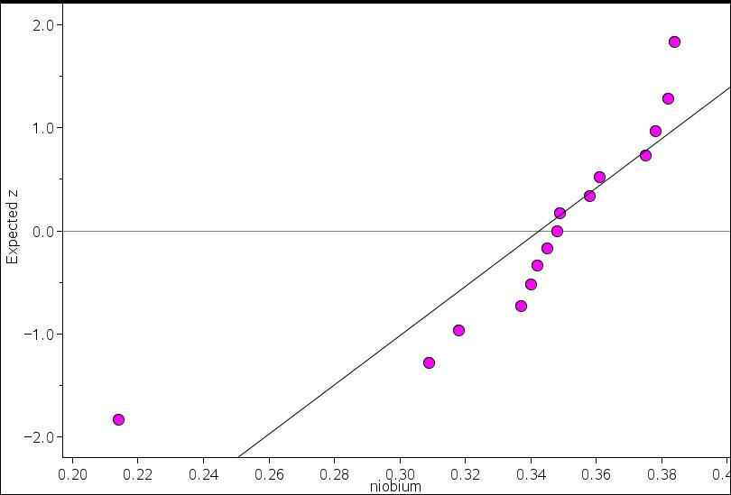

Figure 8. Niobium Normal Probability Plot of Specific Heat

In Figure 8 above, the normal probability plot of niobium is shown. The data seems to be fairly normal since it lies near the line, although the first point is an outlier. With more trials, the data could be proven to be more normal

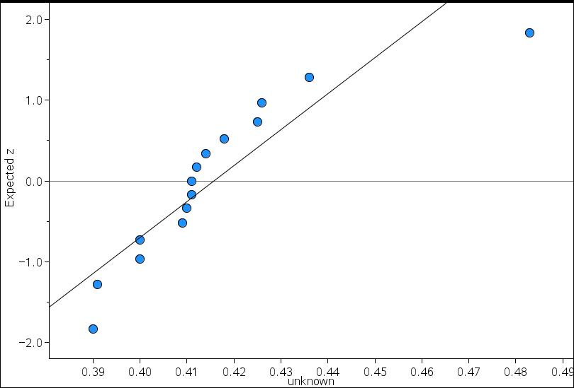

Figure 9. Unknown Normal Probability Plot of Specific Heat

Figure 9 above presents the unknown metals normal probability plot for the specific heat trials. The data shown appears to be normal. Most of the points lie near the line, although there are some outliers, such as the last point.

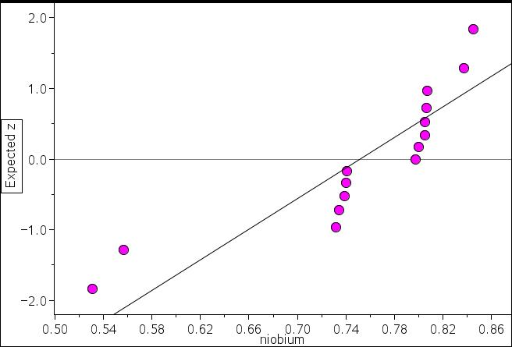

Figure 10. Niobium Normal Probability Plot of Linear Thermal Expansion

Figure 10 shows the normal probability plot for Niobium’s data for the linear thermal expansion trials. The data seems fairly normal. The points of data lie close to the line. Although, the data could be better so the points would be closer to the line. There is a slight pattern which may suggest some skewed data. There seem to be 4 outliers, the first two points and the last two points.

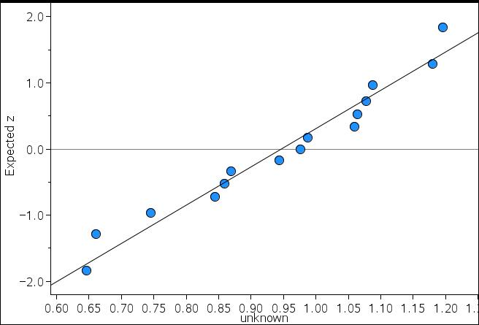

Figure 11. Unknown Normal Probability Plot of Linear Thermal Expansion

Figure 11 above shows the normal probability plot for the unknown metal of the trials for linear thermal expansion. This probability plot shows the data is normal, because all the points of data are relatively near the line.

The null and alternative hypothesis of the data are shown below:

H0: 1 =2

Ha: 1 ≠ 2

The null hypothesis (H0) states that the sample mean of Niobium (1) will be equal to the sample mean of the unknown metal (2). The alternative hypothesis (Ha) states that the sample mean of Niobium (1) will be not equal to the sample mean of the unknown metal (2).

To find out whether the null or alternative hypothesis is true, the researchers conducted a two sample t-test. The first step in this test is to find the t-value. The equation to find this is shown below:

$$t= \frac{(\overline{x_{1}}-\overline{x_{2}})}{\sqrt{\frac{{s_{1}}^{2}}{n_{1}}+\frac{{s_{2}}^{2}}{n_{2}}}}$$

The equation above demonstrates how to find the t value for the two sample t-test. The t-value can be found be the difference of means divided by the square root of the standard deviation of niobium squared divided by the sample size added to the standard deviation of the unknown metal squared divided by that sample size.

In Appendix G, the sample calculation is shown. After the equation was completed, the t-value was found to be -5.95904. The p-value result of this data is 0.000006 after all the given information was inserted into your calculator. Shown below is the density curve of the data and the calculator results spread sheet.

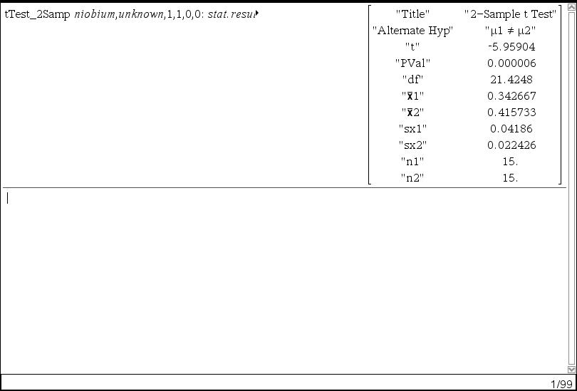

Figure 12. Calculator Results of Specific Heat

Figure 12 shows the results of the calculators two sample t-test. The alternative hypothesis, p-value and all the data from the trials are shown. All of the numbers shown on the right are the ones that were inserted into the two sample t-test equation.

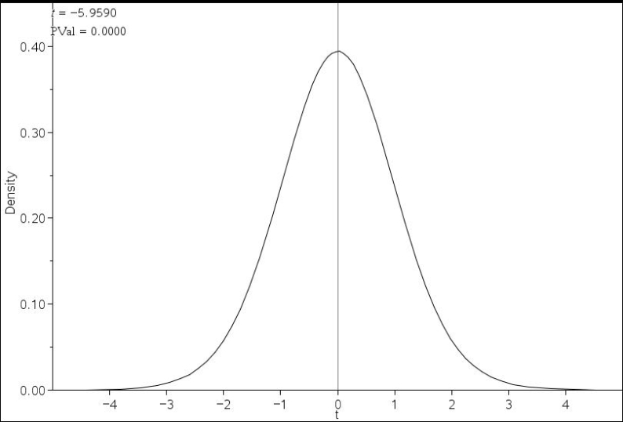

Figure 13. Density Curve

Figure 13 above shows the density curve of the data. The p-value can barely be seen since the number is so critically small. Based on the size of the number, the researchers can possibly assume the results are significant.

In conclusion, since the p-value of 0.000006 is less than the alpha level of 0.1, the researchers reject the null hypothesis that the sample mean of Niobium trials will be equal to the sample mean of the unknown metal. From this t-test the researchers can conclude that there is evidence that the sample means of the two metals are not equal. There is only a 0.0006% chance of these results happening by chance alone if the null hypothesis was proven true.

The null and alternative hypothesis for linear thermal expansion is stated below:

$$H_{o}:μ_{1}=μ_{2}$$

$$H_{a}:μ_{1}≠μ_{2}$$

The null hypothesis (Ho) states that the sample mean of Niobium (µ1) will be equal to the sample mean of the unknown metal (µ2). The alternate hypothesis (Ha) states that the sample mean of Niobium (µ1) will not be equal to the sample mean of the unknown metal (µ2).

The equation presented above demonstrates how to find the t value for the two sample t-test. The t-value can be found be the difference of means divided by the square root of the standard deviation of niobium squared divided by the sample size added to the standard deviation of the unknown metal squared divided by that sample size. In Appendix H, a sample calculation will be shown.

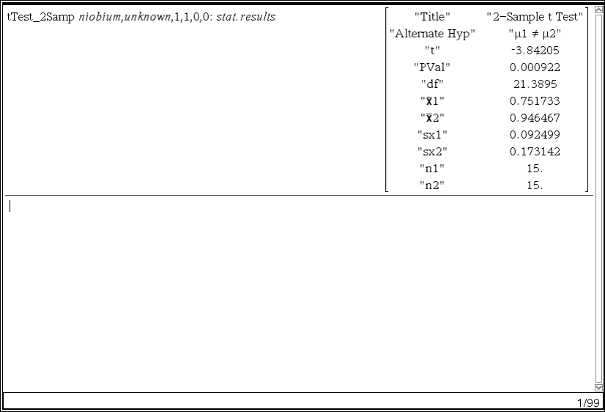

Figure 14. Statistical Test for Linear Thermal Expansion

Figure 14 displays the statistical test results for the two-sample t-test that was run for this experiment. All of these values are needed to conduct a two sample t-test. The t value of -3.8421 and p value of 0.000922 are given.

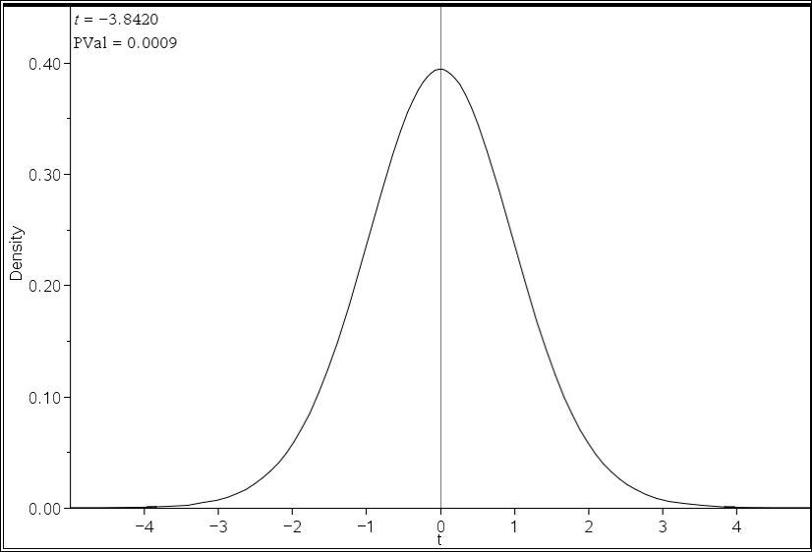

Figure 12. Density Curve

Figure 15. Density Curve

Figure 15 above shows the density curve of the data. Since the p-value is so small, the shaded area can barely be seen on this curve. Based on the small size of the number, the researchers can possibly assume the results are significant.

In conclusion, since the p-value of 0.00092 is less than the alpha level of 0.1, the researchers reject the null hypothesis that the sample mean of Niobium trials will be equal to the sample mean of the unknown metal. From this t-test the researchers can conclude that there is evidence that the sample means of the two metals are not equal. There is only a 0.092% chance of these results happening by chance alone if the null hypothesis was proven true.

Conclusion:

The objective of the researchers’ experiment was to correctly identify the unknown metal as the same metal or different metal as Niobium by conducting a specific heat and a linear thermal expansion experiment. The researchers’ hypothesis that if the specific heat and thermal expansion of the unknown metal are found and identified outside a 20% error, then the metal will not be Niobium was accepted.

This conclusion was decided because of three things the percent error, the p-value and the box-plots. The percent errors were not the same for both the specific heat trials and the linear thermal expansion trials. The percent error was high for the specific heat of the known Niobium rod but it was a lot higher with the unknown metal rod. For the linear thermal expansion percent error it was very low for the known Niobium metal rod; however it was very high for the unknown metal rod. Both p-values for the specific heat two-sample t-test and the linear thermal expansion two-sample t-test were rejected. The p-value for specific heat is 0.000006 which is less than the α level of 0.1. The p-value for linear thermal expansion is 0.000922 which is also less than the α level of 0.1. The box plots also helped the researchers determine that the unknown metal rods were different from the known Niobium metal rods. The box plots for both specific heat and linear thermal expansion barely overlapped. Because the box plots barely overlap this shows that the results are totally different. There are few trials that got the same results. The specific heat of the known metal had a lower specific heat than the unknown metal. Niobium’s specific heat is .265 j/ºC and the unknown metals specific heat had an average of 0.416 J/gºC. The linear thermal expansion coefficients were also off from each other. Niobium’s linear thermal coefficient was 7.1 x 10-6 1/ºC. The unknown metal’s linear thermal expansion alpha coefficient was averaging at 9.4662 x 10-6 1/ºC.

Overall, the researchers’ experimental design was well constructed. The procedure was easy to follow and allowed the researchers’ to conduct the experiment to their best abilities. The researchers did not have the best controls. The changing temperature in the classroom may have had an effect on the experiment as well as some other things. One flaw in the experimental design would be the allotted time to heat up the water. The water sometimes took over 3 minutes to reach the given temperature. Because of this experimental design, the researchers can concur that the results of the experiment did not affect the data. The data contributed to the researchers’ correctly identifying the metal. From the data, the researchers’ were able to conclude that the unknown metal was not the same metal as Niobium.

The errors occurred were tiny problems that should not have affected the outcome of the experiment. The researchers’ had a planned out strategy in order to prevent any skewed data. The researchers overall kept precision and accuracy in their trials. In some of the trials, the researchers’ had dropped the metal before being placed into the linear thermal expansion jig or the calorimeter. In some cases, the researchers’ put the metal back in the water for a couple seconds or they picked up the metal and placed it into the correct jig or calorimeter. Another error was leaving the metals in the boiling water for longer than the allotted time. If the researchers could go back, they would redo all of the trials that they encountered problems. The researchers’ also would have used a different set of tongs to reduce their error.

For further experiments the researchers’ suggest that the next section of students attempting this project to use different tongs, because some of the tongs did not allow them to get a great hold on the metal. They also suggest that instead of using the stopwatch on the TI, to use an actual stop watch. The problem with the stop watch on the TI was that after a certain amount of time, the calculator screen would shut off which stopped the timer from moving.

To continue this research in the future more experiments could be done to identify the metal. One way to identify the metal would be using Molar Mass (“Identification of an Unknown Metal by Molar Mass”).With this experiment, the researchers would be able to identify the metal by the atomic mass. Another way would be to see the ways the metal reacts with acids. Since most metals react differently with acids, the metal could be identified (Antonopoulos). If future researchers use these experiments, it would further them to identify the metal more accurately.

In conclusion, the researchers’ hypothesis was accepted. The data from the two-statistic t-test proved the metals to be different from one another. The researchers’ experiments overall ran well, despite a couple errors and suggestions to future students. With the attention to errors and suggestions, the future researchers’ are capable to improve the experiment to the best of their abilities.

Acknowledgements:

The researchers would like to thank Mrs. Dewey for her guidance throughout the entire paper, as well as the Data Analysis and Interpretation section.

The researchers would like to thank Mr. Supal for his insight and suggestions through the entire writing process.

The researchers would also like to thank Mrs. Hilliard for her helpfulness and suggestions during the entire paper.

The researchers would like to thank Andrew Zannetti and Jeffrey Wainz for helping the researchers with the formulas in the data tables.

Appendix:

Appendix A: Randomizing Trials on TI-Nspire

To keep the data as normal as possible, all trials were randomized using the TI.

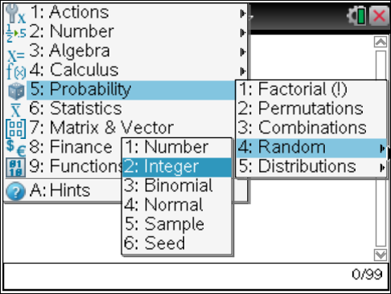

Figure 16. Random Integer

Figure 16 above shows a screen capture on how to get to the random integer setting.

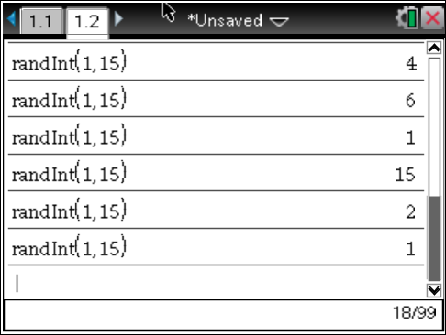

Figure 17. Randomizing

Figure 17 shown above presents how to randomize the trials by placing 1 in the first spot and 15 in the second. It is 1 through 15 because there are 15 trials. You then proceed to press enter until each number is given once then list them in the data tables in that order.

Appendix B: Randomizing Rod on TI-Nspire

To prevent the data from being skewed, the rods were randomized.



Figure 18. Random Integer

Figure 18 shows the screen capture on how to get to the random integer setting on the calculator.

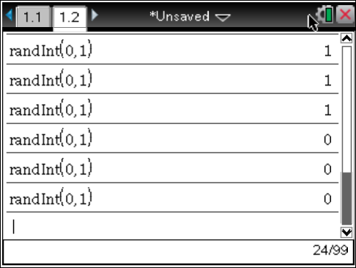

Figure 19. Randomizing

Figure 19 shows how to randomize the rods. Put 0 in the first space which will function as A and put 1 in the next space, this will function as B. Press enter 15 times and then enter the results into the data table.

Appendix C: Building the Calorimeter

To conduct the specific heat trials, the researchers had to build calorimeters. In this case, the researchers constructed 3.

1. Buy at least a 15 inch in length piece of three quarter inch PVC piping, 6 caps, and a piece of armaflex that will fit the outside of the piping.
2. Cut the PVC pipe into 3 sections using a hand saw to a length of 5 inches each.
3. Sand the ends of the pipe to make them not rugged
4. Cut 3 sections out of the armaflex using a handsaw to a length of 4.5 inches.
5. Place the armaflex over the PVC pipe and place on the caps.
6. In one of the caps, drill a hole with a quarter inch drill bit into the center.

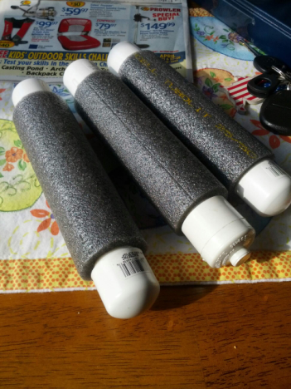

Figure 20. Calorimeters

In Figure 20 above, the three calorimeters the researchers constructed are shown. Each calorimeter is 5 inches in length and is covered in armaflex to preserve the heat inside of the PVC piping.

Appendix D: Logger Pro Set-Up

The logger pro was used during the specific heat experiment to find the equilibrium temperature.

1. Collect logger pro box and temperature probes from cabinet
2. Empty the contents of the box onto the lab area
3. Plug the logger pro into the outlet
4. Plug the temperature probes into the logger pro
5. Turn the logger pro on
6. Place the temperature probe into the hole into the calorimeter.
7. Press start after the metal is put into the calorimeter.
8. Press stop when the temperature has not changed for awhile

Appendix E: Percent Error for Specific Heat

To find percent error the following equation was used

$$percent error= \frac{Experimental Value-True Value}{True Value}×100$$

Below in Figure 21 is the sample calculation using the equation shown above.

$$percent error= \frac{Experimental Value-True Value}{True Value}×100$$

$$percent error= \frac{.361 J/gºC-.265J/gºC}{.265J/gºC}×100$$

$$percent error=\frac{0.096J/gºC}{.265J/gºC}×100$$

$$percent error=0.362J/gºC×100$$

$$percent error=36.226 J/gºC$$

Figure 21. Sample Calculation for Percent Error

Figure 21 shows a sample calculation for percent error of specific heats first conducted trial. To find percent error you take the true value subtracted from the experimental value all divided by the true value which is then multiplied by 100. The end result of percent error for this trial is 36.226 J/gºC.

Appendix F: Percent Error for Linear Thermal Expansion

To find percent error for linear thermal expansion the following equation was used

$$percent error= \frac{Experimental Value-True Value}{True Value}×100$$

Below in Figure 22 is the sample calculation using the equation shown above.

$$percent error= \frac{Experimental Value-True Value}{True Value}×100$$

$$percent error= \frac{0.000008056\frac{1}{ºC}-0.0000071\frac{1}{ºC}}{0.0000071\frac{1}{ºC}}×100$$

$$percent error=\frac{0.000000956\frac{1}{ºC}}{0.0000071\frac{1}{ºC}}×100$$

$$percent error=0.13464788\frac{1}{ºC}×100$$

$$percent error=13.465\frac{1}{ºC}$$

Figure 22. Sample Calculation for Percent Error

Figure 22 shows a sample calculation for percent error of linear thermal expansions first conducted trial. To find percent error you take the true value subtracted from the experimental value all divided by the true value which is then multiplied by 100. The end result of percent error for this trial is 13.465 1/ºC.

Appendix G: Two-sample T-test for Specific Heat

To find the t-value for the data of specific heat the two-sample t-test was used. The equation is shown below.

$$t=\frac{\overline{x_{1}}-\overline{x_{2}}}{\sqrt{\frac{{(S_{1})}^{2}}{n_{1}}}+ \sqrt{\frac{{(S_{2})}^{2}}{n_{2}}}}$$

In Figure 23 below a sample calculation is shown.

$$t=\frac{\overline{x_{1}}-\overline{x_{2}}}{\sqrt{\frac{{(S_{1})}^{2}}{n_{1}}}+ \sqrt{\frac{{(S_{2})}^{2}}{n_{2}}}}$$

$$t=\frac{0.343-0.416}{\sqrt{\frac{{(0.042)}^{2}}{15}}+ \sqrt{\frac{{(0.022)}^{2}}{15}}}$$

$$t=\frac{0.343-0.416}{0.011+ 0.006}$$

$$t= \frac{-0.073}{0.017}$$

$$t=-5.959$$

Figure 23. Sample Calculation for two sample t-test

Figure 23 demonstrates how to find the t value for the two sample t-test. The t-value can be found be the difference of means divided by the square root of the standard deviation of niobium squared divided by the sample size added to the standard deviation of the unknown metal squared divided by that sample size. The t-value of the specific heat trials is -5.959.

Appendix H: Two-sample T-test for Linear Thermal Expansion

To find the t-value for the data of linear thermal expansion the two-sample t-test was used. The equation is shown below.

$$t=\frac{\overline{x_{1}}-\overline{x_{2}}}{\sqrt{\frac{{(S_{1})}^{2}}{n_{1}}}+ \sqrt{\frac{{(S_{2})}^{2}}{n_{2}}}}$$

In Figure 24 below a sample calculation is shown.

$$t=\frac{\overline{x_{1}}-\overline{x_{2}}}{\sqrt{\frac{{(S_{1})}^{2}}{n_{1}}}+ \sqrt{\frac{{(S_{2})}^{2}}{n_{2}}}}$$

$$t=\frac{0.752-0.946}{\sqrt{\frac{{(0.092)}^{2}}{15}}+ \sqrt{\frac{{(0.173)}^{2}}{15}}}$$

$$t=\frac{0.752-0.946}{0.024+ 0.045}$$

$$t= \frac{-0.194}{0.068}$$

$$t=-3.842$$

Figure 24. Sample Calculation for two sample t-test

Figure 24 demonstrates how to find the t value for the two sample t-test. The t-value can be found be the difference of means divided by the square root of the standard deviation of niobium squared divided by the sample size added to the standard deviation of the unknown metal squared divided by that sample size. The t-value of the linear thermal expansion trials is -3.842.

Works Cited

Antonopoulos, Alexander. " ." *Digication E-Portfolio*. Digication.com, n.d. Web. 13 May 2013. <https://salve.digication.com/alexanderantonopoulos/Lab_27_Identifying_ an_Unknown_Metal >.

Biomedizinische Technik/Biomedical Engineering. Volume 30, Issue 12, Pages 334–339, ISSN (Online) 1862-278X, ISSN (Print) 0013-5585, DOI: 10.1515/bmte.1985.30.12.334, July 2009

Blauch, David N. "Calorimetry." : Heat Capacity of the Calorimeter. Davidson University, 2009. Web. 26 Mar. 2013. <http://www.chm.davidson.edu/vce/calorimetry/heatcapacityofcalorimeter. html>.

Carmen, Iancu, Bara Vasile, Sarca Gheorghe, and Timar Adrian. "Solutions of Heat Exchangers Used in Food Industry." *Prot Med*. N.p., n.d. Web. 15 May 2013. <http://protmed.uoradea.ro/facultate/anale/ecotox_zooteh_ind_alim/2009/i pa/57%20Iancu%20Carmen.pdf>.

"ChemLab - Instruments - Calorimeter." *ChemLab - Instruments - Calorimeter*. N.p., n.d. Web. 15 May 2013. <http://www.dartmouth.edu/~chemlab/techniques/calorimeter.html>.

Cramb, Alan W.. "A Short History of Metals." . N.p.. Web. 8 May 2013. <http://neon.mems.cmu.edu/cramb/Processing/history.html>.

De Leon, N. "Specific Heat." Specific Heat. Indiana University Northwest, n.d. Web. 26 Mar. 2013. <http://www.iun.edu/~cpanhd/C101webnotes/matter- and-energy/specificheat.html>.

"The Element Niobium." Jefferson Lab. N.p.. Web. 21 Mar 2013. <http://education.jlab.org/itselemental/ele041.html>.

"Identification of an Unknown Metal by Molar Mass." *Ups.edu*. University of Puget Sound, n.d. Web. 13 May 2013. <http://www2.ups.edu/faculty/thoyt/c110/Exp_10%20c110%20F- 12%20Unknown%20Metals.pdf>.

"Niobium." Chemicool Periodic Table. Chemicool.com. 17 Oct. 2012. Web. 5/17/2013 <http://www.chemicool.com/elements/niobium.html>.

"Niobium." Water Treatment Solutions Lenntech. N.p.. Web. 20 Mar 2013. <http://www.lenntech.com/periodic/elements/nb.htm

"Niobium-Raw Materials and Processing." TIC. N.p.. Web. 20 Mar 2013. <http://tanb.org/niobium>.

"Superconducting Magnet System Applications." American Magnetics. N.p.. Web. 17 May 2013. <http://www.americanmagnetics.com/tutorial/system_apps.html>.

"Tantalum." Water Treatment Solutions Lenntech. N.p.. Web. 24 Mar 2013. Timm, John. <http://www.lenntech.com/periodic/elements/ta.htm>.

"The kinetic-molecular theory and its relation to heat phenomena." (1935): 31. Web. 26 Mar. 2013. <http://pubs.acs.org/doi/abs/10.1021/ed012p31?prevSearch=%5BTitle%3 A+Kinetic+Molecular+Theory%5D&searchHistoryKey=>