Giselle Gaitan-Stephanie George-Leah Guardiola
Brooke Hassig-Aleksandra Kocz
Professor Susak
English 3020
28 November 2016
Project 2
Introduction
The Genesis II building of the Detroit Rescue Mission Ministries is one that provides up to 90 days of shelter housing and up to 18 months of transitional housing to homeless women and their children. Once the residents are in the shelter, they are offered both transitional housing and drug abuse programs, if they are struggling with addiction. This is a place where the homeless people of Detroit are able to work on becoming financially independent and mentally stable. The shelter supports many residents, but just a few employees who help these strangers build their lives back up. It is a challenge for everyone involved, but there is one important key factor that must come into play, and that is communication. Both external and internal communication are important for the residents’ success. In terms of external communication, there is confusion and unclear messages between the faculty and volunteers. The messages are not delivered in a timely manner and the staff is then unsure of what to do with the volunteers. Because of unclear messages, valuable time is wasted in which volunteers could be spending it helping in the kitchen or filing important papers for the DRMM. Internal communication between the faculty members is also an important division of transmission. The faculty members have sporadic meetings in order to get on the same page, but there are a few things that could make their communication more consistent such as: having more meetings and sending out frequent emails or messages to update staff on volunteers who are coming in or things that are occurring in the upcoming weeks. The research group has been analyzing the means of external and internal communications by interviewing staff and observing the community while volunteering. The researchers decided that this problem was worth analyzing because communication was deemed to be a prominent concern for the volunteers, the faculty members, and most importantly, the clients.
Methods
In order to analyze and assess the communication, the researchers asked questions to gain information. The research goal was to better analyze the communication between the Resident Specialists and Administrators at DRMM Genesis II. In order to gain information to help with the analysis of communication, the researchers decided to interview Resident Specialists and Administrators. With that being said, we are guests in their facility. The researchers believed that with asking questions, it was more personable, and the employees would be able to express themselves, giving us a more detailed response, without having to limit themselves to a simple yes or no answer. Since the researchers volunteer on certain days, they are only exposed to certain people. As a result, the researchers only had access to very few people, which were interviewed. The interview questions were written allowing the interviewee to answer the questions in their own way. They were left open ended, so the interviewee would not leave out any crucial information that could aid in our analysis. The researchers decided it would be best to keep the names of each employee as anonymous in order to prevent any possible repercussions from their answers. The full interview for Resident Specialists can be viewed in Appendix A and for Administrators in Appendix B.
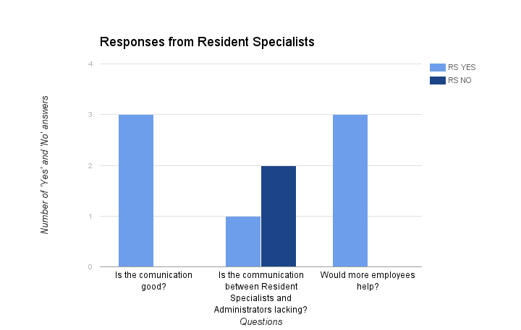
Figure 1. Responses from Resident Specialists
As previously mentioned above, the interview questions were left open ended so the employees were not forced to give a single yes or no answer. From their answers, we decided the ‘Yes’ or ‘No’ portion of the question. There were three resident specialists interviewed. As you can see in the chart above, the majority agreed with each other, except for the second question regarding the whether or not the communication was lacking. These results were then used to analyze the communication system.
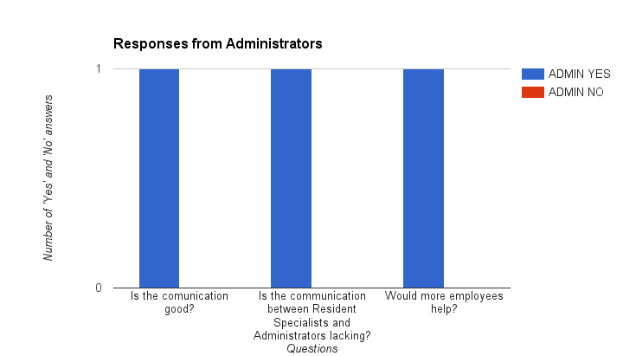
Figure 2. Responses from Administrators
Again, the interview questions were left open ended so the administrators were not forced to give a single yes or no answer. From their answers, we decided the ‘Yes’ or ‘No’ portion of the question. As you can see in the chart above, there was only one administrator who was interviewed. This was a direct result of volunteering during hours where the administrators were either busy or not in the facility. These results were then utilized to analyze the communication system.
The researchers also utilized field notes for their analysis. These field notes were taken either during or after the volunteering time period. The field notes consisted of any observations, questions, or explanations that the researchers had about their encounters. The researchers utilized their field notes in order to choose the topic of communication as the main focus for their analysis. The field notes were brief, but descriptive in order to make sure no vital or key information was left out. Appendix C contains some of these field notes and the observations that the researchers had.
Analysis
After interviewing the DRMM employees and administrators about Genesis II’s current communication and observing the effects of their communication choices from a volunteer standpoint, we, as researchers, have drawn conclusions on what works well, what does not work well, what could be improved, what could be implemented, and most importantly, why.
One of the resident specialists brought up that having more staff meetings throughout the year would address overall miscommunication. Since a lot of information is distributed among the faculty during these meetings, it is probable to say that this is one of the primary forms of communication. If everyone is present at these frequent meetings, then everyone will be receiving the same information in the same way at the same time diminishing the probability of miscommunication. More meetings would benefit this example: When we, the WSU volunteers, came into the DRMM for our first work day, many of the staff did not know why we were there or where we were from. They also didn’t know exactly what to do with us that first day and many other days after that. This showed through their tones of voice and unpreparedness. Although two of us assisted with administrative work for the majority of our volunteering, three of us were tasked with jobs that were necessary to be completed, but were assigned with little thought to other options of what could have been assigned. Having more frequent meetings allows each member of the facility to know exactly what is happening and going to happen including student volunteers coming in for their research-driven English class. If there was meeting in between the time we were assigned to Genesis II and the time we first came into work, administrators could have addressed work that needed to be done and could be completed by volunteers and staff could have had the opportunity to brainstorm how to use us to their advantage.
Another resident specialist suggested that more staff bonding could improve communication and the work environment. Many of the current resident specialists and administrators have been working at this facility and with the DRMM for a long time. Unfortunately, this can cause work for an individual to become tedious and boring, therefore making team efforts more tedious and boring. A bored and annoyed individual will let rules slide, skip important steps, and even become forgetful. Holding more bonding opportunities for the staff allows everyone to learn about their coworkers and what each person does, hence learning how the facility runs. Allowing staff to build relationships outside of the work setting, creates a positive environment and a more enjoyable workplace. A more enjoyable workplace leads good communication among coworkers.
Very passionately, a resident specialist, spoke with us about wanting the DRMM to provide workshops and trainings to improve employee skills. Because there is little room to move up in ranks in the organization and little opportunity to receive monetary raises from the employer, equipping each employee with new and/or improved technical and leadership skills enables each individual to grow professionally. An argument was made that the clients are continuously given these types of trainings as a part of their programs to develop and motivate, so if the staff were given these trainings not only would this help them develop and motivate them as a professional but also in their current line of work. Having motivated and skilled workers is always beneficial to an organization. Staff can communicate easier amongst one another because they now know how. Staff can develop alternative ways to communicate digitally creating accessible documents to be referenced in the future. Supplying employees with the opportunity to grow will make the organization grow.
Each of the staff members we interviewed stated that having more employees in the Genesis II house would help communication within the facility tremendously. We, as researchers, and staff both realize that this is not an immediate solution due to needing funds that are not available. However, the consensus of this statement was found to be a clear sign of the need, so it was deemed necessary to include in our analysis. There are only a few resident specialists working at a time and a lot to get done within that time frame. Because of the unproportional ratio of staff to client/task, an individual is tasked with many duties to fulfill and left with little time to communicate. With more employees working in one shift, specialists can focus on a few tasks and perform them well and communicate with others well.
Conclusion
In closing, our analysis shows that communication is a main concern for the Genesis II building of the Detroit Rescue Mission Ministries. One can only do so much when it comes to limited communication and we want to help improve this to make communication easier for everyone involved in this community. Hopefully, by making the mode of communication simpler it will be easier to spread and continue what they are doing because we truly believe it is a good cause. To restate, some ideas that we have to improve communication in Genesis II is to have more meetings, to provide the employees with workshops and trainings, and lastly to employ more workers. Again, the idea of employing more workers is more complicated than it seems but we agree that it will help in the long run. All of these ideas were just suggestions but we truly believe that they will better the community long term. Not only will these ideas help to further unite the community but they will also make the community stronger and allow it to grow.

Appendix A: Resident Specialist Questions and Responses
- What do you think about the communication between administrators and the staff? Why?
- Where do you think communication is best and where does it lack?
- What would you do to fix /improve it?
- Do you think having more employees would help this?
Resident Specialist 1
- With the immediate supervisor, the communication is terrific. She advocates for us. She stresses our work duties, but tries to make it simplistic. She works with you. She is approachable which is important. If you mess up, you can go to her.
The director is aloof, and the supervisor is more direct. The director is more of a watcher. The sends the supervisor to talk to you and knows how to put people in place. The director is also approachable. I look for results after communication.
2. The communication is best between the supervisor and the employees. The communication lacks between the supervisor, the director, and everyone else. There is nothing negative about the communication
3. To improve the communication, I would suggest more training. Training staff and open up training to elevate (promote). The jobs get mundane and you get too comfortable start to make mistakes. Offer more training for people who want to move up from their position.
4. Need more staff to help elevate those who want to try to promote and propel themselves.
Resident Specialist 2
- It has improved a lot. Trying to improve on communication by accepting feedback, allowing us to have our voices known.
- The communication is best between the administrators and staff through face-to-face in monthly meetings, where we can have food. Lacks between staff and advisor when they don’t listen.
- I love role playing in situations when you don’t see how you might have affected the decision.
- Having more employees would not hurt. Night time is the busiest so something will be left undone.
Resident Specialist 3
- Lines are always open. With Dr. Audi, the door is always open, but you still call and make an appointment. Easy access to those here.
- The communication is best between people doing same job than with others doing different jobs.
- There could be more meetings to come together and work as a team.
- More employees would help. There are 3 floors and 3 programs, so it is hard to function without the accurate amount of staff. If you don’t have an accurate number, you will be working harder than you should.

Appendix B: Administrator Questions and Responses
- What do you think about the communication between administrators and the staff? Why?
- Where do you think communication is best and where does it lack?
- What would you do to fix /improve it?
- Do you think having more employees would help this?
Administrator 1:
- The communication between administrators and the staff is decent. If it is every not decent or lacking we just have meetings so that everyone can get back on the same page.
- Sometimes our communication process isn’t very strong. Sometimes everyone is on a different page and we have to meet to try to get everyone back to where they need to be so that we can get our work done.
- I would make our communication processes stronger because it would eliminate any miscommunication between us. We should definitely have stronger processes in place.
- Having more employees would definitely help. Right now everyone kind of does more than one job around here which can cause miscommunication. If we had more employees to do these jobs it would definitely help.

Appendix C: Field Notes and Observations
While working with DRMM our group has noticed complications when it comes to communication, this includes problems with getting in contact, what we do while we are there, and not knowing when we are coming. When we first started trying to get in contact with DRMM all we had was a phone number. This resulted in us trying to contact them with no response back because the supervisors were not in their offices. We knew that this was because they were busy due to lack of staff but it was still difficult to communicate with them. It took us up to two weeks to finally get in contact with the administration and start working with the facility. Once we started volunteering at the facility the staff was not aware that we would be there due to a lack of communication with the supervisors and therefore they did not know what to do with us. They typically put us to work doing manual labor including mopping, working in the kitchen, and making copies. Even after being there for a few hours the facility would sparkle due to lack of effort when it came to cleaning. Most of the work that we would partake in was considered busy work because the staff was not expecting us to be there and they were underprepared. The staff needed work done but at the same time it felt like they were nervous to put us to work, as in they did not want to offend us. This can be seen through them asking us if we wanted to do a particular activity or for example none of us were ever asked to clean a bathroom in our time there and everything that we were asked to do were considered pretty low stress level activities. When we finished a task in under an hour the entire staff was surprised with our commitment and that we wanted to be there in the first place. Every time we came back to work the staff was pleasantly surprised. Personally, i’ve never been committed to a volunteer project for this long and we could tell that the staff felt the same way. Again, this could be seen through them expressing surprise and gratitude when we came back and again when we took interest in what was being done. Overall many complications came up through the DRMM when it came to communication and this can be seen through our field notes and observations.

Appendix D: Team Meeting Notes
November 10th- Initial Discussion Phases
Step One:
- To analyze the activity system of communication that occurs in the DRMM Genesis 2: Women's Transitional and Shelter Housing
- Main Goals
  - To complete all aspects of the rhetorical situation
  - To complete all aspects of the activity system analysis map
  - To provide in depth analysis for each statement
  - Provide useful and relevant information
  - Provide possible resolutions
- Main Audiences
  - Susak
  - DRMM
  - Future classes
  - Classmates
- *To be persuasive, our report must:
  - Provide detailed descriptions to experience
  - Provide detailed reasons to the "WHY"
  - Utilize active writing, not passive
  - Remain open-minded and professional
  - Stay on topic
- Project Drafting Plan of Superstructure:
  - Leah's outline
  - Walk through of the activity systems triangle - intro
  - THESIS STATEMENT
  - Defined mechanism of triangle and connect to DRMM - transition/topic sentence
  - CONCLUSION
Step Two:
- Purpose:
  - To provide construction criticism to the DRMM's communication process through a professional manner using the activity systems analysis.
- Necessities for creating a useful communication:
  - Group Chat
  - Face to Face meeting
  - Wiki Page
  - Google Doc
  - Email
- Creating a persuasive communication in this situation
  - See above *
- Reader's Profile
  - Susak
    - to grade us
    - help to improve teaching
  - DRMM - PRIMARY
    - asses problems
    - consider changes made
  - Site Supervisor - SECONDARY
    - address what's specifically going on in their facility
  - Future classes
    - look as model
  - Classmates
    - to compare problems among the DRMM's facilities
- Important Contextual Information
  - Field Notes
  - Knowledge Base
  - Information provided at/from the DRMM
  - Short writing assignments
- Ethical Treatment of Stakeholders
  - Write with respect
  - Unbias information
  - Keep identities anonymous
Initial Discussion (Conjecture Phase):
-this will be viable and interesting, due to the wide variety of employees that we interact with.
-it is promising, because we have a lot to offer and communication is key.
-communication is a problem
-what other forms of communication do they offer?
-how often signs and information updated?
-why is there a rule no cellphones?
-why is it not enforced?
-the supervisors do not properly communicate with the staff
-understaffed
-hiring more people specifically for communication
-sending out information on new things
-residents could respect the staff more/follow the rules
-see question 1 above for rhetorical framework
Initial Discussion (Definition Phase):
-for communication we will focus on the communication between the staff and supervisors
-through interviews
-breaking down the activity of communication to analyze the relationship
-theme: social, communication, organizational, and technical
-focus on one issue to several examples
-Mrs. Thomas, Mrs. Moye
-Mrs. Dukes, Mrs. Cooper
-not knowing about us
-not knowing what needs to be done
-is there a task schedule
-what the night people do/ what it entails
-see question 2 above
Questions:
-What do you think about the communication between administrators and the staff? Rate? Why?
-Where do you think communication is best and where does it lack?
-What would you do to fix it/improve it?
-Do you think having more employees would help this?
Ask Supervisors/Higher-Ups and Staff
-Mrs. Thomas
-Mrs. Moye
-Mrs. Dukes
-Mrs. Cooper
-Mrs. Williams

November 15th- Meeting 2
Essay Structure
Intro:
-Drmm
-Genesis 2
-Communication
-between Administrators and Staff
Collaborative- take parts from everyones paper and fill int the blanks (Aleksandra)
State our purpose/thesis
Collaborative-figure out in group message (Aleksandra// type out)
mention activity system analysis?
observation of their communication
Collaborative- add what you have from field notes

headings- of administrators and staff (resident specialist)
-interview information
Brooke- Resident Specialist
Stephanie- Admin
(don't forget to address the good and bad)
address a possible solution(s)
Gigi
conclude with why this is important/ relates to them
Leah
-final thoughts//
-check transitions
-make sure paper 'flows'
-make sure information is relevant
-check grammar and spelling
November 22nd- Meeting 3
1. Keep it anonymous
-keep it respectful and professional
-keep questions open ended
-keep questions unbiased
-during interview, pay attention

2. Brooke & Gigi - Review OWL Tips
Leah&Stephanie- Mapping Categories
Aleksanda- Primary Research Tool notes

3. In person questionnaire: a short list of questions asked face-to-face

