Brooke Hassig and Sade’ Lemons
Mrs. Tallman
AP Calculus
2 February 2015
Silent Killer
Lead exposure has been a major problem in previous years and needs to be stopped. It has detrimental health effects, mainly targeting children. A test was conducted in Detroit testing the lead levels of children in Detroit from 1992 to 2008. Among the 169,000 children tested, more than 74,000 had lead levels of 5 micrograms or higher, which many researchers consider unsafe. Lead is a neurotoxin that can reduce a child’s intelligence and can cause a lifetime of behavioral and health problems. The most common way lead is exposed to humans is through lead-based paint in old homes, or in the air, dust, water, and soil. Lead can contaminate the body in a number of different ways, has damaging effects, and can cause lifetime learning disabilities.
Contamination of lead can occur in a very discrete way, some may not even notice until later years or months of life. Children have a higher risk of lead absorption and permanent damage, which is why they should be the most protected. Babies often get hungry lying around and tend to chip small pieces of paint off the walls and ingest it. Although lead does not have a taste or smell, this old paint is an attraction to small children because it contains a sweet flavor. Once the lead is inside the body, it travels through the blood stream and attacks cells in tissues and organs. In the bones and in the kidneys is where high concentrations of lead are held, where lead can be released again later in life causing more destruction. When the lead reaches the brain, this is where the most damage happens. Children with greater lead levels may also have problems with learning and reading, delayed growth, and hearing loss. At high levels, lead can cause permanent brain damage and even death (AACAP).
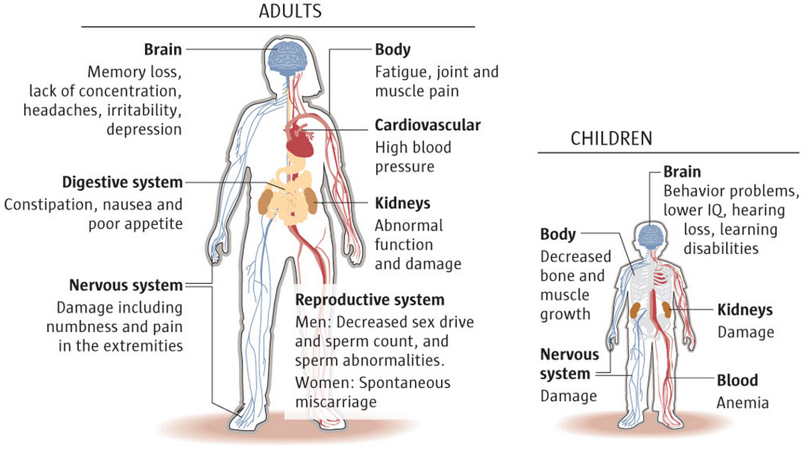
Figure 1. Effects Lead has on Different Parts of the Body
Figure 1 above shows the different areas that lead effects in both adults and children. As noted, as children progress in their lives and are exposed to small amounts of lead, it can lead to chronic disorders and disabilities. It may be assumed that lead acts as a chemical stressor and causes breakdown of the homeostatic cellular mechanisms (Finkelsteina). Homeostasis is the process that maintains the stability of the human body's internal environment in response to changes in external conditions.
These multiple side effects are the cause of learning disabilities resulting in a low IQ score and overall development delay. WSU nursing professor Lisa Chiodo studied a group of Detroit children from birth to the age of 20. The study showed that kids with higher lead levels had lower IQs. Children with lead poisoning tend to be easily frustrated and inattentive because of problems with memory and learning. Lead exposed students are seven times more likely to drop out of school than those with low levels of lead.
Once the lead has fully taken affect, has circulated through the body and made its presence known, it is very hard to get the lead out. Lead can only get out of the body through urine, hair, skin, and nails.

Figure 2. Graph of Scenario over 400 Days
Figure 2 above shows the graph of the given scenario. In a study in 1973, Rabinowitz and colleagues measured over an extended period of time the lead levels in bones, blood, and tissue of a healthy male volunteer. Their measurements produced specific lead transfer coefficients between the different parts of the body. The study also showed that the average rate of lead ingestion per day was 49.3 micrograms. In the graph, it is clear to see that the blood and tissue lead levels increase in the beginning but then level off at around the 160 day mark. The lead level in the bones seems to keep increasing even after the 400 day mark. This implies that over time the lead levels in the blood and in the tissue are easier to extract, especially if the body is moved out of a lead environment after 400 days. The bones are much harder to extract lead out of. This is probably due to the high concentrations of lead that they hold. Over time, the bones can recirculate the lead through the body again.
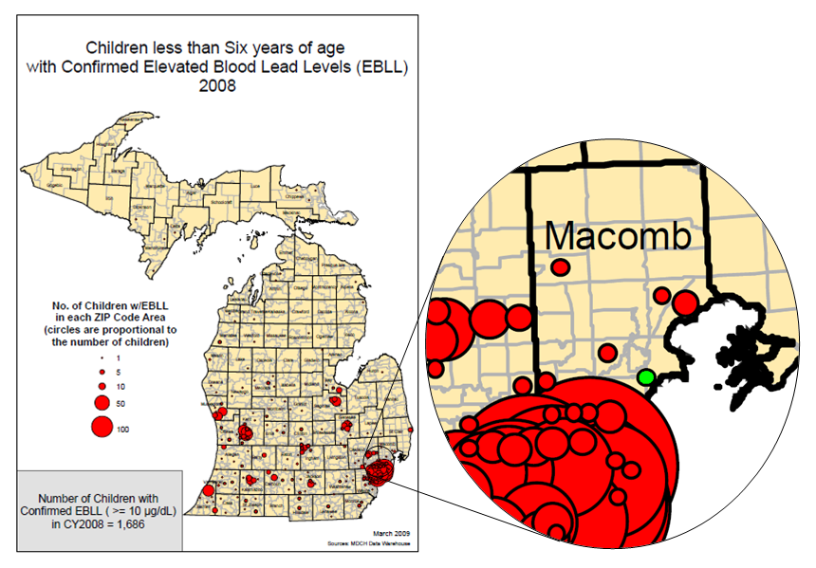
Figure 3. Macomb County Lead Levels
Although Detroit is very close to our community, lead poisoning does not seem to be an issue in our community. In figure 3 above, you can see that only a small portion of Macomb County suffers from lead poisoning. According to Michigan State’s Department of Medicine annual report on Blood Lead Levels from 2011, approximately 6% of adults in Macomb County suffer from lead in the bloodstream (Rosenman). This number is very low suggesting that lead poisoning is not an issue in our community. The surrounding homes in the neighborhood are mostly new and refurbished which would result in no lead paint or a very minimal amount to cause the poisoning.
Lead poisoning is a serious problem, as shown from the graphs of homes in Detroit with lead-based paint. To fix these problems, we should try to refurbish the homes, schools, and buildings with lead paint. Essentially, the goal would be to remove the paint from the walls and then put up new paint that is not lead based. Since this task would be dangerous, the workers would have to take precautions to prevent lead poisoning. Some precautions would be to wear a mask and a protective body suit so the workers would not be harmed trying to fix this issue.
In conclusion, lead poisoning is dangerous to everyone, especially children. Lead contaminates the body through air, food, and water. Lead has damaging affects to the brain and can cause long-term learning difficulties in young children who are exposed to it. Although Detroit is close to our community, studies show that approximately 6% of people in Macomb County suffer from lead poisoning which is a fairly small amount. To fix the issue of lead poisoning, buildings, homes, and schools need to remove lead paint. Working together on this issu will help save all future generations from this silent killer.

Works Cited
AACAP. "Lead Exposure In Children Affects Brain And Behavior." Lead Exposure In Children Affects Brain And Behavior. American Academy of Child and Adolescent Psychiatry, Nov. 2012. Web. 01 Feb. 2015. <http://www.aacap.org/AACAP/Families_and_Youth/Facts_for_Families/Facts_fo r_Families_Pages/Lead_Exposure_In_Children_Affects_Brain_And_Behavior_45 .aspx>.
Borrelli, and Coleman. "Differential Equations, A Modeling Approach." Duke University.
John Wiley and Sons Inc., 1996. Web. 31 Jan. 2015. (Adaption)

Finkelsteina, Yoram, Morri E. Markowitz, and John F. Rosen. "Low-level Lead-induced Neurotoxicity in Children: An Update on Central Nervous System Effects." Low- level Lead-induced Neurotoxicity in Children: An Update on Central Nervous System Effects. Elsevier Science B.V, July 1998. Web. 01 Feb. 2015. <http://www.sciencedirect.com/science/article/pii/S0165017398000113>.
Lam, Tina, and Kristi Tanner-White. "Detroit Free Press." Detroit Free Press 16 May
2010: 8A-9A. Detroit Free Press. 16 May 2010. Web. 31 Jan. 2015. <http://www.freep.com/article/20100516/NEWS01/5160413/High-lead-levels-hurt-learning-DPS-kids>.

Rosenman, Kenneth D., MD, Joanna Kica, MPA, and Martha Yoder. 2011 Annual Report on Blood Lead Levels on Adults in Michigan. East Lansing: n.p., 24 May 2013. PDF.

Tanner-White, Kristi, et al. "Interactive Map Shows Lead Levels in Detroit
Neighborhoods over Time." Detroit Free Press. N.p., 16 May 2010. Web. 31 Jan. 2015. <http://www.freep.com/article/20100516/NEWS01/100514031/Interactive-map-shows-lead-levels-Detroit-neighborhoods-over-time>.

