Introduction

In the early 19th century American citizens became infected with tuberculosis. In the mid-1900s, the antibiotic Streptomycin was introduced to cure the disease. Tuberculosis began to gain resistance to Streptomycin, which means that the antibiotic no longer worked in treating the disease. In 2010, there were approximately 8.5 million people worldwide infected with the disease (Charleroy). Tuberculosis is one of the many types of bacteria that have become resistant to antibiotics. Methicillin-resistant Staphylococcus aureus, also known as MRSA, is another example. Antibiotic resistance causes around 23,000 deaths just in the United States alone each year. This is a large death rate caused by bacteria that should be able to be treated. The Center for Disease Control and Prevention is working to activate the government’s national plan to detect, prevent, and control antibiotic resistance ("National Strategy to Combat Antibiotic-Resistant Bacteria"). According to the White House Staff, “This National Strategy is the basis of a 2014 Executive Order on Combating Antibiotic Resistance, as well as a forthcoming National Action Plan that directs Federal agencies to accelerate our response to this growing threat to the nation’s health and security” (Vision). The growing threat of antibiotic resistance is the reason that the CDC and government are working on this plan to detect, prevent, and control the antibiotic resistance in America.

The primary focus of the research was concentrated around the natural ability of bacteria to acquire resistance to an antibiotic. The plan of the research was to first force this adaptation amongst the bacteria. To complete this task, disks of the Streptomycin antibiotic were incorporated into the growth area of the designated bacteria, *E. coli*. Streptomycin has a long history with the bacterium which causes infections and diseases such as Strep Throat and Tuberculosis. The next sector of the process dealt with the removal of the antibiotic to promote growth of a wild type without the presence of an environmental stress upon the *E. coli*. Afterwards, the Streptomycin was reapplied in order to evaluate the effects that it had upon the wild type bacteria. The results could prove that a period of abstinence after antibiotic application could have the same results as the initial application while reducing the chance for the bacteria to gain resistance. The researchers expected results similar to Klein and Kimmelman’s experiment which successfully bred in antibiotic resistance.

The research experiment conducted could possibly benefit the medical field. As previously stated, antibiotic resistance is a growing issue. Thousands of people in the United States alone die each year from antibiotic resistant bacterial infections. With the conducted research, medical professionals could potentially decrease the amount of antibiotic resistant bacterial infections. Containing the antibiotics from the infection would allow the bacteria to revert back to the original state of susceptibility. Since the bacteria would lose the antibiotic resistance, the antibiotics would then decrease the zone of inhibition again. This method of removing resistance could not only save lives, but is also very cost effective. Instead of spending money trying to find other antibiotics to work in fighting the bacterial infection, the medical professionals could simply isolate the antibiotic for a length of time before beginning use again.

Review of Literature

The primary focus of the research was concentrated around a bacteria's natural ability to acquire resistance to an antibiotic. Most types of bacteria that gain said resistance over a period of time are considered gram – negative. These are the types of bacteria that cause most of the infections in the world today ("Antimicrobial (Drug) Resistance”). Because it is classified as a gram-negative type of bacteria, *Escherichia coli*, or simply *E. coli*, was selected to receive the treatment. *E. coli* colonies exist primarily in the intestines of humans and warm-blooded animals ("*E. coli* Definition”). Like most gram-negative bacteria, *E. coli* develops resistance to a consistent antibiotic treatment over a period of time. The processes though which *E. coli*, and all other types of bacteria, acquire this resistance are called transformation and conjugation.

 Transformation is the process in which a cell accepts bits of foreign genes from its environment ("Objectives”). The genes or DNA may be anything from viruses or from antibiotics. Once the DNA is accepted into the cell, it may begin to mutate. This is how the idea of resistance is introduced into a cell.

Conjugation is the transfer of DNA from bacteria cell contact. Cells that contain F plasmid are named F+ and cells that don’t have the F plasmid are labeled F-. F plasmid has around 100 genes within the cell and can duplicate its particular DNA. Cells that contain F plasmid stimulate synthesis on the bacteria’s cell’s exterior of pili, the hair-like appendage found on the surface of many bacteria. Both F+ and F- cells are allowed to conjugate. In the process of conjugation, F+ cells act as donors of F plasmid (see Figure 1 for details). F plasmid DNA duplicates and the synthesized replica of the F molecule is transported to the F- recipient.

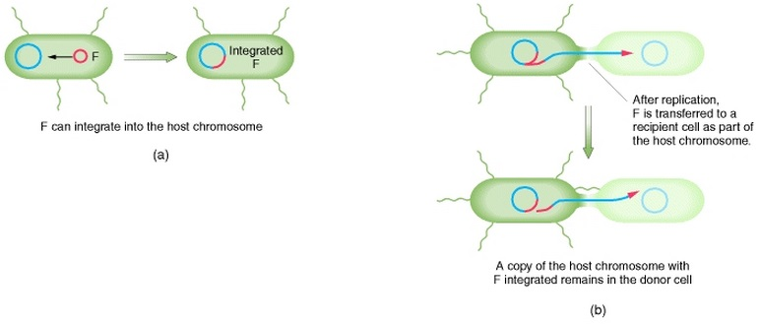

Figure 1. The Integration of F Plasmid (Griffiths)

Figure 1 above shows this point throughout conjugation in which the F+ cells donate the F plasmid. In the process, the F- recipient is then changed into an F+ cell because it receives the F genome. F+ cells do not usually make contact with other F+ cells because the F plasmid cannot be transferred from F+ to F+. The last process contains the transfer between F plasmid and host genes. F plasmid only blends into the chromosomes of a few cells. Those cells can then transfer chromosomal alleles to the second strain. The transfer is evident because the genetic recombinants made from donor and recipient alleles can be identified. The first discovery of gene transfer by conjugation was seen by the examination of recombinants (Griffiths). In a recent study, scientists determined that the transfer of plasmids in conjugation triggered a bacterial stress response also known as the SOS response in the recipient cells. The SOS initiates genome modifications. Human and animal pathogens couple with environmental bacteria that favor DNA exchange. The induction of SOS during conjugation is most likely impacting genomes. Bacterial SOS response could be labeled as a convenient target for treating infections while avoiding the transfer of antibiotic resistance (Bahargolu et al.).

Other processes such as transcription and translation are also important to understand because they describe the ways in which cells produce the proteins necessary for their upkeep. Transcription is essentially the copying of the DNA of one cell for the production of another (MacGregor). The aforementioned DNA, formally known as deoxyribonucleic acid, is simply a formation that holds all of the genes belonging to both the cell and organism ("What is DNA?”), and mRNA, or messenger ribonucleic acid, is a copy of the DNA formation that is used for cell replication. In the process, DNA's natural, double-helix formation is unwound and split in two as an RNA polymerase enzyme moves down the helix formation. Every strand of DNA has matching pairs of nucleotides – Adenine (A), Thymine (T), Cytosine (C), and Guanine (G) – that the RNA polymerase breaks the ties between in order to pair them with other nucleotides, matching G with C and A with Uracil (U) instead of Thymine. Once all of the nucleotides of the mRNA match with those of the DNA, the RNA polymerase runs down the helix formation once more to separate them (see the Figure 2 for a diagram).

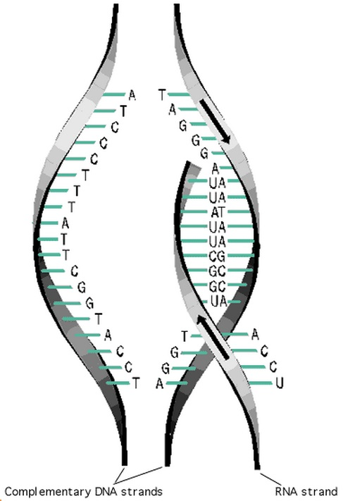

Figure 2. Transcription Process (Council-Garcia)

Figure 2 above shows a model of the transcription process. Note that the picture captures the mRNA replication and matching of nucleotides. After the mRNA leaves the nucleus of the cell and the double-helix formation of the DNA reforms, the transcription process is complete and the translation process begins (Council-Garcia).

The process of translation takes the copy of the DNA and coverts it to a protein. Translation starts with the moving of the mRNA from the nucleus, the site of transcription, to the cytoplasm. The mRNA is bound to the cell's ribosome at the start of the sequence of designated nucleotides. All the while, the different amino acids that are present amongst the interior of the cell bind to many tRNA, also known as transfer RNA which connects mRNA with amino acids. As the mRNA strand moves through the ribosome, it coordinates each trio of nucleotides with one specific amino acid through the tRNA (see Figure 3 for a model).

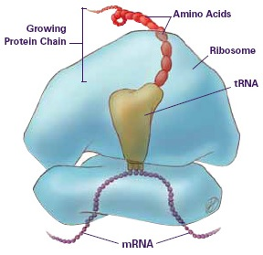

Figure 3. Translation Process (Rice)

Figure 3 above shows a model of the translation process. Note that the picture captures the amino acid production with the ribosome and tRNA strand. After many amino acids are added, the ribosome releases the newly formed polypeptide chain along with the initial mRNA. The polypeptide chain then begins to form into active protein for the cell (Rice).

However, Streptomycin is part of a group of antibiotics that interrupt the bacteria’s function of cells’ ribosomes. The interruption of ribosomes prevents the synthesis of proteins and have two parts called “subunits”. The larger subunit builds proteins and is guided by messenger RNA also called mRNA. The smaller subunit scans the mRNA and chooses the corresponding transfer RNA also known as tRNA. Streptomycin closely binds to the smaller subunit resulting in the subunit to incorrectly scan the mRNA. The bacteria are eventually killed due to the incorrect scan that caused a synthesis of random proteins. When Streptomycin is bound, the distance between two helices is decreased. This decrease is important because the helices make the decoding site, and the decoding process can only take place if the mRNA and tRNA are spaced correctly. The binding of Streptomycin causes one of the first two helices and a third helix to separate. Overall, the bonding of Streptomycin to the subunit destabilizes the unit because it disrupts the bacteria’s reproduction and life cycle (Mgrdichian).

Bacteria replicate through asexual reproduction or the reproduction of offspring through singled celled organisms. Asexual reproduction does not involve meiodid, ploidy reduction, or fertilization (“Asexual Reproduction” *Asexual*). Since there is no new genetic material produced, asexual reproduction is basically cloning. This results in the organisms being genetically identical (“Asexual Reproduction” *Princeton*). Asexual reproduction is also known as binary fission. During the process, one molecule of DNA is replicated and both molecules attach to the cell membrane. The cell membrane between the two molecules grows to about twice the original size. When the membrane reaches this size, the cell membrane then constricts. A cell wall if formed between the molecules that will divide the molecules resulting in two identical cells (Bailey).

Experiments that are similar to this have been conducted before. One example is in *The Correlation between the Inhibition of Drug Resistance and Synergism in Streptomycin and Penicillin*. The journal was recorded by biologists Morton Klein and Leonard J. Kimmelman who wrote on the forced adaptation of resistance into bacteria in times as early as 1947. The two conducted an experiment that bred and measured resistance of some of the time's most common and effective antibiotics, Streptomycin, Penicillin, and Sulfadiazine, into the bacteria Staphylococcus aureus, or the bacteria that causes the familiar staph infection. The current research contrasts to Klein and Kimmelman's because E. coli, was the tested bacteria. Although Staphylococcal infection solutions are the primary application for the current experiment, the use of the bacteria in a public, classroom setting would be too risky and possibly harmful. Also, the researchers of the past experiment simply measured the resistance amongst the bacteria, while the present researchers went the extra mile and worked to revert the bacteria back to its original state of susceptibility through the regeneration of E. coli grown without the Streptomycin treatment before the eventual reapplication of the antibiotic.

Problem Statement

Problem:

To determine whether the bacteria, E.coli, that has acquired resistance to the antibiotics, Streptomycin, over generations will maintain the bacteria’s antibiotic resistance or if the bacteria will revert back to its original state of susceptibility.

Hypothesis:

If the researchers breed Streptomycin antibiotic resistance into the E.coli sample, then the area of non-growth caused by the antibiotic will decrease after each successive day. After the antibiotic is removed from the sample on the fifth day and then placed in the sample again on the ninth day, then the area of non-growth on the ninth day will equal the area of non-growth from the first day.

Data Measured:

For the experiment, the independent variable was the application of the environmental stress, or the 10 µg dosage of Streptomycin. Because the size of the area of non-growth depended on the antibiotic presence and generation of the bacteria, the area of the zone of inhibition was the dependent variable for the experiment. Those zones were measured in centimeters and analyzed with 2 two-sample *t* tests. One test compared the first and fourth generations, the interval in which the Streptomycin was applied, to acknowledge the presence of antibiotic resistance within the bacteria sample. The other compared the first and ninth generations to test whether sudden antibiotic presence after a period of time would yield the same results as the initial application. Considering that there were three sets of nine generations, the experiment consisted of 27 total trials.

Experimental Design

Materials:

(15) 10 µg Streptomycin Disks

(27) Petri Dishes (8.5cmx1cm)

Transfer Loop

(3) 10 mL Pyrex Test Tubes

*E. coli* Sample

81 mL Distilled Water

Fisher IsoTemp 500 Series Incubator (37° C)

Black Sharpie

Bunsen Burner

Striker

(3) 10 mL Pyrex Graduated Cylinders

Procedure:

**4 Generations with Antibiotic Treatment**

1. Prepare the agar (See Appendix A: Preparation of Agar)
2. Place three Petri dishes out on the lab table.
3. On the bottom of the dish, use the sharpie to label each Petri dish as Set 1, Set 2, or Set 3 and label the dishes according to their corresponding generation (or trial number).
4. Randomize the preparation order of the sets (See Appendix B: Randomizing Trials).
5. Pour a thin layering of agar into the Petri dish that covers the bottom of the dish.
6. Pour 3 mL of distilled water into three graduated cylinders.
7. Pour one graduated cylinder of water into each test tube.
8. Light the Bunsen burner with the striker.
9. Sterilize the transfer loop with the Bunsen burner.
10. Use the loop to swab a sample of *E. coli* from the previous one by gently scraping the loop across the surface of the agar.
11. Place the transfer loop with *E. coli* into the test tube and mix the *E. coli* into the water.
12. Sterilize the transfer loop with the Bunsen burner.
13. Pour the aqueous solution of *E. coli* into the Petri dish.
14. Put the lid on the Petri dish and swish around the solution. Ensure that the liquid has covered the entire Petri dish.
15. Take off the lid and dispose of excess water in a safe way.
16. Place the Streptomycin disk in the center of a Petri dish.
17. Return the lid to the Petri dish and carefully place it in the incubator for approximately 24 hours.
18. After the 24 hours, use the ruler to measure the area and diameter of the area non-growth (See Appendix C: Measuring the Area of Non-Growth).
19. Repeat all steps three more times for each of the sets, but each time get the new sample’s *E. coli* from the previous sample’s *E. coli* by swabbing *E. coli* from the area closest to the non-growth section. **\*NOTE: Make sure the *E. coli* samples are going to the same sets. Ex: The swab from Set 1, Generation 5 will be the sample for Set 1, Generation 6*.**

**4 Generations without Antibiotic Treatment**

1. Prepare the agar (See Appendix A: Preparation of Agar)
2. Place three Petri dishes out on the lab table.
3. On the bottom of the dish, use the sharpie to label each Petri dish as Set 1, Set 2, or Set 3 and label the dishes according to their corresponding generation (or trial number).
4. Randomize the preparation order of the sets (See Appendix B: Randomizing Trials).
5. Pour a thin layering of agar into the Petri dish that covers the bottom of the dish.
6. Pour 3 mL of distilled water into three graduated cylinders.
7. Pour one graduated cylinder of water into each test tube.
8. Light the Bunsen burner with the striker.
9. Sterilize the transfer loop with the Bunsen burner.
10. Use the loop to swab a sample of *E. coli* from the previous one by gently scraping the loop across the surface of the agar.
11. Place the *E. coli* loop into the test tube and mix the *E. coli* into the water.
12. Sterilize the transfer loop with the Bunsen burner.
13. Pour the aqueous *E. coli* solution into the Petri dish.
14. Put the lid on the Petri dish and swish around the solution. Ensure that the liquid has covered the entire Petri dish.
15. Take off the lid and dispose of excess water in a safe way.
16. Place the closed Petri dish into the incubator for approximately 24 hours.
17. Repeat all steps for three more times, but each time get the new sample’s *E. coli* from the previous sample’s *E. coli*. Swab *E. coli* from the center. **\*NOTE: Make sure the *E. coli* samples are going to the same sets. Ex: The swab from Set 1, Generation 5 will be the sample for Set 1, Generation 6*.**

**Final Generation with Antibiotic Treatment**

1. Prepare the agar (See Appendix A: Preparation of Agar)
2. Place three Petri dishes out on the lab table.
3. On the bottom of the dish, use the sharpie to label each Petri dish as Set 1, Set 2, or Set 3 and label the dishes according to their corresponding generation (or trial number).
4. Randomize the preparation order of the sets (See Appendix B: Randomizing Trials).
5. Pour a thin layering of agar into the Petri dish that covers the bottom of the dish.
6. Pour 3 mL of distilled water into three graduated cylinders.
7. Pour one graduated cylinder of water into each test tube.
8. Light the Bunsen burner with the striker.
9. Sterilize the transfer loop with the Bunsen burner.
10. Use the loop to swab a sample of *E. coli* from the previous one by gently scraping the loop across the surface of the agar.
11. Place the transfer loop with *E. coli* into the test tube and mix the *E. coli* into the water.
12. Sterilize the transfer loop with the Bunsen burner.
13. Pour the aqueous solution of *E. coli* into the Petri dish.
14. Put the lid on the Petri dish and swish around the solution. Ensure that the liquid has covered the entire Petri dish.
15. Take off the lid and dispose of excess water in a safe way.
16. Place the Streptomycin disk in the center of a Petri dish.
17. Return the lid to the Petri dish and carefully place it in the incubator for approximately 24 hours.
18. After the 24 hours, use the ruler to measure the area and diameter of the area non-growth (See Appendix C: Measuring the Area of Non-Growth).

Diagram:

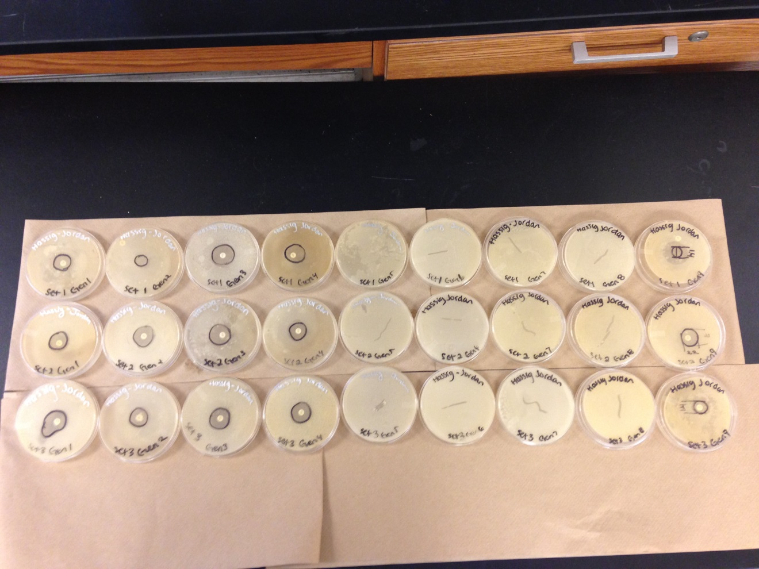Figure 4. Petri Dish Diagrams

Figure 4, shown above, models the general process of the experiment. The streptomycin disk is to be placed in the center of each of the first generation Petri dishes and, as a result, the decrease in the area of non-growth in the *E. coli* over the generations is shown. The diagram then shows where the environmental stress, the antibiotic, was removed after the fourth day. The antibiotic was placed in again after the next four days without environmental stress.

Data and Observations

The experimental process outlined the steps that were taken to collect the data. The dependent variable in the experiment was the area of the zone of inhibition, or the area of non-growth, of the *E. coli* measured in centimeters. After the researchers spent four of the bacteria's generations breeding resistance to Streptomycin into it, the bacteria was allowed to grow without the environmental stress for another four generations. Afterward, the antibiotic was applied once more to analyze whether or not the *E. coli* retained the resistance it acquired. Figure 5 shows all of the Petri dishes within the experiment with their outlined zones of inhibition.

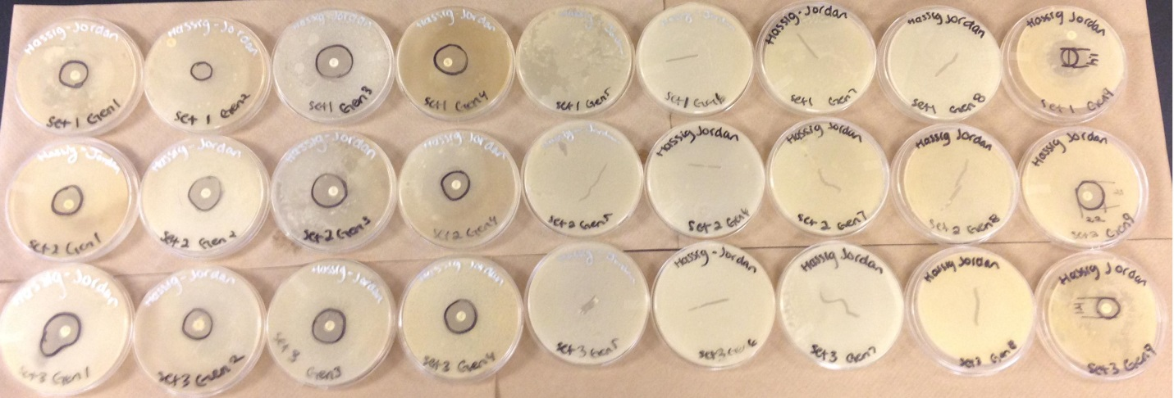

Figure 5. All Petri Dishes from the Experiment Arranged in Order of Generation

As previously stated, Figure 5 is an image of all the trials. There were three sets of data with nine successive generations. The image above shows the four days with antibiotic treatment, four days without antibiotic treatment, and the final day with antibiotic treatment. Each day was considered one generation.

Table 1

Raw Data of the Measured Areas of the Zones of Inhibition



Table 1 above displays all of the data collected during the experiment. All of the values represent the areas of the circular zones of inhibition that surrounded the Streptomycin disks. There are no data values for generation 5 through generation 8, because no data was collected since the antibiotic was not place in during those days. They were calculated using the area formula that is shown below.

$$A=πr^{2}$$

$$A=π ({d/2)}^{2}$$

In the equation, *A* represents the area of the zone of inhibition and *r* represents the radius. In the experiment, the researchers measured the diameter of the zone instead of the radius, but the *r* value may be derived from the diameter with a division by 2 as shown above. By inserting that *r* value into the equation and multiplying it by itself and the value of $π$, the area may be calculated. See Appendix C for an explanation and sample calculation.

One apparent observation of Table 1 involves the range of the data. By paying no mind to the separate sets and generations, it is clear that the range in the varying areas of non-growth seems relatively small as the lowest value was recorded in Generation 9 Sets 1 and 3 as approximately 1.5 cm2 while the highest was recorded in Generation 1 Set 3 as approximately 4.3 cm2. Even though this range appears small in comparison to the total area of a Petri dish, it caused the researchers to question the consistency of the experimental process, for the measurements were not observed in the order they were expected to be in.

By this it is meant that not all of the sets modeled the downward trend that they were expected to have from generations one through four. Each generation was expected to have an area less than that of the previous one in the same set, meaning the highest values throughout the experiment should have been from each of the sets' first generations. That would have ensured that the *E. coli* gained more and more resistance to the Streptomycin as the days went on. However, that is not the case for all of the sets, especially Set 1. The highest calculated area within Set 1 alone was measured in the third generation. In fact, most of the sets experienced a rise in the area as opposed to a fall in the third generation. This, too, leads to the questioning of the consistency of the testing process – in the third generation specifically.

Table 2

Observations Taken During the Experiment

Table 2 shows the observations taken during the experiment. After analyzing the observations and correlating them with the results of the experiment, it was discovered that in generation three there were areas on the agar of the first two Petri dishes that were not being covered as the aqueous *E. coli* solution was being applied. Because of this, the lids were opened to get a better view, and the Petri dishes were vigorously rotated to ensure that the *E. coli* would have a chance to grow on the entire surface of the agar. By taking the extra time to complete this task, the *E. coli* was allowed to begin its growth on the agar prematurely, for the Petri dishes had yet to make it to the incubator to start the generation. The results follow this observation considering that these “dry spots” appeared on the surfaces of the first two Petri dishes, Sets 2 and 1, and the increase in the area of generation three was found solely in Sets 2 and 1. With regards to the observation, it was noted that this *may* be the reason for the unexpected *E. coli* growth pattern, however there is no way to know if this was the only factor that affected the bacteria's rise in area. Note that, while the area trend is not consistent for all of the sets, the results from the ninth generation in which the Streptomycin was re-applied showed a majority of seemingly significant decreases in area. By appearance alone, the results from generation 9 seem to counter the researchers' hypothesis, as they predicted that average area of the zone of inhibition in the ninth generation would be the same as that of the first.

Throughout the trials, there were factors that the researchers kept constant so as to ensure there was consistency within the experiment’s testing process. Such observations were not included in the table above. Note that Researcher 2 sterilized all of the transfer loops, collected the samples of *E. coli* from the proceeding Petri dishes, and made observations throughout the trial process, and Researcher 1 took over and mixed the aqueous solutions, applied the solutions to the nutrient agar, and placed the Petri dishes in the incubator. Both researchers took part in set up and clean up before and immediately after the trials.

Another factor the researchers attempted to keep constant was the time intervals between testing. Table 2 clearly shows that not all of the generations were created at the exact same time every day, but for the most part each generation that was created on a weekday had a range of 22 to 27 hours to grow the bacteria. The generations that were created on Friday, however, were exposed to a growth period of three days rather than just one. This did not happen many times in the experiment, only in generations 4 and 9, but this may have had an effect on the results of the experiment.

In the few cases in which the *E. coli* had a growth period of approximately 72 hours (gen. 4 and gen. 9), two observations were made: there was more condensation inside of the Petri dishes than there would have been if the bacteria only had one day to grow, and the agar actually shrank within the dish. The researchers do not believe that these two occurrences had much of an effect on the results of the experiment, but clearly there was no way for them to guarantee this conjecture. However, they continued with the experimental process and the statistical analysis of the data.

Data Analysis and Interpretation

Throughout the experiment, control, randomization, and replication were demonstrated. The researchers randomized the data on the first day. The E.coli was randomly selected from the starter plate to be placed into the first generation of three sets. The data was randomized in order to reduce bias. The data was controlled by attempting to conduct trials at the same time every day and by making sure the petri dishes were in the incubator after completion. Controlling the experiment helps reduce effects of lurking variables. The researchers replicated the experiment by conducting three sets of the nine generations. The replication of the experiment helped make sure that the results are not just by chance alone. Using control, randomization, and replication in the experiment ensured good data. These processes helped ensure good data, because they decreased the effects of bias and lurking variables and variability that could appear in the experiment. The quantitative data collected in these generations and sets were the area of non-growth in cm2.The data for area was collected using a ruler. The diameter of the circle of non-growth was measured in order to find the area of non-growth. The data appears to be valid. The order the sets were done in was randomized to provide the most valid data to the researchers’ best ability. The data is considered to be valid since randomization reduces bias in the experiment.



Median (left)

Mean (right)

Median (right)

Mean (left)

Figure 6. Generation One and Generation Four dot plots

Figure 6 above presents the dot plots of generation one and generation four. Generation one is the top dot plot and generation four is on the bottom. Generation four is overlapped by the data generation one. The first data point in the dot plot lying at 2.544 is the only outlier for generation one. The last data point of generation four located at 3.80133 is the only outlier for that dot plot. The means and medians do not overlap between the graphs at all. The means and medians were not overlapped in the graphs which mean the data is not in the same range.



Median (right)

Mean (left)



Median (right)

Mean (right)

Figure 7. Generation One and Generation Nine dot plots

Figure 7 above presents the dot plots of generation one and generation nine. Generation one is the top dot plot and generation nine is the bottom dot plot. Generation nine and generation one is spread out from one another. The last data point of generation nine overlaps in generation one’s range. The first data point in the dot plot at 2.544 is the only outlier for generation one. The last data point of generation four located at 3.46361 is the only outlier for that dot plot. The means and medians were not overlapped in the graphs which mean the data is not in the same range.

In carrying out a statistical test for the data, two 2-sample *t* tests were used. The two samples are independent of each other. The first day and the fourth day are independent generations as well as the first and the ninth day. The first assumption of independence was met. The sample size the researchers had was three sets for each generation. Since there was nine generations, there were a total of twenty-seven trials which is the entire population size. Since the sample sizes are so small the assumption was not met, the normal probability plots are shown below in Figures 8, 9, and 10 to prove the data is normal. From looking at the probability plots, the researchers can conclude the third assumption was met since the data points do not vary that much from the normal line.

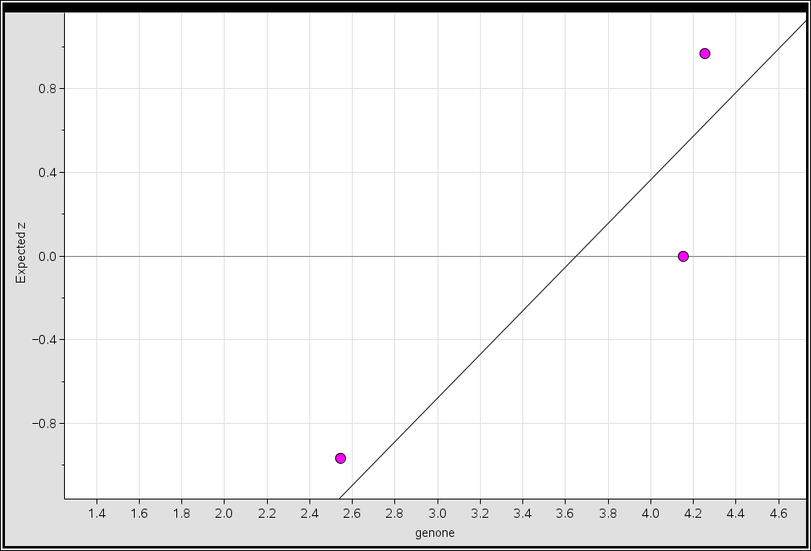

Figure 8. Generation One Normal Probability Plot

In Figure 8 above, the normal probability plot of generation one is shown. The data seems to be fairly normal since it lies near the line. The range of the expected z is small which means the points are extremely close to the line even though the image suggests they are farther away. Point two would look to be the only outlier, since it lies the farthest away from the line.

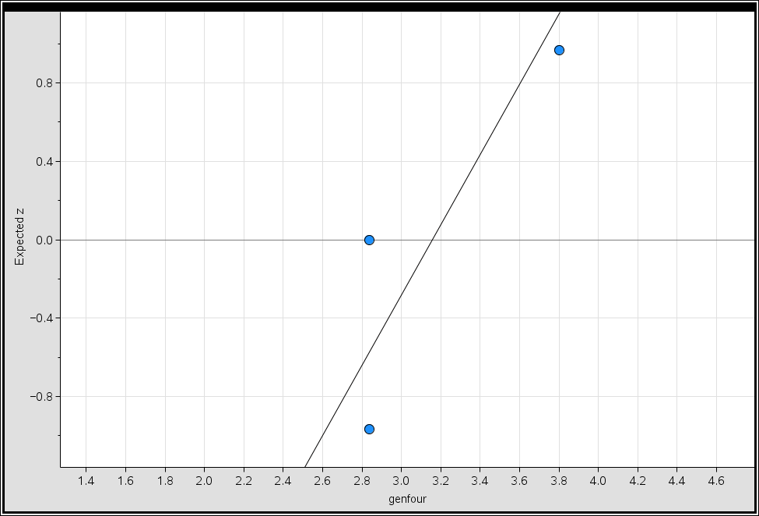

Figure 9. Generation Four Normal Probability Plot

In Figure 9 above, the normal probability plot of generation four is shown. The data seems to be fairly normal since it lies near the line. The range of the expected z is small which means the points are extremely close to the line even though the image suggests they are farther away. Point two seems to be the only outlier, since it is the farthest away from the line. With more trials, the data could be proven to be more normal.

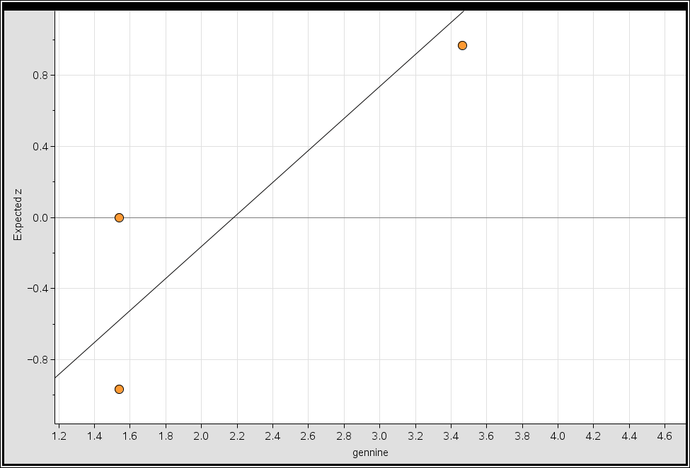

Figure 10. Generation Nine Normal Probability Plot

In Figure 10 above, the normal probability plot of generation nine is shown. The data seems to be fairly normal since it lies near the line. The range of the expected z is small which means the points are extremely close to the line even though the image suggests they are farther away. Point two which is on the zero expected z line seems to be the only outlier, since it is the farthest away from the line.

The null and alternative hypotheses of the data are shown below:

H0:  1 =2

Ha: 1 ≠ 2

The null hypothesis (H0) states that the mean of generation one (1) will be equal to the mean of generation four (2). The alternative hypothesis (Ha) states that the mean of generation one (1) does not equal to the mean of generation four (2).

To find out whether the null or alternative hypothesis is true, a two-sample *t* test was conducted. In Appendix D: Two-Sample *t* test, the sample calculation is shown. The t-value was found to be 0.770366. The p-value result of this data is 0.493756 after all the given information was inserted into the calculator. Shown below are the calculator results spread sheet and the density curve of the data.

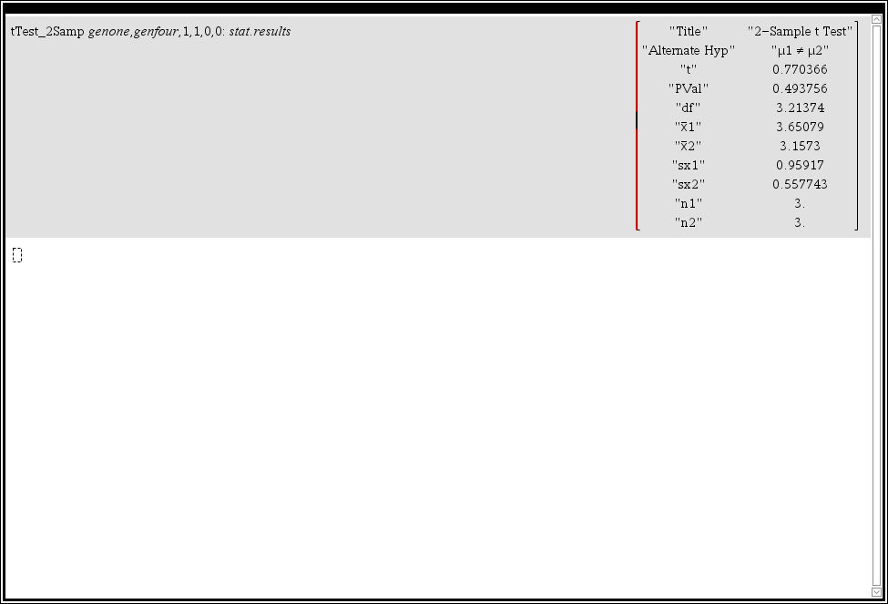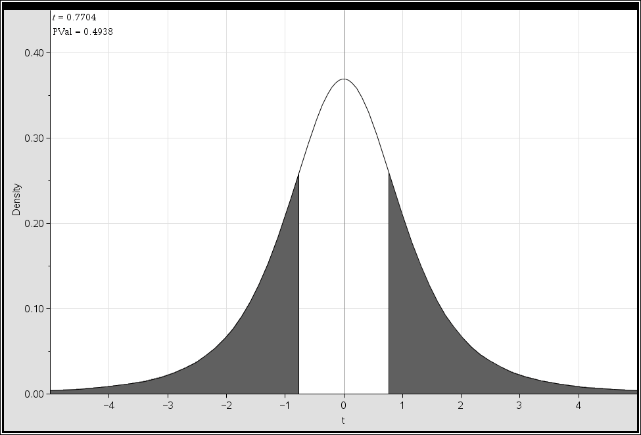

Figure 11. Two-Sample *t* test Results for Generation One and Generation Four

Figure 11 shows the results of the two-sample *t* test. The alternative hypothesis, p-value and all the data from the trials are shown. All of the numbers shown on the right are the ones that were inserted into the two- sample *t* test equation. Figure 11 above also shows the density curve of the data. The p-value shaded region is visible due to the value being so large.

In conclusion, since the p-value of 0.493756 was greater than the alpha level of 0.1, the researchers fail to reject the null hypothesis that the mean of generation one was equal to the mean of generation four. From this *t* test it can be concluded that there was no evidence that the mean of generation one was not equal to the mean of generation four. There was a 49.3756% chance that these results happened by chance alone if the null hypothesis was assumed true. The researchers are 95% confident that the population mean would lie between -1.47057 cm2 and 2.45755 cm2. Since zero, no difference is in this interval, this supports our decision of failing to reject the null hypothesis.

The null and alternative hypothesis for generation one and generation nine are shown below:

$$H_{o}:μ_{1}=μ_{2}$$

$$H_{a}:μ_{1}≠μ_{2}$$

The null hypothesis (Ho) states that the mean of generation one (µ1) equals the mean of generation nine (µ2). The alternate hypothesis (Ha) states that the mean of generation one (µ1) does not equal the mean of generation nine (µ2). The same two-sample *t* test equation used to compare generation one to generation four was also used to compare generation one to generation nine.

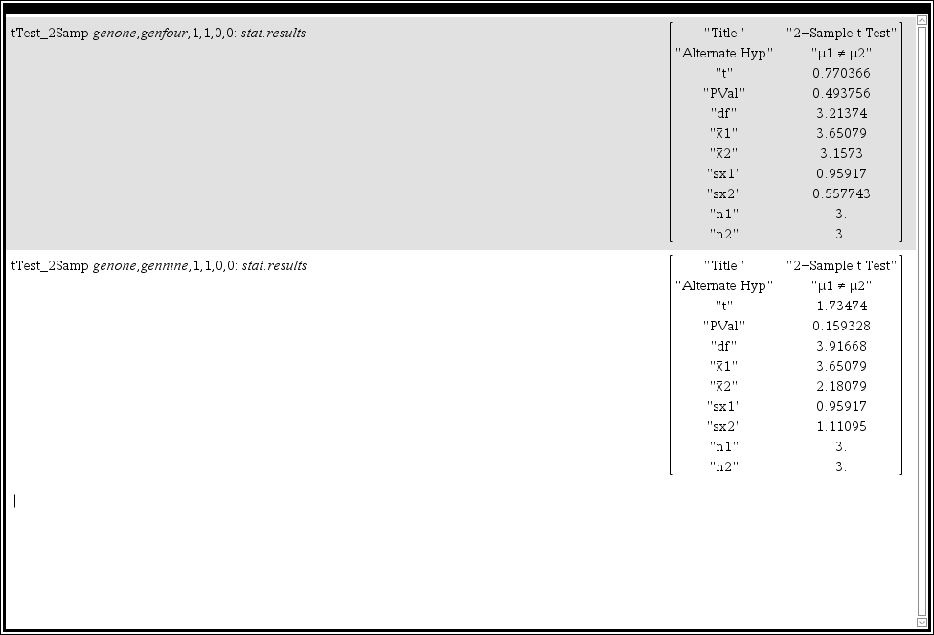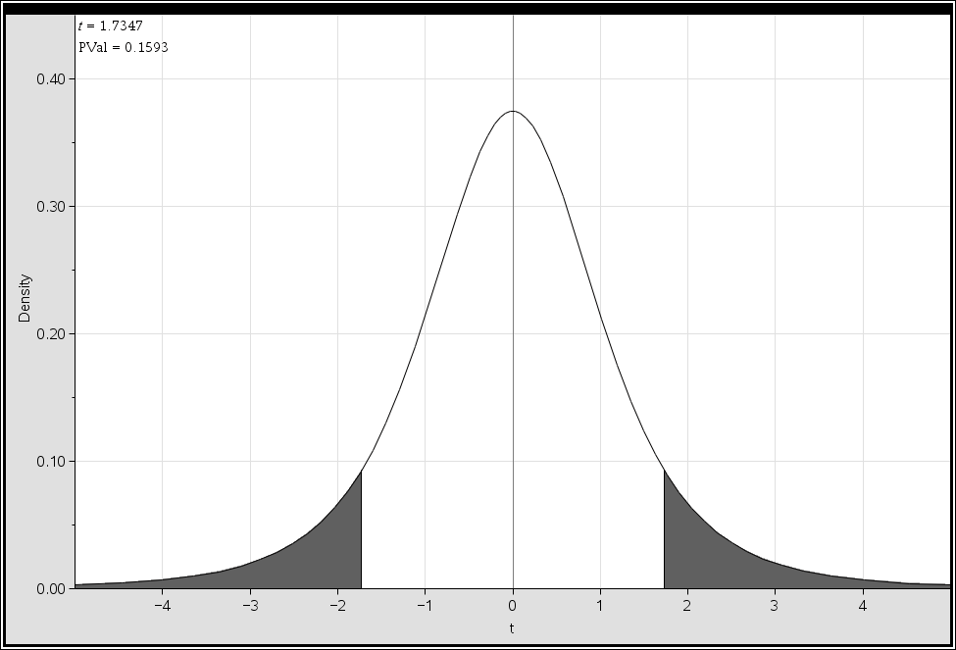

Figure 12. Two-Sample t test Results for Generation One and Generation Nine

Figure 12 shows the results of the two-sample *t* test. The alternative hypothesis, p-value and all the data from the trials are shown. All of the numbers shown on the right are the ones that were inserted into the two-sample *t* test equation. Figure 12 above also shows the density curve of the data. Since the p-value is larger, the shaded area can be seen under this curve. Based on the large p-value, it could be plausibly assumed that the results were insignificant. This could be assumed because with such a large number, the results would most likely to occur, if the experiment were to be repeated.

In summary, since the p-value of 0.159328 was greater than the alpha level of 0.1, the researchers fail to reject the null hypothesis that the mean of generation one trials equal the mean of the generation nine trials. From this *t* test, there was evidence that the means of the two generations were equal. There is a 15.9328% chance that these results happened by chance alone, if the null hypothesis was assumed true. The researchers were 95% confident that the true population mean would lie between -9.026 cm2 and 3.84261 cm2. Since zero, no difference is in this interval, this supports our decision of failing to reject the null hypothesis.

Conclusion

In the experiment conducted, antibiotic resistance was tested. The hypothesis for each test was accepted. The experiment consisted of treating an *E. coli* generation with antibiotics for four days and then taking away the stress factor for four days. After the four non-treatment days, the sample was treated with antibiotics again. The researchers tested three sets of *E. coli* samples to determine whether the bacteria, E.coli, which acquired resistance to the antibiotics, Streptomycin, over generations, maintained resistance or reverted back to its original state of susceptibility. The zone of inhibition, or area of non-growth, was measured using a ruler and then recorded. The results from the first generation and fourth generation were assessed using a two-sample *t* test. The results from the first generation and ninth generation were also assessed with a two-sample *t* test.

The hypothesis stated that if the researchers bred Streptomycin antibiotic resistance into the E.coli sample, then the area of non-growth caused by the antibiotic will decrease after each successive day. After the antibiotic is removed from the sample on the fifth day and then placed in the sample again on the ninth day, then the area of non-growth on the ninth day will equal the area of non-growth from the first day. From each two-sample *t* test the null hypothesis was accepted.

When comparing the first generation to the fourth generation, the p-value was found to be 0.493756. This result means that the mean of area of non-growth of generation four was the same size as the mean of the area of non-growth of generation one. The two-sample *t* test that compared generation one to generation nine had a p-value of 0.159328. The result of the test means that the mean of the area of non-growth of generation one was equal to the mean of the area of non-growth of generation nine. These results are similar to those in a previous experiment.

In Morton Klein and Leonard J. Kimmelman’s journal, *The Correlation between the Inhibition of Drug Resistance and Synergism in Streptomycin and Penicillin*, antibiotic resistance was also tested. The two conducted an experiment that bred and measured resistance of some of the time's most common and effective antibiotics, Streptomycin, Penicillin, and Sulfadiazine, into the bacteria Staphylococcus aureus, or the bacteria that causes the familiar staph infection. The researchers of the past experiment simply measured the resistance amongst the bacteria, while the present researchers went the extra mile and worked to revert the bacteria back to its original state of susceptibility through the regeneration of *E. coli* grown without the Streptomycin treatment before the eventual reapplication of the antibiotic. The results of the present experiment partially followed the past experiment since antibiotic resistance was successfully bred in.

Although the researchers accepted their hypothesis and received similar results as Morton Klein and Leonard J. Kimmelman’s experiment, they encountered issues that may have slightly affected the results of the experiment. As aforementioned, the zones of inhibition in generation three of all of the sets had an increase in area as opposed to the expected decrease. This outcome was most likely due to the previously mentioned lid removal. The lid was removed from the first two tested sets so that the aqueous solution would spread evenly about the agar. However this decision increased not only the amount of time that the *E. coli* spent growing in the cooler environment, but also the chances of foreign bacterial pervasion.

Because *E. coli* is a bacterium that lives within the intestines of warm-blooded animals, it grows best in environments and temperatures that model that of the body, such as the 37° Celsius incubator. When the lid was removed, the Petri dishes were exposed to the room temperature, or 22° Celsius, environment for an extended period of time. This may have affected the growth rate of the bacteria and caused the Streptomycin to treat and terminate more of the *E. coli* cells than usual, causing an increase in the areas of the zones of inhibition.

Also, as the lid was removed, the agar was exposed to not only the bacteria within the aqueous *E. coli* solution, but also the foreign, aerial bacteria. Because this experiment took place whilst others were conducting separate experiments with other bacteria, there were unknown types and amounts of bacteria within the general area of testing. This may have caused an alteration in the bacteria growth in generation three because any aerial bacteria that may have permeated the walls formed by the Petri dishes lids and sides was most likely a very common and minor strand that could be easily terminated by the presence of the Streptomycin, causing an increase in the amount of bacteria killed in and, consequently, the area of the zone of inhibition. The Petri dishes in the trials that experienced this issue did look different than the others. Both conjectures proved to be reasonable and certainly possible explanations to the flaw in the data. If given the expected outcome, the researchers would have continued to accept their hypothesis that stated that the fourth generation zones of inhibition were significantly smaller than those of the first, with the ninth generation going back to being the same size as the first generation.

There were few design flaws in the experiment. One issue was that there were opportunities to conduct the experiment with more sets, yet only three were designated. Initially, an amount of Petri dishes were chosen that would ensure that all of the sets had an equal amount of time for bacterial growth, or enough sets so that each day’s first Petri dish would not have been made at a significantly earlier time than the day’s last. Consequently, three sets were chosen to be the tested amount and there were only enough supplies ordered for that amount. However, with a few more sets and a more adequate amount of supplies, there would have been more sets to conduct to get better data. This is but one way one might further this experiment for future research.

There are many other ways to further this research experiment. Not only could future researchers extend the length of the experiment with more sets to get more conclusive data, but instead of only doing three sets over 9 days, the researchers could try to at least get in a month of data with over 10 sets of data. The plan should then be to treat the antibiotic over 15 days, and remove treatment for the next 15 days. Much like this experiment, the future experimenters should compare the first day to the fifteenth day to determine whether they bred resistance into the E.coli. On the 30th day, the researchers should add back in the antibiotic and compare the first day to the last day to see if they could successfully breed in resistance and then take it out. The more data along with a longer trial period would enhance the results of this experiment. The research would then relate more to the current work within the medical field by modeling the time period in which it would be best to keep the antibiotics in confinement from the bacterial infections.

The conducted research and experiment could, therefore, benefit researchers in the medical field. There are currently numerous bacterial infections which are resistant to antibiotics. In the United States alone, approximately 23,000 people die from antibiotic resistance each year (“Antibiotic/Antimicrobial Resistance”). By taking these results into consideration, patients with antibacterial infections could be treated in a way that not only proves to be more effective, but also is more cost efficient. Instead of the constant application of antibiotics, such as Streptomycin, along with hopes that patients would show improvement, antibiotic resistance within bacteria could simply be decreased by containing the antibiotics. With both these plans and the results of this research, today’s world-wide problem could become tomorrow’s resolved issue.

Acknowledgements

We would like to thank Mr. Estapa for assisting throughout the entire project.

We would like to thank Mrs. Cybulski for answering any questions we had throughout this project.

We would like to thank Mrs. Kendall Hassig for answering our questions about antibiotic resistance in the medical field.

Appendix A: Preparation of Agar:

Materials:

23 g Carolina Nutrient Agar

Stirring Rod (4.7cm x 0.8cm)

1000 mL Flask

Corning Stirrer/Hotplate

Tap Water

Procedure:

1. Measure out 23 grams of agar
2. Mix 23 grams of the agar mix in one liter of tap water in the flask until evenly dispersed
3. Insert the stirring rod into the flask
4. Boil until completely dissolved

Appendix B: Randomizing Trials

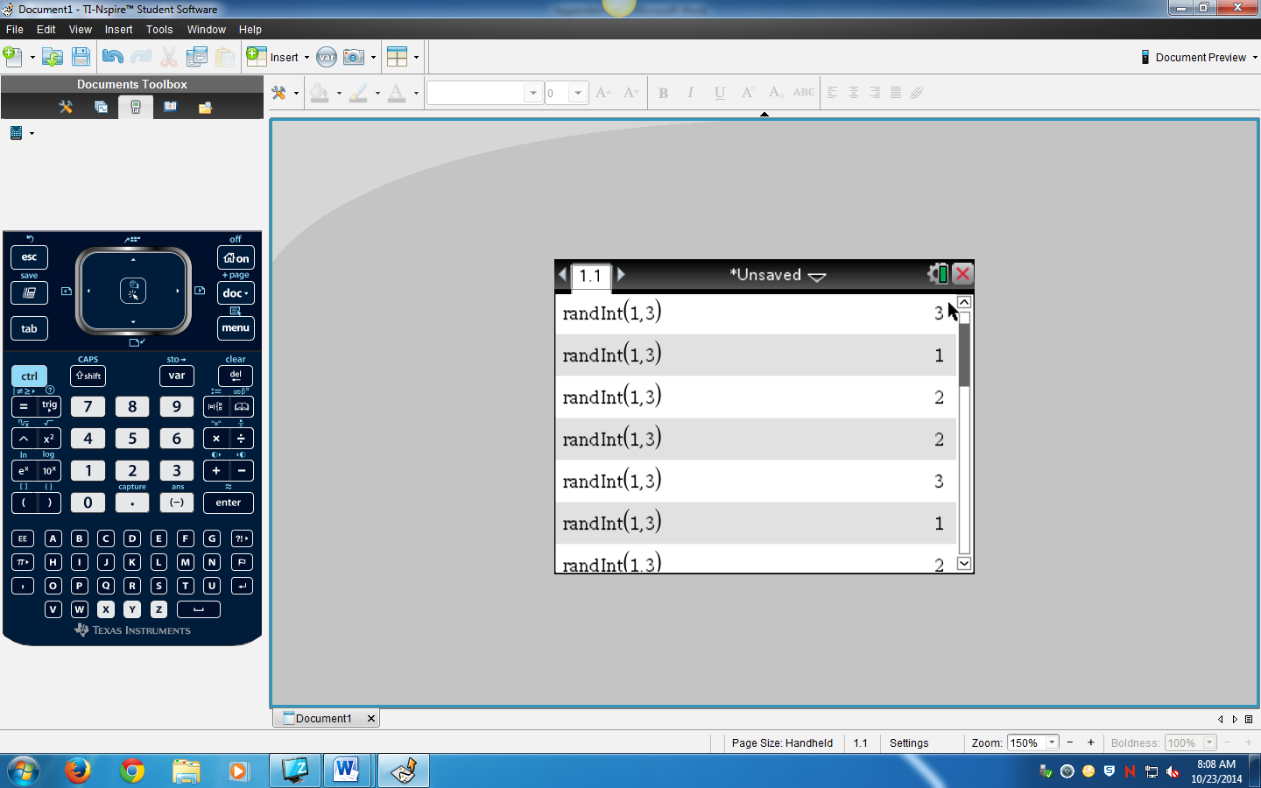

Figure 13. Screenshot of Sample Randomization

Figure 13 shows a screenshot of a TI-Nspire calculator page where a sample randomization occurred. The random integer function was used by going to the menu, probability, random, and integer. Then, a one and three were inserted into the parentheses to signify that the random numbers started with one and ended with three. Therefore, either any number between a one and three would be chosen at random. The number chosen represented in which order the sets would be completed each day. The process of finding the order of trials was repeated each day.

Appendix C: Measuring the Area of Non-Growth

Materials:

Ruler

TI-Nspire CX Calculator

Petri Dish with Antibiotic

Black Sharpie

Procedure:

1. Flip over the Petri dish so it’s on its lid and the area of non-growth in the *E. coli* is clearly seen around the Streptomycin disk
2. Carefully observe the area of non-growth and place a ruler along its diameter. **\*This area should be in the shape of a circle\***
3. Measure this diameter in centimeters and record it.
4. Follow the equation in Figure 14 to calculate the area.

$$A=πr^{2}$$

$$r= \frac{Diameter}{2}$$

$$A={π(\frac{Diameter}{2})}^{2}$$

Figure 14. Equation to calculate the area of non-growth

Once the measured diameter is divided by two, substitute it into the equation. The area is measured in centimeters squared.

Appendix D: Two-Sample *t* test

To find out whether the null or alternative hypothesis is true, the researchers conducted a two-sample *t* test. The first step in this test is to find the t-value. The equation to find this is shown below:

$$t= \frac{(\overline{x_{1}}-\overline{x_{2}})}{\sqrt{\frac{{s_{1}}^{2}}{n_{1}}+\frac{{s_{2}}^{2}}{n_{2}}}}$$

The equation above demonstrates how to find the t value for the two-sample *t* test. The t-value can be found be the difference of means divided by the square root of the standard deviation of generation one squared divided by the sample size added to the standard deviation of generation nine squared divided by that sample size. A sample calculation is shown below.

$$t= \frac{(\overline{x_{1}}-\overline{x_{2}})}{\sqrt{\frac{{s_{1}}^{2}}{n_{1}}+\frac{{s_{2}}^{2}}{n_{2}}}}$$

$$t= \frac{(3.65079-2.18079)}{\sqrt{\frac{{0.95916962082331}^{2}}{3}+\frac{{1.1109523990817}^{2}}{3}}}$$

$$t=\frac{3.65079-2.18079}{0.847392}$$

$$t= \frac{1.47}{0.847392}$$

$$t=1.73474$$

Figure 15. Sample Calculation for Two-Sample *t* test

Figure 15 demonstrates how to find the t value for the two-sample *t* test. The t-value can be found be the difference of means divided by the square root of the standard deviation of generation one squared divided by the sample size added to the standard deviation of generation nine squared divided by that sample size. The t-value of the area of non-growth of generation one and generation nine is 1.73474.

Appendix E: Confidence Interval

The researchers conducted a confidence interval to determine where the true mean lies. The equation for the confidence interval is displayed below.

(x1 − x2) ± t* ×

The confidence interval is found by the difference of means added and subtracted to the t* multiplied by the square root of the standard deviation of generation one squared divided by the sample size added to the standard deviation of generation nine squared divided by that sample size.

(x1 − x2) ± t* ×

± t* x

1.47 ± 2.3726104232346

Figure 16. Confidence Interval

Figure 16 shows the confidence interval between generation one and generation nine. The researchers are 95% confident that the true population mean of the data will fall between -9.026 cm2 and 3.84261cm2.

Works Cited

“Antibiotic / Antimicrobial Resistance.” Centers for Disease Control and Prevention. Centers for Disease Control and Prevention, 06 Aug. 2014. Web. 21 Sept. 2014. <http://www.cdc.gov/drugresistance/>

"Antimicrobial (Drug) Resistance." *Gram-Negative Bacteria*. National Institute of Allergy and Infectious Diseases, 30 Apr. 2012. Web. 04 Oct. 2014. <http://www.niaid.nih.gov/topics/antimicrobialresistance/examples/gramne gative/Pages/default.aspx%5C>.

"Asexual Reproduction." *Asexual Reproduction*. N.p., n.d. Web. 02 Oct. 2014. <http://www.ucmp.berkeley.edu/glossary/gloss6/asexual.html>.

"Asexual Reproduction." *Princeton University*. N.p., n.d. Web. 03 Oct. 2014. <https://www.princeton.edu/~achaney/tmve/wiki100k/docs/Asexual_reprod uction. html>.

Bahargolu, Zeynep, David Bikard, and Didier Mazel. "Conjugative DNA Transfer Induces the Bacterial SOS Response and Promotes Antibiotic Resistance Development through Integron Activation." *PLOS Genetics:*. N.p., 21 Oct. 2010. Web. 03 Oct. 2014. <http://www.plosgenetics.org/article/info%253Adoi%252F10.1371%252Fjo urnal.pgen.1001165>.

Bailey, Regina. "How Bacteria Reproduce:." About. N.p., n.d. Web. 02 Oct. 2014. <http://biology.about.com/od/bacteriology/a/aa080907a.htm>.

Charleroy, M.L. "Bynum, Helen. Spitting blood: the history of tuberculosis." CHOICE: Current Reviews for Academic Libraries Sept. 2013: 113. Academic OneFile. Web. 22 Sept. 2014. <http://go.galegroup.com/ps/i.do?id=GALE%7CA343155831&v=2.1&u=lo m_accessmich&it=r&p=AONE&sw=w&asid=eb60eaaf8f84a04512b74f2fb0 092477>

Council-Garcia, Cara Lea. "Transcription and Translation." *UNM Biology Undergraduate Labs*. The University of New Mexico, n.d. Web. 02 Oct. 2014. <http://biology.unm.edu/ccouncil/Biology_124/Summaries/T%26T.html>.

"E. Coli Definition." *Diseases and Conditions*. Mayo Clinic, n.d. Web. 25 Sept. 2014. <http://www.mayoclinic.org/diseases-conditions/e- coli/basics/definition/con-20032105>.

Griffiths, Anthony JF. "Bacterial Conjugation. U.S.National Library of Medicine, 17 Jan. 0099. Web. 2 Oct. 2014. <http://www.ncbi.nlm.nih.gov/books/NBK21351/>.

Klein, Morton, and Leonard J. Kimmelman. "The Correlation between the Inhibition of Drug Resistance and Synergism in Streptomycin and Penicillin."*Journal of Bacteriology* 54.3 (1947): 363-70. American Society of Microbiology. American Society of Microbiology, July 2006. Web. 9 Sept. 2014. <http://jb.asm.org/content/54/3/363.full.pdf>.

MacGregor, Alanna. "The Basics: Transcription." *Microbial Genetics*. Acadia University, n.d. Web. 30 Sept. 2014. <http://plato.acadiau.ca/courses/biol/Microbiology/Transcription.htm>.

Mgrdichian, Laura. "BNL Newsroom | Molecular Structure Reveals How the Antibiotic Streptomycin Works." N.p., 5 Sept. 2013. Web. 21 Sept. 2014.

<http://www.bnl.gov/newsroom/news.php?a=24251>.

"National Strategy to Combat Antibiotic-Resistant Bacteria." Centers for Disease Control and Prevention, 22 Sept. 2014. Web. 1 Oct. 2014. <http://www.cdc.gov/drugresistance/national-strategy/>.

"Objectives -Theory -Principle." *Virtual Amrita Laboratories Universalizing Education*. Amrita Vishwa Vidyapeetham University, n.d. Web. 29 Sept. 2014. <http%3A%2F%2Famrita.vlab.co.in%2F%3Fsub%3D3%26brch%3D77%2 6sim%3D1107%26cnt%3D1>.

Rice, George. "Translation: Messenger RNA Translated Into Protein."*Microbial Life Educational Sources*. National Science Digital Library, 15 Dec. 2013. Web. 29 Sept. 2014. <http://serc.carleton.edu/microbelife/research_methods/genomics/translat. html>.

Vision:. *NATIONAL STRATEGY FOR COMBATING ANTIBIOTIC- RESISTANT BACTERIA* (2014): n. pag. *White House*. Sept. 2014. Web. 1 Oct. 2014. <http://www.whitehouse.gov/sites/default/files/docs/carb_national_strategy .pdf>.

"What Is DNA?" *Genetics Home Reference*. United States National Library of Medicine, 29 Sept. 2014. Web. 30 Sept. 2014. <http://ghr.nlm.nih.gov/handbook/basics/dna>.