Introduction
Hunters in Michigan spent 9.4 million days afield in 2012, according to a survey taken by the Michigan Department of Natural Resources (Frawley). There were approximately 650,000 hunters total, which comes out to each hunter spending about 14 days hunting. If a hunter is to spend 14 days hunting, some of those days probably being vacation days, he/she would definitely want to be successful and have some kills. What if a better way to hunt could be developed, with new ways to hold a gun? What if this way could increase targeting accuracy? The results from this research experiment can help hunters improve their techniques, especially those who use BB guns or air guns.
The research conducted focuses on whether or not the angle and height of launch affect the launch of a projectile. It used a homemade launch mechanism that harnessed the power of compressed air to launch darts. It tested whether the height of launch or the angle of launch affected how far the projectile went. The dart was shot from the launcher from different combinations of angle and height and the distance it was projected was measured. The distance measured determined the significance of the factors. This deals with the topic of projectile motion. Projectile motion is the motion experienced when an object is thrown, dropped, or launched. Bullets, pellets, and BBs are all projectiles, and when they are launched from guns, they follow the same parabolic path as the darts in this experiment. The homemade launch mechanism simulated a BB gun or air rifle and the darts signified the pellets or BBs. BB guns, air rifles, and the launcher all use compressed air to launch their respective projectiles. Therefore, the results of whether or not the angle and height of launch affect the horizontal distance a projectile travels can help hunters. It can help them determine how to shoot their guns to get the level of accuracy they desire. The results could help the hunters determine whether the use of a tree stand would be beneficial, or determine if it would be better to just hunt from a blind on the ground. The results would also help the hunters to determine what angle is best to shoot the BB gun or air rifle at in order to hit a long range target, in this case an animal.
There are two air gun events in the Olympics. The 10m air pistol and 10m air rifle. Both competitions are available for men and women, although men fire 60 shots while women only fire 40. During the air pistol and air rifle events, participants shoot the prescribed number of shots from 10 meters away from the target. The event was debuted in the 1984 Summer Olympics and has been at every Summer Olympics since (10 m Air Rifle (60 Shots) Men). The research conducted dealing with height and angle of shot could help hopeful Olympians perfect their shooting stance.
Hunting and the Olympics are two things the majority of the world share. Improving the way two events in the Olympics and the way people hunt is a very beneficial and noble feat. This research would help complete that task. Projectile motion is the key to unlocking a better way to shoot an air rifle or BB gun.

Review of Literature
By definition, a projectile is an object that moves in two dimensions upon which the only force acting is gravity (“What is a Projectile”). If an object is dropped from rest or thrown upward, it is a projectile. Therefore, projectile motion is the motion experienced when said object is dropped or thrown. Projectiles travel in a parabolic path (Davis). The parabolic path is caused by gravity acting on the object to make it experience free fall. The object is experiencing the velocity from the toss on the way up, and then is pulled back down by gravity. Projectile motion is a combination of vertical motion with constant acceleration and horizontal motion with constant velocity (Davis). The motion can be witnessed by the human eye when a ball is tossed.
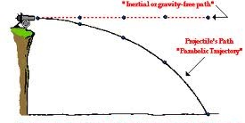

Figure 1. Projectile Motion
Figure 1 shows projectile motion. When a projectile, in this case a ball, is launched, gravity drags it down to create a parabolic path. If there was no gravity, a projectile would go in a straight line, as shown by the dotted line.
The distance a projectile travels is affected by many factors. Some of the factors include projection angle, projection speed, and projection height. The angle of projection affects the range of the projectile’s motion because it determines the shape of the parabolic path a projectile takes. The smaller the angle from the ground, the path of motion becomes more horizontal. Vice versa, when the angle is larger, the path of motion is more vertical. When the projectile has speed when it is released, it affects how far the projectile goes because that speed propels the object to go farther. When the speed of projection is constant, a higher height creates a longer flight time for the projectile. A longer flight time then increases the distance a projectile travels. Gravity also affects projectile motion because it is a constant force that always pulls the projectile down to the ground (Smith).
Aristotle’s theory of motion discusses his beliefs that projectiles are acted upon by an external force that is transmitted through the air. Aristotle and his supporters believed that the projectile took a path of two consecutive straight lines. Galileo looked into Aristotle’s theory after cannon warfare became prominent. The cannons showed the projectiles moving in a parabolic path: not a path of two consecutive straight lines. Galileo used an inclined plane to test out his theory of projectile motion. He changed the ball’s horizontal velocity and distance the ball was dropped to test his theory of projectile motion. In the act of completing this experiment, Galileo proved his theory that projectiles moved in a parabolic path (Jennings).
Galielo’s theory of projectile motion can be seen in everyday activities, such as sports. One sport that projectile motion can be seen in quite frequently is football. When a football is thrown, the ball takes the shape of a parabolic path. In the sport of football, gravity makes long-range passes very difficult. The use of formulas and many experiments using the theory of projectile motion can determine a way to make long range passes easier (“How Should You Launch a Ball to Achieve the Greatest Distance?”).
Several experiments were reviewed in order to grasp a deeper understanding of how to format the experiment at hand. However, one stood out as being the most similar to the current experiment. This experiment, performed by fellow high school students Hoopes, Shauklas, and Young, used pneumatic cannon to shoot Nerf darts at varying angles. It used a bicycle tire pump to fill a cannon with air. That air then shot the dart from the cannon when the pressure-release valve was opened (Hoopes, Shauklas, and Young). The researchers used a bicycle pump to propel the Nerf dart, but the current experiment used a Super Soaker gun instead of a bicycle pump to provide the compressed air used to launch the dart. The reviewed experiment used ten angles and that was the only variable. This slightly differs from the project at hand because it only used three angles and added another factor; height.
In a prior experiment, a group of researchers used projectile motion to determine the landing spot of the Nerf dart. The group of Ismail, King, Matasci, Paulius, and Smith, five students at the University of Notre Dame, used the theory and equations of projectile motion to find the Nerf dart’s landing point. The researchers did many trials to test their calculations. They then found the probability of figuring the correct landing spot. Using the projectile motion equations, the researchers ended up with finding the spot correctly a large portion of the time. The research group used a tripod as a launcher and attached the Nerf gun to the top (Ismail, King, Matasci, Paulius, and Smith). The experiment is similar to the current experiment. In this case, the two research groups both used Nerf darts and some sort of compressed air pump. In the groups experiment, they used an actual Nerf gun to project the dart while the current experiment used a PVC pipe and Super Soaker gun to launch the dart. The groups also determined how the angles affect the distance. The Nerf darts were used in both experiments, current and past.
Another reviewed experiment tested different types of Nerf guns and different types of Nerf darts. The experiment, performed by O’Neil and Drueen, two Nerf gun enthusiasts, compared dart accuracy and range with three different types of darts and two guns; two were modified and two were unmodified. After looking at several distributions of the data and using the Analysis of Variance statistical analysis, it was determined that the orange Nerf Elite darts had the greatest level of accuracy whether they were used in modified or unmodified guns (O’Neil and Drueen). This project is similar to the current experiment because in said experiment, the “mega” version of the orange Nerf Elite darts is used. However, this experiment used Nerf brand guns while the current experiment used guns that are original creations.
All three reviewed experiments were fairly similar to the current experiment. The results from the experiments did not lead the researchers to a concrete idea of what would happen in their experiment. Therefore, the previous experiments did not help them create their hypothesis. The researchers made an educated guess instead.

Problem Statement
Problem Statement:
To determine the effect of the height of launch and the angle the Nerf dart is fired at on the distance of projection.
Hypothesis:
If the researchers use the standard angle of 45º and highest height, 22 inches, of launch, then the Nerf dart will go farther than with any other combination of factors.
Data Measured:
The data measured was the distance the Nerf dart was shot. The distance was the dependent variable. The height of the launcher and angle of the launch were the independent variables. This data was measured using a tape measure (in inches) and measuring the distance from the launch site to where the Nerf dart landed. The Nerf dart’s end was painted so it left a paint spot on the paper to determine exactly where the Nerf dart landed. The researchers conducted four runs of a Two Factor DOE.

Experimental Design
Materials:

(2) Milk crates; 11 in. tall Roll of duct tape
Tape measure; at least 20 feet (4) Zip ties
Launcher Bottle of water-soluble paint

NERF® N-Strike Elite Mega Dart

Refill Pack

Procedure:
- Build launcher (see appendix A).
- Randomize the trials on a TI inspire calculator (see appendix B).
- Set up experiment according to trial number: adjust the number of milk crates in accordance to the experiment and adjust the launcher to the correct angle.
- Lay a strip of duct tape on the floor to mark where the launcher should begin during every trial.
- Dip tip of the dart in paint.
- Set dart in launcher.
- Pull back on Super Soaker attached to launcher to pressurize air.
- Push the handle of the Super Soaker in quickly to launch dart.
- Measure the distance the dart went with a tape measure.
- Use a wet paper towel to clean up the paint spot.
- Record the distance of the dart in data tables.
- Repeat for all trials.
- Clean up lab area after all trials are completed.

Super Soaker
Diagram:
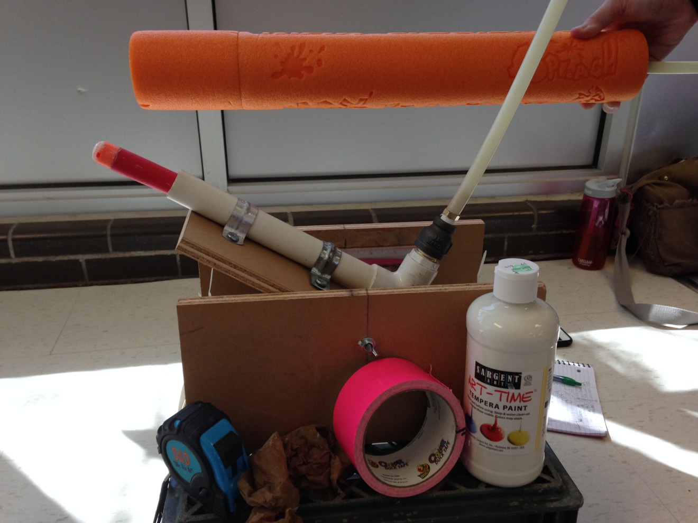
Wet Paper Towel
Tape Measure
Dart
Duct Tape
Paint
Launcher
Figure 1. Diagram of Experiment

Figure 1 shows the set-up of the researchers’ experiment. First the researchers painted the tip of the dart. The researchers then inserted the painted dart into the launch tube, pulled back on the Super Soaker, and pushed the handle on the Super Soaker all the way in to launch the dart. The dart then followed a parabolic path through the air and landed on the ground. The paint on the tip of the dart marked the dart’s exact landing point. The researchers then used the tape measure to measure the distance from the launch point to the paint mark and cleaned the paint mark off the ground with a paper towel.

Data and Observations
Table 1
Distance Data from 2 Factor DOEs
DOE | +, + | +, - | -, + | -, - | standard 1 | standard 2 | standard 3
1 | 131.5 | 192 | 157 | 195 | 240.5 | 240 | 239.5
2 | 131 | 182 | 165 | 198 | 240 | 241.5 | 239.5
3 | 131 | 184 | 169 | 194.5 | 240.5 | 241.5 | 241.5
4 | 130 | 187 | 170 | 200 | 240 | 240.5 | 240

Table 1 shows the data collected by the researchers all four DOEs. The order of the trials was randomized using the randomization function on the TI-Nspire calculator. An example of randomization can be seen in Appendix B.
Table 2
Observations from 2 Factor DOEs
Trial | DOE | Date | Observations
1 | 1 | 5/2/2014 | Researcher 1 launched
2 | 1 | 5/2/2014 | Researcher 1 launched
3 | 1 | 5/2/2014 | Researcher 1 launched
4 | 1 | 5/2/2014 | Researcher 1 launched
1 | 2 | 5/2/2014 | Researcher 1 launched
2 | 2 | 5/2/2014 | Researcher 1 launched
3 | 2 | 5/2/2014 | Researcher 1 launched
4 | 2 | 5/2/2014 | Researcher 1 launched
1 | 3 | 5/2/2014 | Researcher 1 launched
2 | 3 | 5/2/2014 | Researcher 1 launched
3 | 3 | 5/2/2014 | Researcher 1 launched
4 | 3 | 5/2/2014 | Researcher 1 launched
1 | 4 | 5/2/2014 | Researcher 1 launched
2 | 4 | 5/2/2014 | Researcher 1 launched
3 | 4 | 5/2/2014 | Researcher 1 launched
4 | 4 | 5/2/2014 | Researcher 1 launched

Table 2 shows the observations taken during all of the DOEs. As shown, no irregular observations were taken. Researcher 1 launched the dart in all trials in attempt to keep the data consistent.
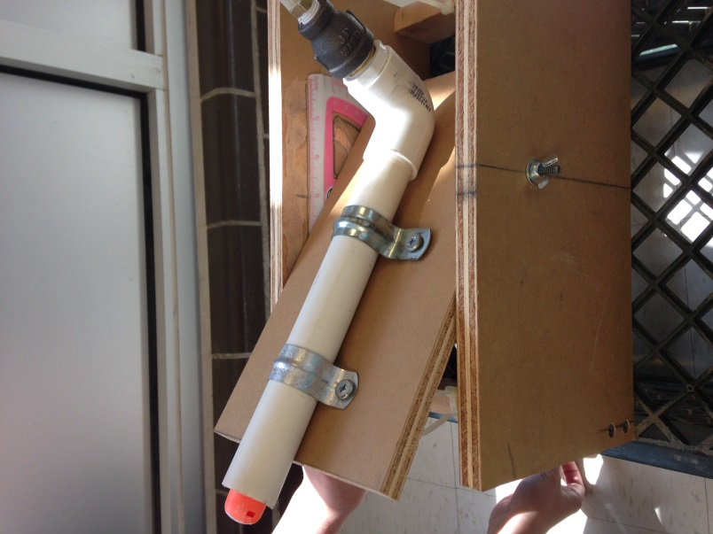
Crates
Protractor
Nerf Dart
Figure 1. Set-up of Launcher
Figure 1 shows that researcher 2 placed the dart into the PVC pipe, adjusted the height using crates, and then adjusted the launch pad aim at the correct angle.
Super Soaker
Figure 2. Set-up of Super Soaker
Figure 2 shows that researcher 1 pulled back the handle all the way and then pushed in the handle quickly in order to launch the dart.
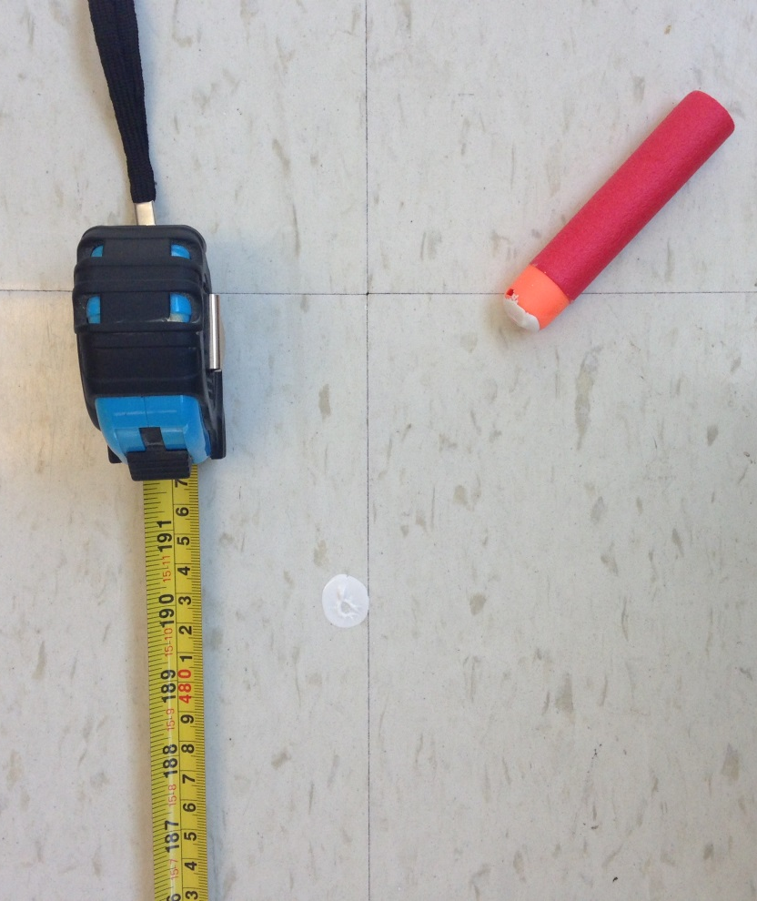
Nerf Dart
Tape Measure
Paint Spot
Figure 3. Set-up of Measurement
Figure 3 shows that researcher 1 held the top of the tape measure at the launching point and researcher 2 took the tape measure to the white paint spot on the ground. Researcher 1 recorded the data of the darts distance in inches.

Data Analysis and Interpretation
In the experiment, angle and height were changed in order to measure their effect on the distance of launching a Nerf dart. The distance data was collected by launching the dart using a launcher and then measuring how far the dart went with a tape measure.
Table 3
Factors of DOE
Angle of Launch(º degrees) |  |  | Height of Launch (inches)
- | Standard | + | - | Standard | +
30 | 45 | 60 | 0 | 11 | 22

Table 3 shows the two factors of this experiment including the low, standard, and high values.
Table 4
Averages
Runs |  | First DOE | Second DOE | Third DOE | Fourth DOE | DOE  AVERAGE
+ | + | 131.5 | 131 | 131 | 130 | 130.9
- | - | 195 | 198 | 194.5 | 200 | 196.9
+ | - | 192 | 182 | 184 | 187 | 186.3
- | + | 157 | 165 | 169 | 170 | 165.3

Table 4 shows the averages from all four of the DOEs. Each trials average was put into the chart and then all four were averaged out. The grand average of all of the trials and DOEs was 169.85.
Height
Figure 4. Height vs. Distance Graph
Figure 4 displays the graph of height vs. distance. On average, as height increases, distance decreases by 22.6 inches. The effect of height is -11.3.
Table 5
Height Factor Values
Height
- | +
165.3 | 130.9
196.9 | 186.3
Avg = 181.2 | Avg = 158.6
Table 5 shows the height factors on distance. On average, the higher value of height goes a shorter distance than the lower height values.

Angle
Figure 5. Angle vs. Distance Graph
Figure 5 displays the graph of angle vs. distance. On average, as angle increases, distance decreases by 43.5 inches. The effect of angle is -21.75.
Table 6
Angle Factor Values
Angle
- | +
186.3 | 130.9
196.9 | 165.3
Avg = 191.6 | Avg = 148.1

Table 6 shows the angle factors on distance. On average, the higher value of angle goes a shorter distance than the lower angle values.

Height (+)

Height (-)

Angle
Figure 6. Interaction Effect of Angle and Distance
Figure 6 presents the interaction graph of angle and height. The interaction effect was 11.9. Since the graphs do not have the same slopes, there is a possibility of an interaction.
Table 7
Interaction Effect of Height and Angle
 |  |  | Angle
 |  |  | (-) | (+)
 | Line segment (solid) | (+) | 186.3 | 130.9
 | Line segment  (dotted) | (-) | 196.9 | 165.3

Height

Table 7 shows the average times of the factors. The height factor values were on the left side of the table and the angle factor values were on the top of the table. The two lines were graphed and used to determine whether or not the combination of height and angle affected the distance of the dart.

Figure 7. Twelve Standards
Figure 7 displays the twelve standards from all four of the DOEs. The standards remain mostly constant. The values only vary by, at most, 2 inches. Since the standards do not vary by much, this suggests that the experiment conducted was consistent.
Table 8
Twelve Standards
240.5 | 240 | 239.5 | 240.5 | 241.5 | 239.5 | 240.5 | 241.5 | 241.5 | 241 | 240.5 | 240
Twelve Standards

Table 8 displays the twelve standards. Three standards were done at the beginning, middle, and end of each of the four DOEs.

Figure 8. Dot Plot of Effects
In Figure 8, the dot plot of effects is shown. Each of the values graphed are positive because the absolute value of the effects were taken. The effect of height was -11.3. The effect of angle was -21.75. The interaction effect between angle and height was 11.9. To find out if the effects were significant, the researchers multiplied the range of standards by two; any effect greater than that amount was considered significant. The researchers’ range of standards was two. When multiplied by two, the researchers received four as the marker for significance. All of the effects are above this significant marker. All of the effects that are considered significant in the experiment include: height, angle, and the interaction of height and angle. See Appendix C for the parsimonious prediction equation of these results.

Conclusion
In the experiment conducted, projectile motion was studied. It tested whether or not the height and angle of launch affected the distance a Nerf dart went. The experiment consisted of a homemade launch mechanism which was used to launch a dart (See Appendix A for instructions about the launch mechanism). The researchers adjusted the angle and height of the dart to determine if either factor had a significant effect on the distance the dart was projected. The darts distance after being launched was measured using a tape measure and then the measurement was recorded. The measurements were averaged out and then assessed using a DOE to find out if the factors affected the distance. The DOE results presented that the factors of angle and height were significant, meaning they both had an effect on the distance the dart was launched.
The hypothesis was not supported, and therefore rejected. The researchers hypothesized that if the the highest angle of 60º and highest height, 22 inches, of launch were used, then the Nerf dart will go farther than with any other combination of factors. The hypothesis was not supported because the largest distance the dart was projected was not caused by the greatest height and greatest angle. Instead, when the launcher was set with the lowest height and lowest angle, the greatest distance was observed.
The results here occurred because of the basic theories of projectile motion. The lowest height and lowest angle caused the greatest distance out of all of the combinations of height and angle, 196.88 inches, because the horizontal projection is the greatest and the vertical projection is the lowest with these factors. When there is a low height and a low angle, the projectile will go far and low. This is because vertical projection is increased, therefore horizontal projection is decreased. The 30º angle creates a 30º vertical angle and a 60º horizontal angle, which results in a greater horizontal height than vertical height. The high height and low angle combination created the second longest distance on average, 186.25 inches. The 30º angle creates a 30º vertical angle and a 60º horizontal angle, which results in a greater vertical height than horizontal height. However, when there is a high height, it increases vertical distance and decreases horizontal distance. The low height and high angle had the third longest distance, 165.25 inches. These factors together created this distance because when there is a low distance and a high angle, there will be more vertical and less horizontal projection than when there is a low angle, but there will still be more horizontal projection than if it was a high height. The 60º angle creates a 60º vertical angle and a 30º horizontal angle, which results in a greater vertical height than horizontal height. This brings us to the combination of factors with the lowest distance; high height and high angle. High height and high angle had a distance of 130.86 inches, which is 66 inches less than low height and low angle. This occurred because when there is a high height, a higher angle will provide more vertical projection because it is projected more vertically than horizontally. The standard overall had the best projection. On average, the standard went 240.42 inches. The standard was the best by far because a 45º angle is optimum for a long projectile motion. A 45º angle creates the maximum range for a projectile because since the sum of the vertical and horizontal angles must be 90º, if they are equal they will be equidistant and create the longest distance. This is a fact proven in previous research done by both the researchers and other scientists. The results found in this experiment are very similar to those of known facts about the field. The distances associated with each factor go along with what experts have already determined are the predicted results (Cordry). These results further prove that existing models for projectile motion are true.
The researchers found no design flaws in their experiment. Everything went smoothly and without flaws. However, there are a few things about the experiment that could be improved. First, there was not constant pressure during launch. Researcher 1 launched the dart each time using the Super Soaker. However, due to a human and not a machine launching, there was not a consistent amount of force used on the Super Soaker. The researchers contemplated using an air compressor to be the source of a constant compressed air, but if the air compressor reached a certain PSI, the PVC pipe could explode. In the future, a safe mechanism could be designed to be the source of constant force on the Super Soaker. Another option is that an air compressor could be designed so that there would be no worry of the PVC pipe exploding. Because there was not a constant pressure during launch, the results could be skewed. Inaccurate data may have been collected. Another flaw is the fact that a Super Soaker water gun was used as the source of compressed air. A Super Soaker is not the most efficient or accurate source of compressed air. This flaw could also have skewed the data by creating inaccurate measurements. If a better source of compressed air was used, more accurate and reliable results would occur. These better results would create a more reliable experiment.
There are several opportunities for further research. Other factors could be tested such as the weight, size (diameter or length), or brand of dart used. A smaller or larger launcher could also be built. All of these changes could affect the results of the experiment. In society, these results can be used by hunters and Olympians. Hunters that use air rifles or BB guns can determine how high to hold their guns and what angle to hold them at to get the distance they desire. Olympians in the 10m air rifle events can use these results to determine exactly how to hold their guns to get the desired accuracy in order to win.

Acknowledgements
We would like to thank Brian Hassig for assisting in the construction of the homemade launch mechanism.
We would like to thank Mr. McMillan for giving us zip-ties to use in our experiment and for the background knowledge and lessons of projectile motion.
We would like to thank Mrs. Cybulski for answering any questions we had throughout this project.

